Managing your calendar for Peak:

By Amir Mustafa. D.O.S – 06/02/2022

Private and Confidential

Type: Productivity

[amirengg15@gmail.com](mailto:amirengg15@gmail.com) +918170954991 [LinkedIn](https://www.linkedin.com/in/amirmustafa1/) [Twitter](https://twitter.com/amir__mustafa) [GitHub](https://github.com/AmirMustafa) [YouTube](https://www.youtube.com/channel/UCiRv7SECTSF3-tXQM1IoMTw)

🡪 For this we will be using Google and Microsoft Calendar

🡪 STEP1 – Pin your Calendar in browser

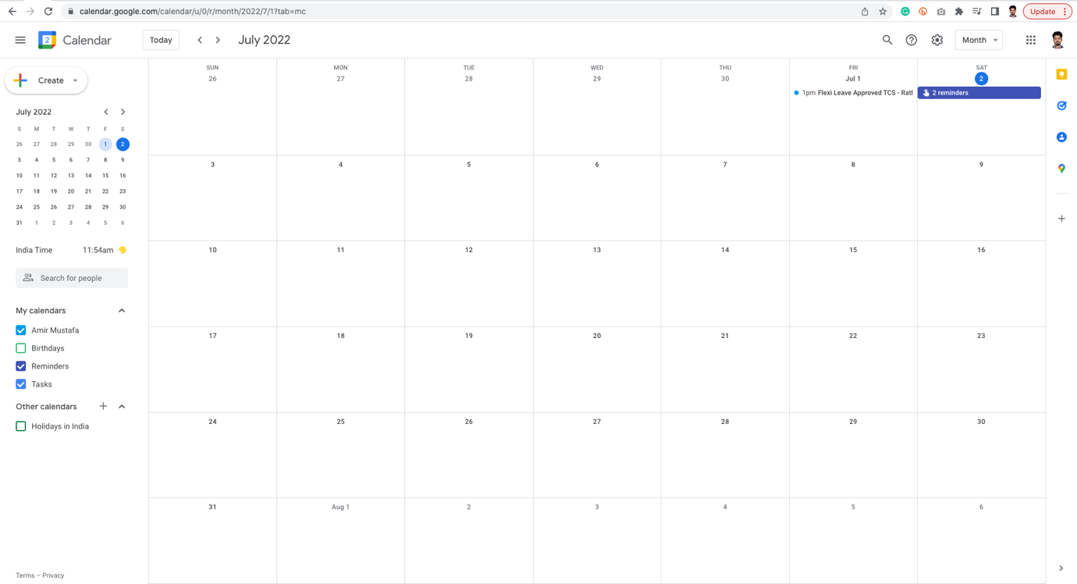

Tip1: Remove Sat and Sun from Google Calendar:

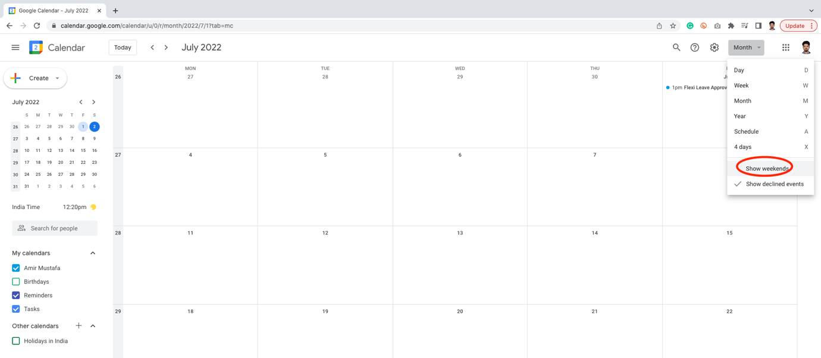

Tip 2: If we are working on two secondary times:

Add secondary times and check it.  
  
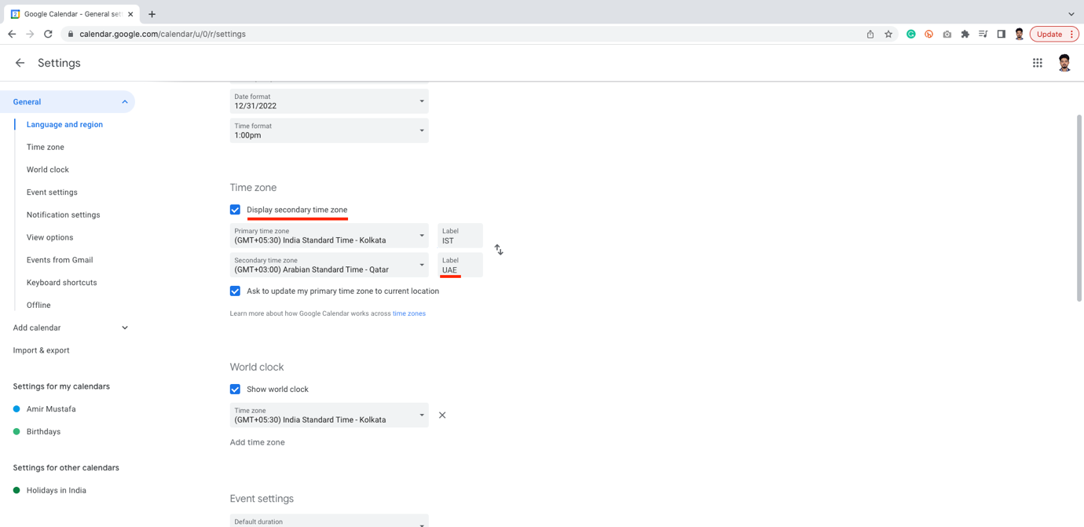

Some settings to know:

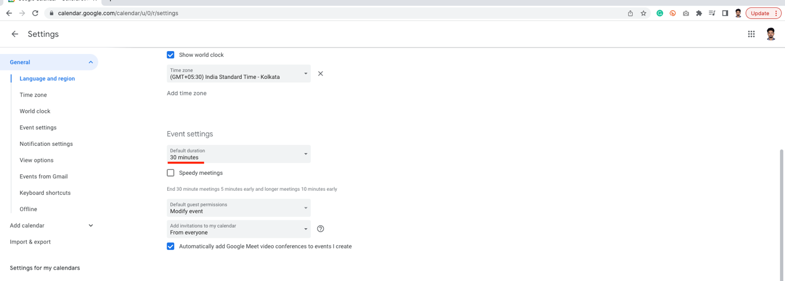

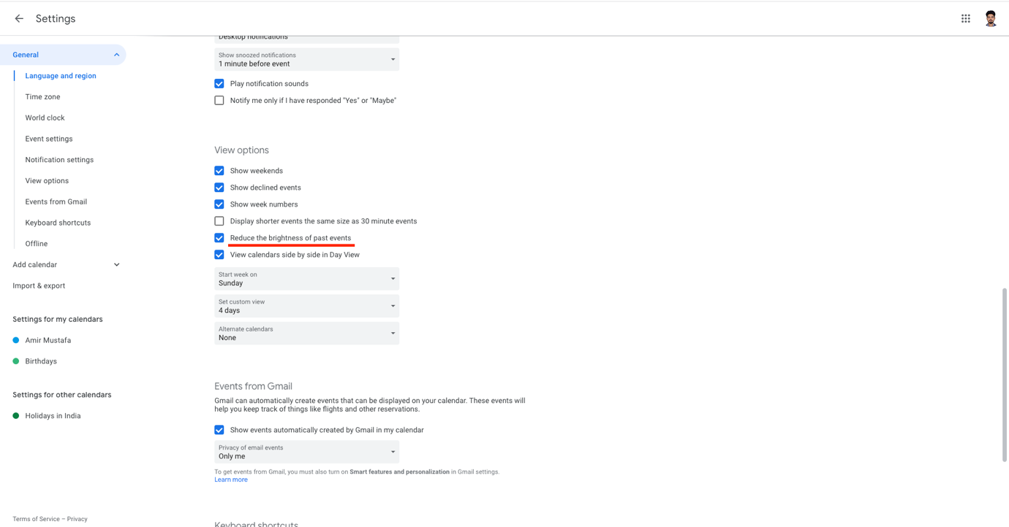

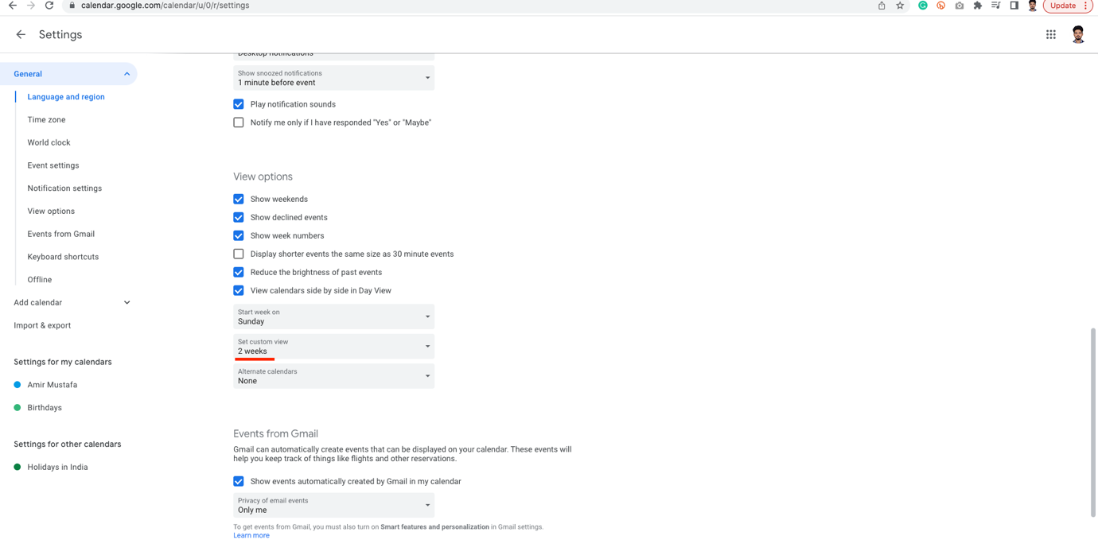

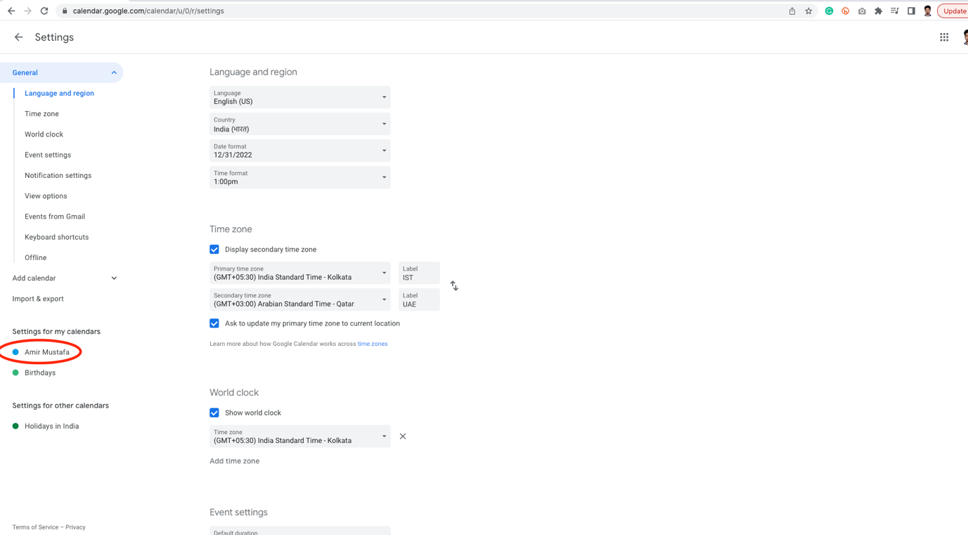

We can also change calendar colour:

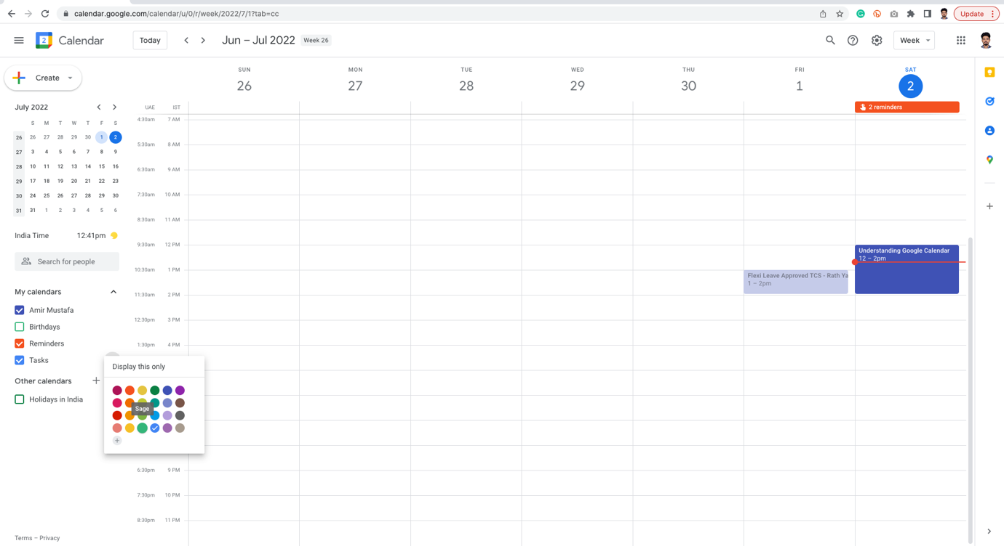

🡪 After updating settings:

We see two time zones, opacity less of past events

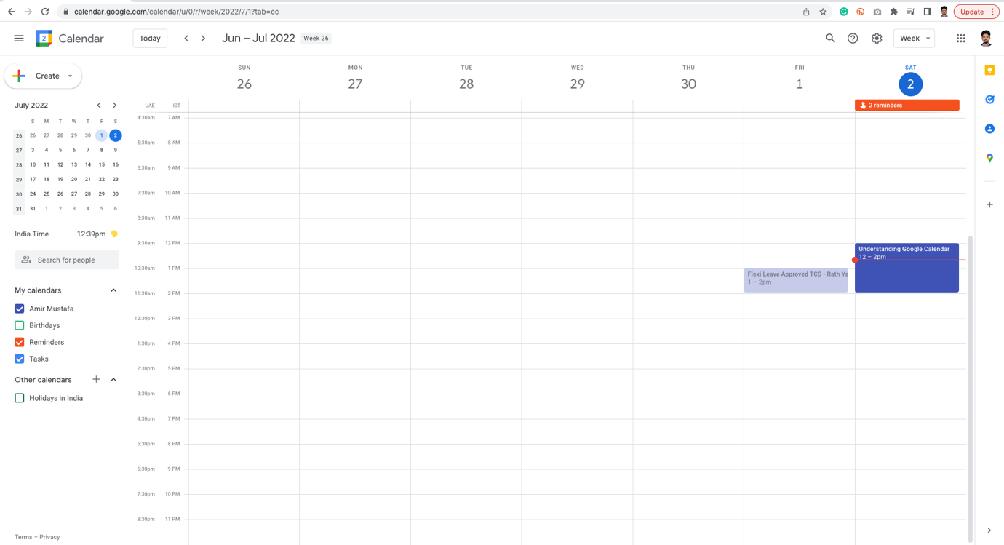

2. Create Edit Events:

1. First way:

🡪 Click plus icon 🡪 Create Event 🡪 add your event time slots

🡪 We can also add guests or Google Meet icon

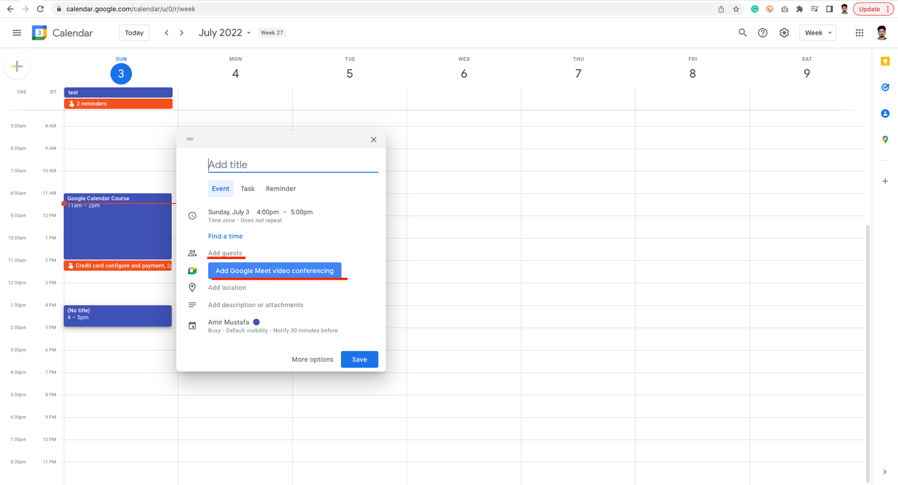

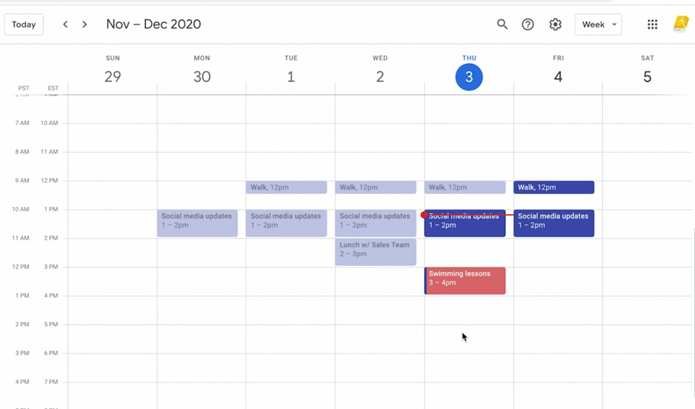

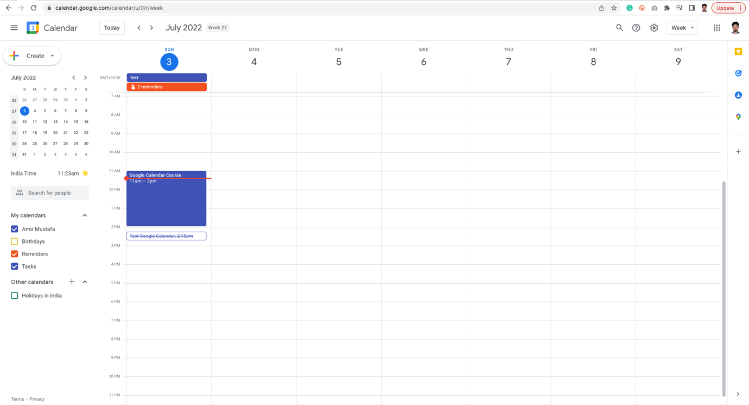

b. Second way of creating calendar:

🡪 It is the same way, but we will be dragging in the time bar, so that we are happy with time selected.

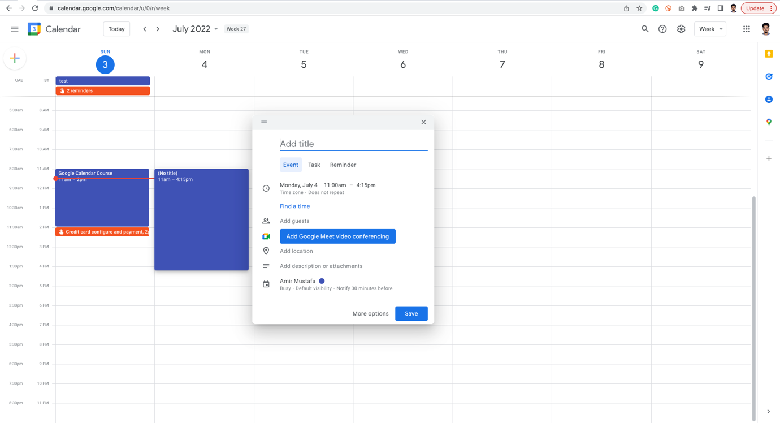

Dragging even further:

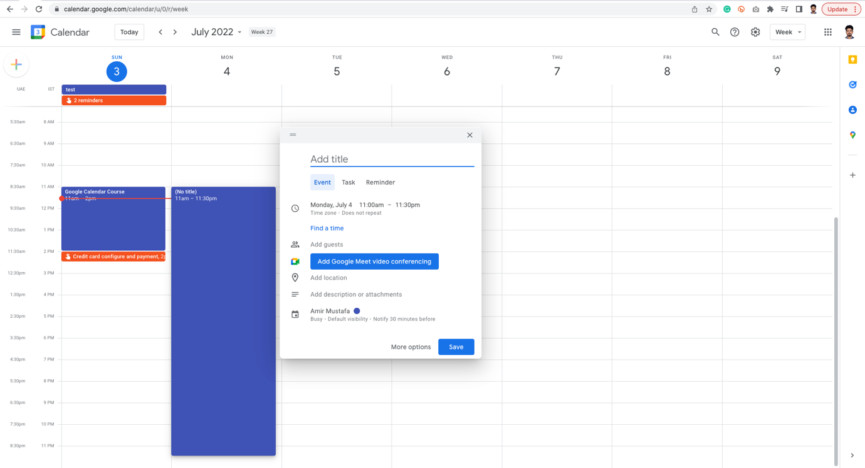

2. Create all day and repeating events:

* Some events does not happen for single day. It might happen every week or three days a week.

Eg. Swimming Lessons

🡪 So we have to make it recurring events

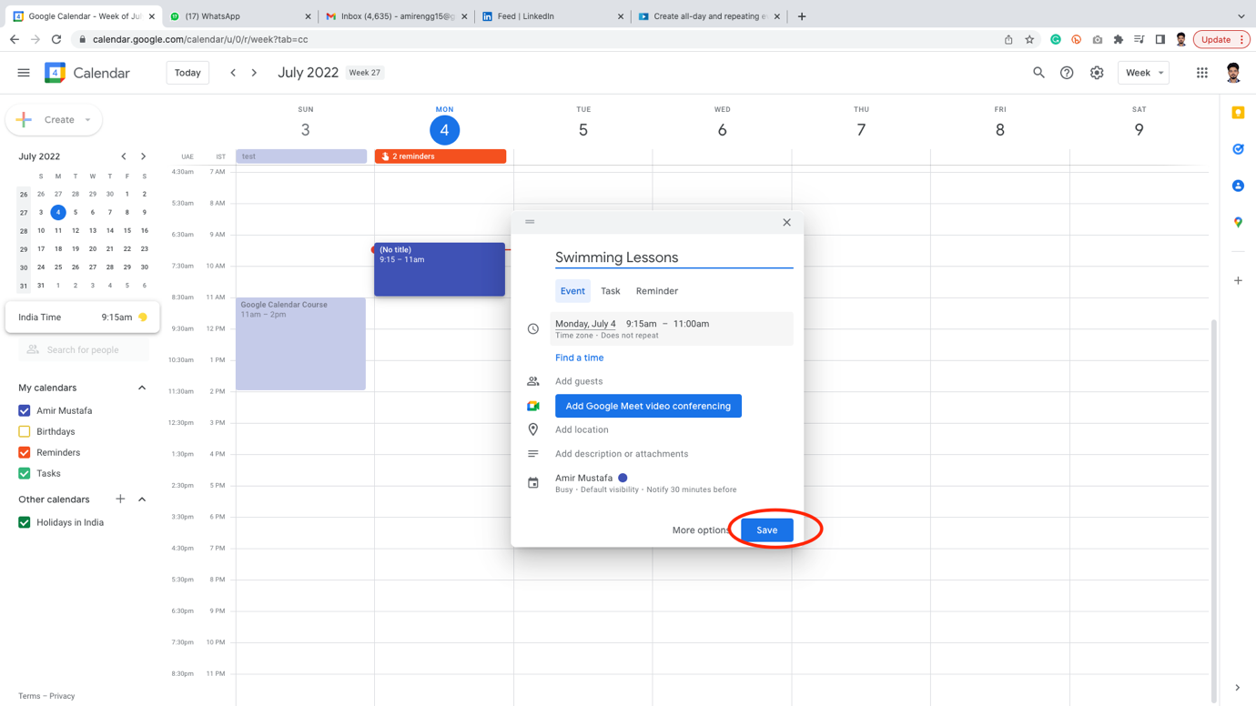

🡪 After creation, double click on the event, a larger form pops up

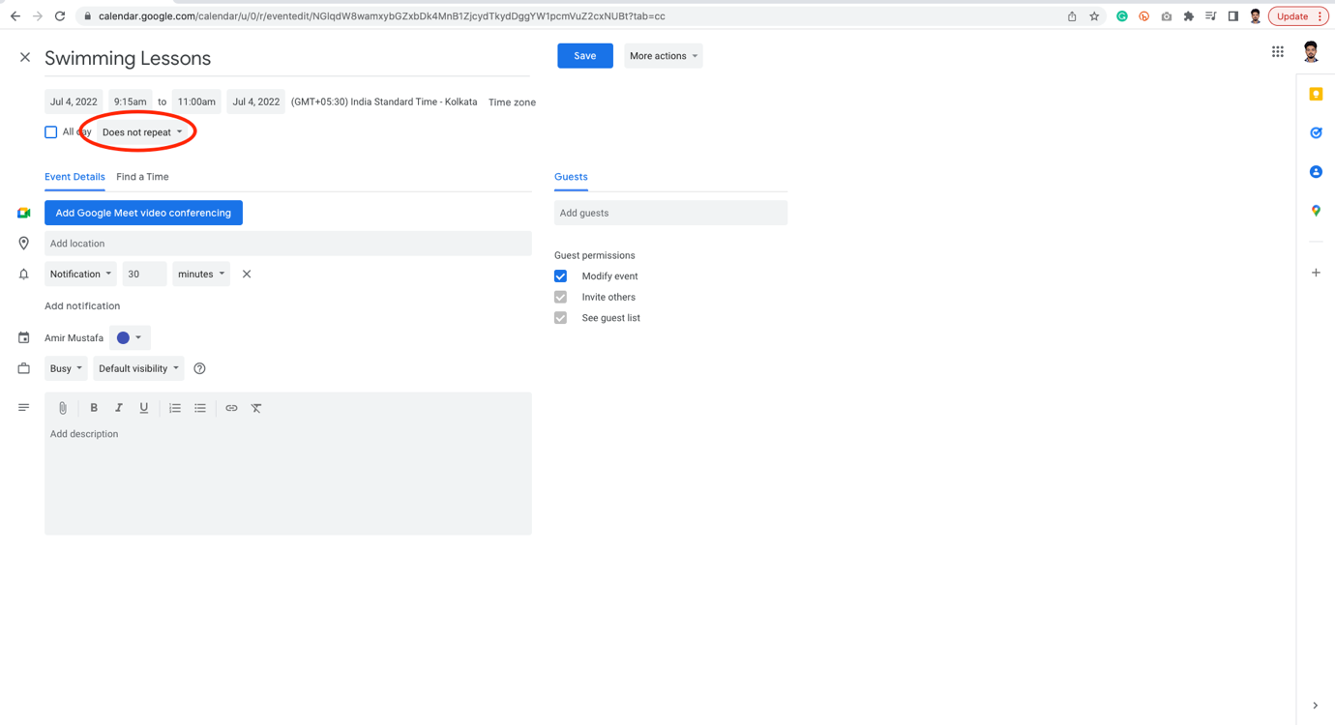

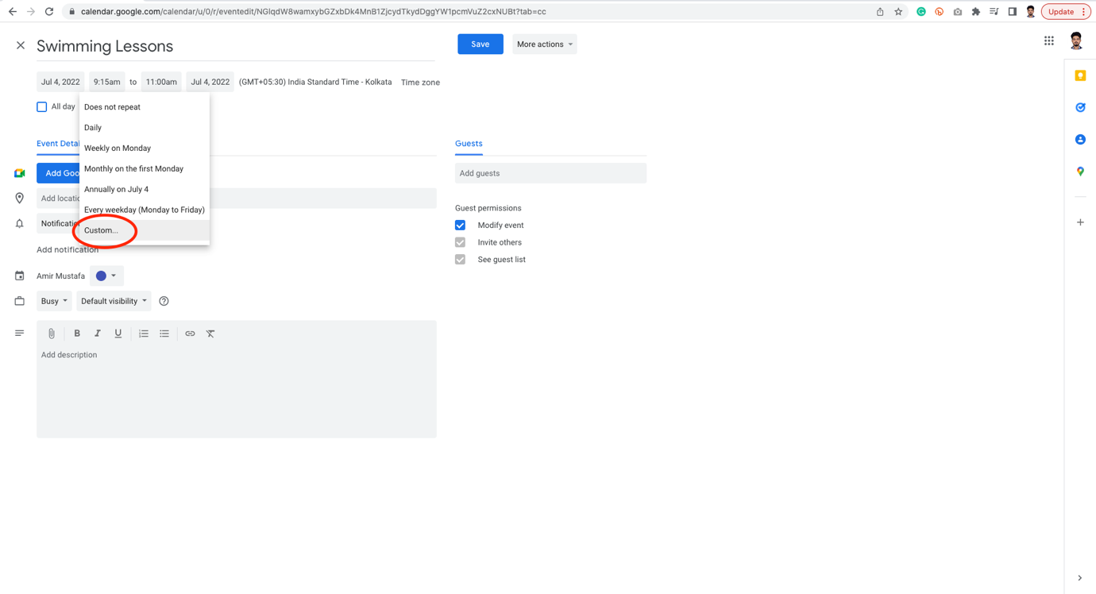

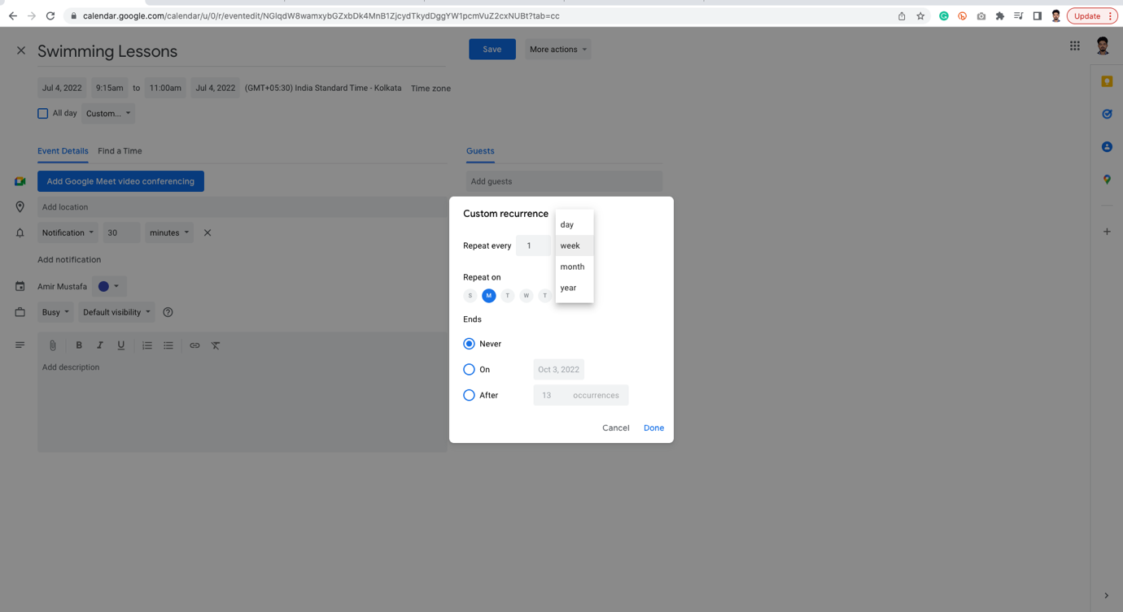

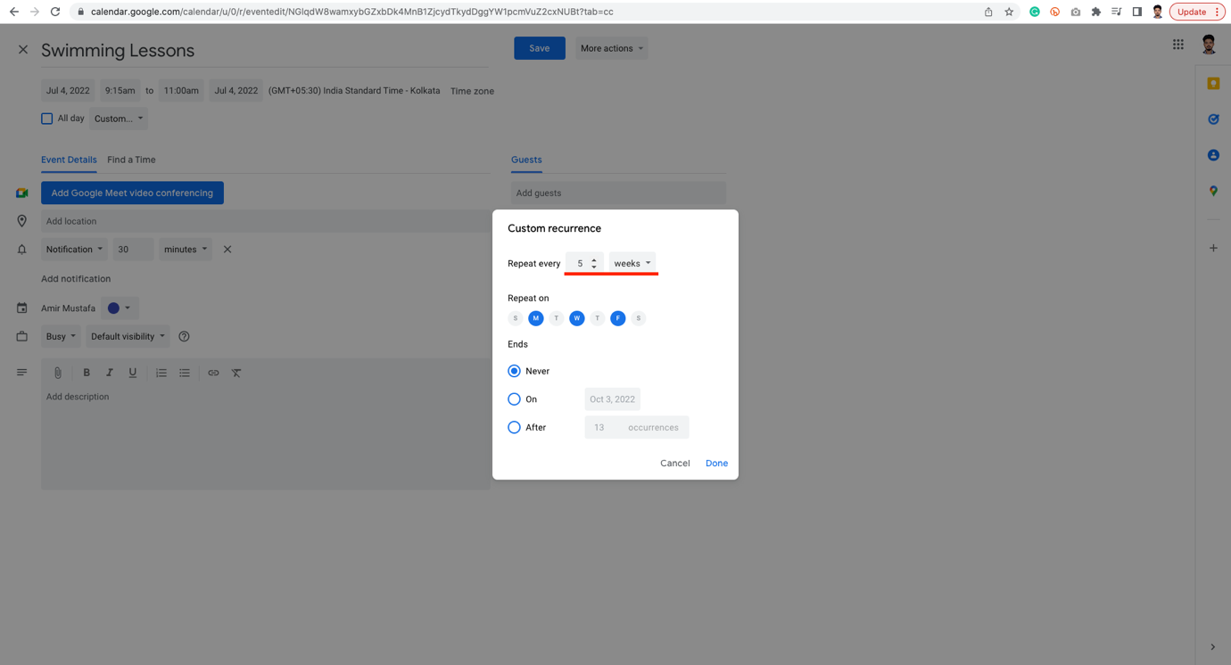

🡪 The last three are the ending date – Never, On or After.

Never – means event repeating never ends

On – means ends on specific date

After – End after specific number of occurrences

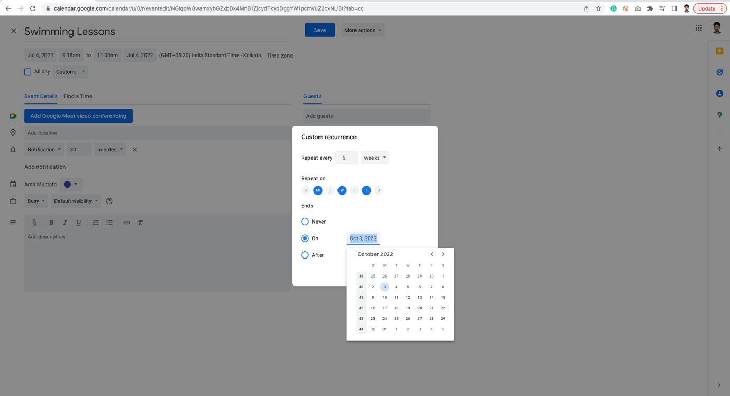

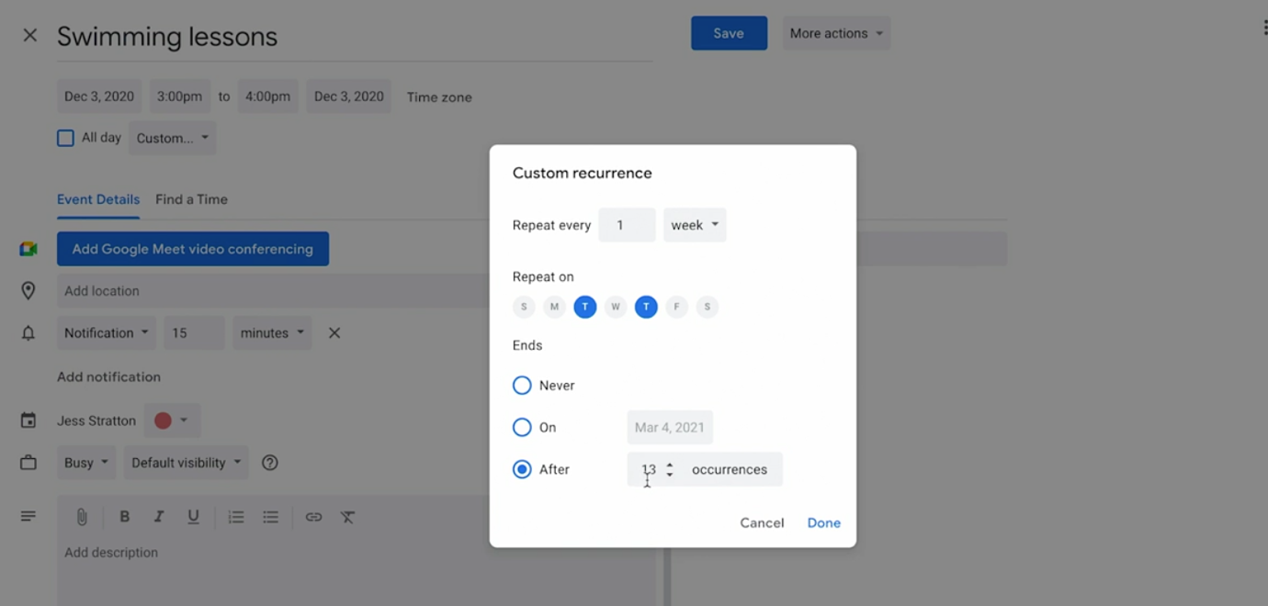

🡪 Eg, we know swimming lessons ends after 13 occurrences (i.e. 13 weeks)

🡪 When the event is over and we click done, we can see occurrences. We see below:

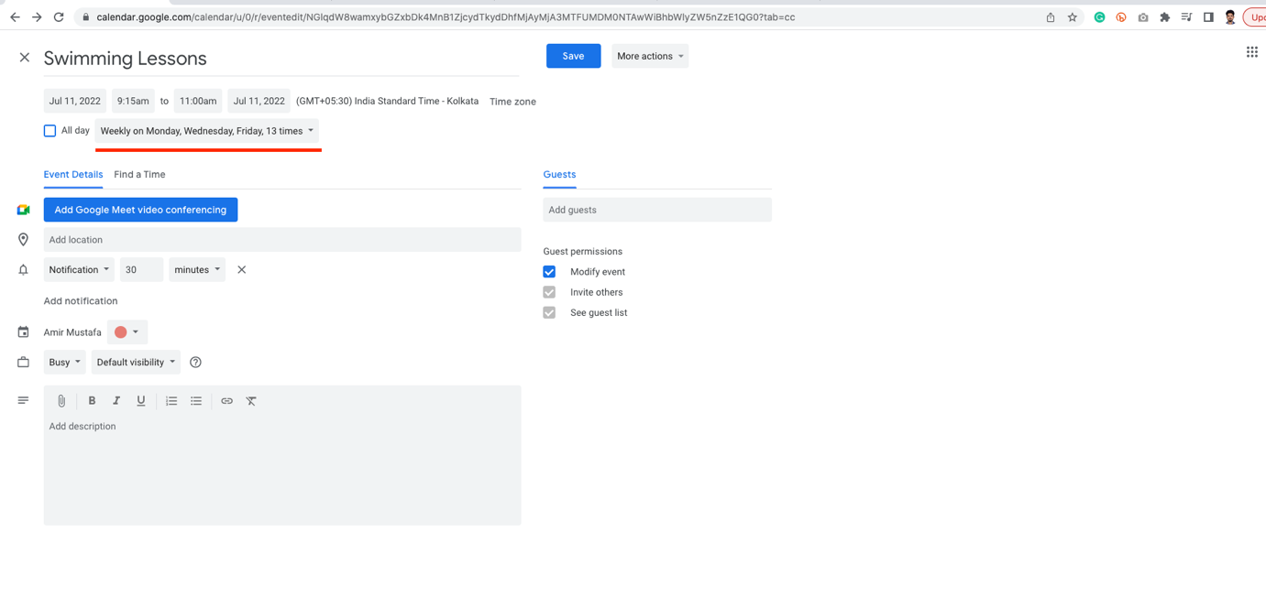

🡪 Change colour code for finding difference between personal and professional distinction (for eg)

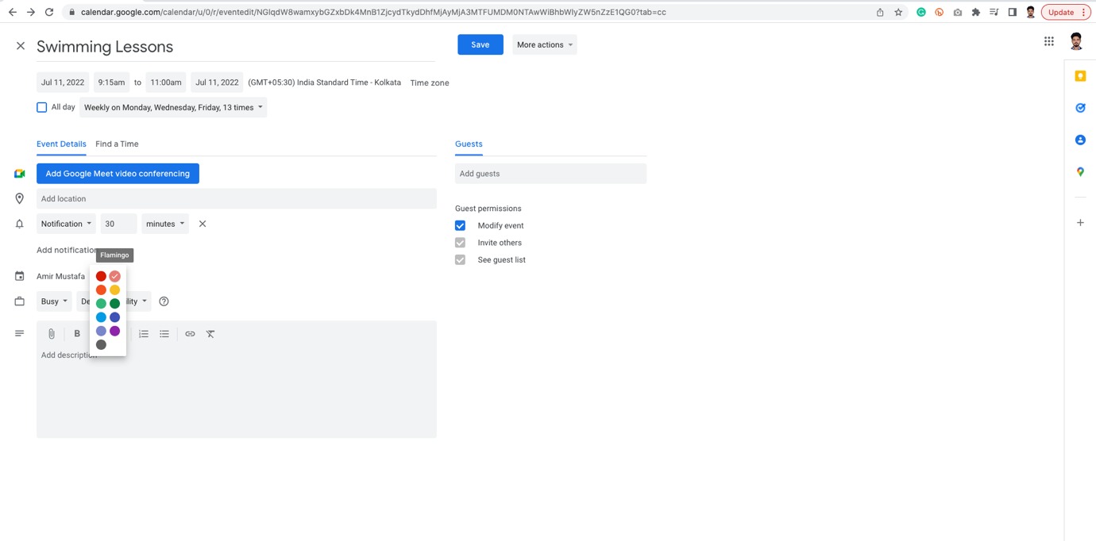

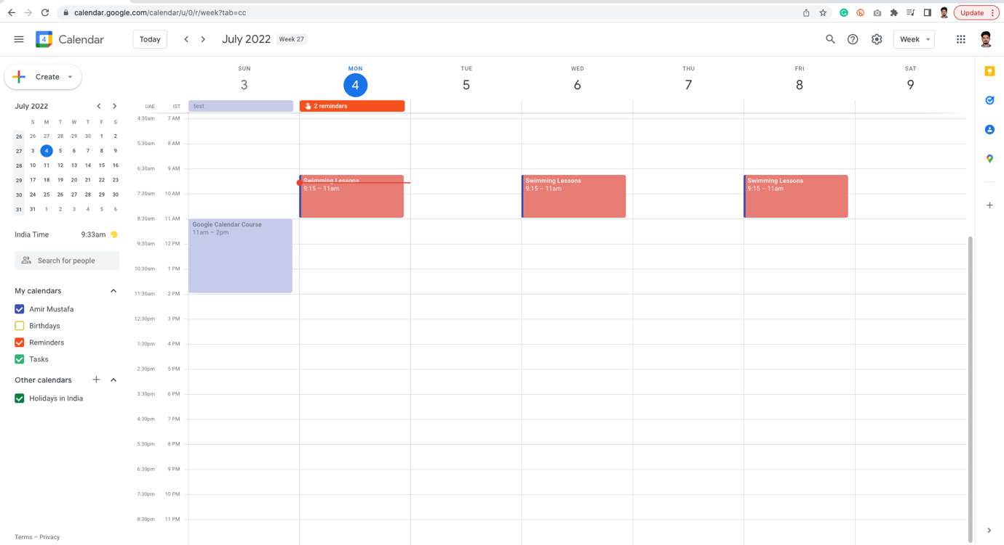

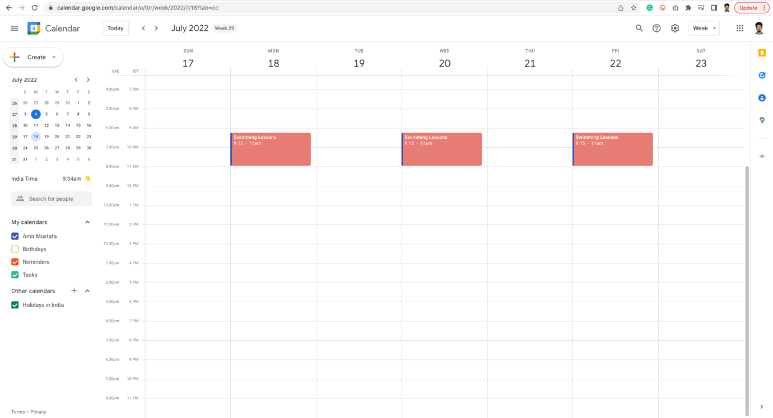

Create All day event:

🡪 This is very useful if we wish event for specific date

🡪 Eg. Trip to Puri

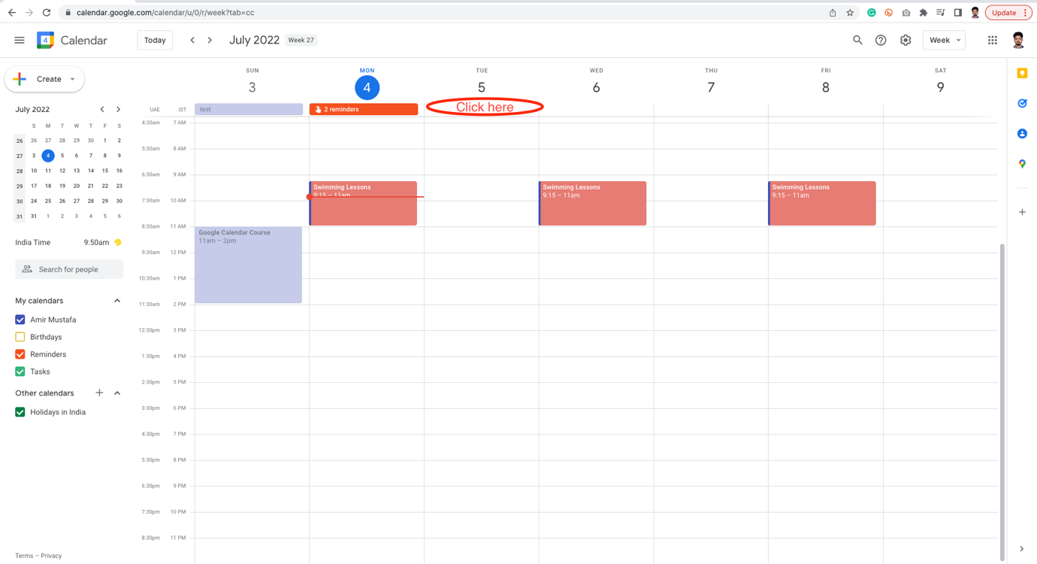

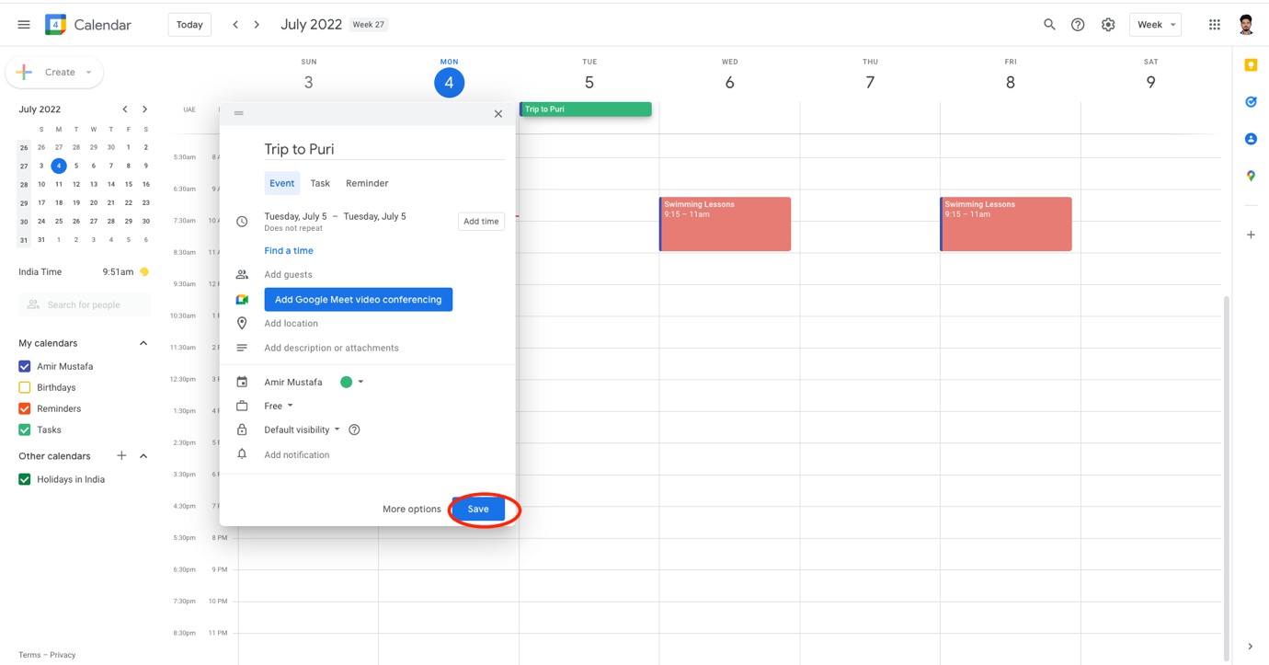

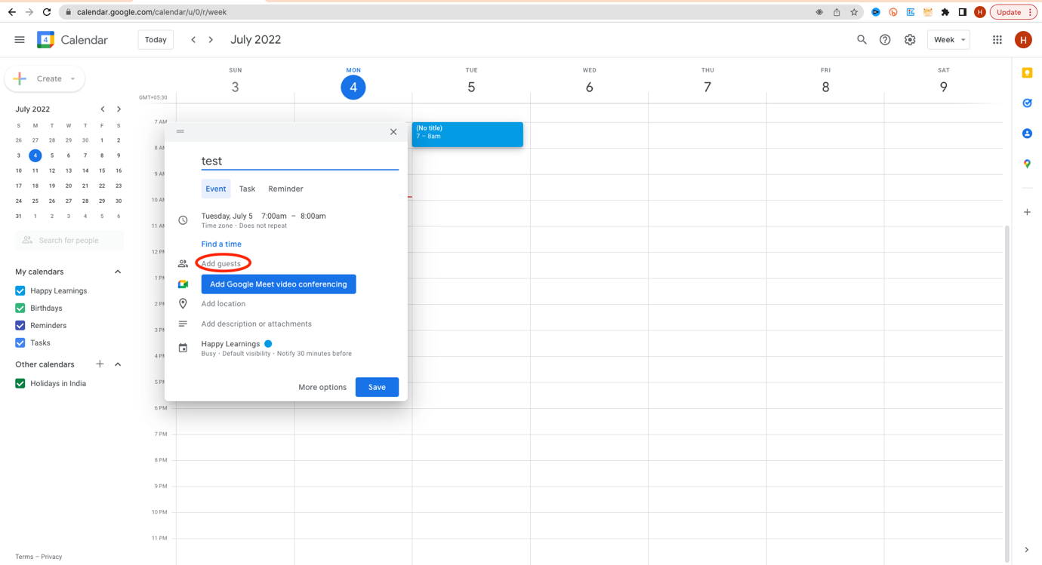

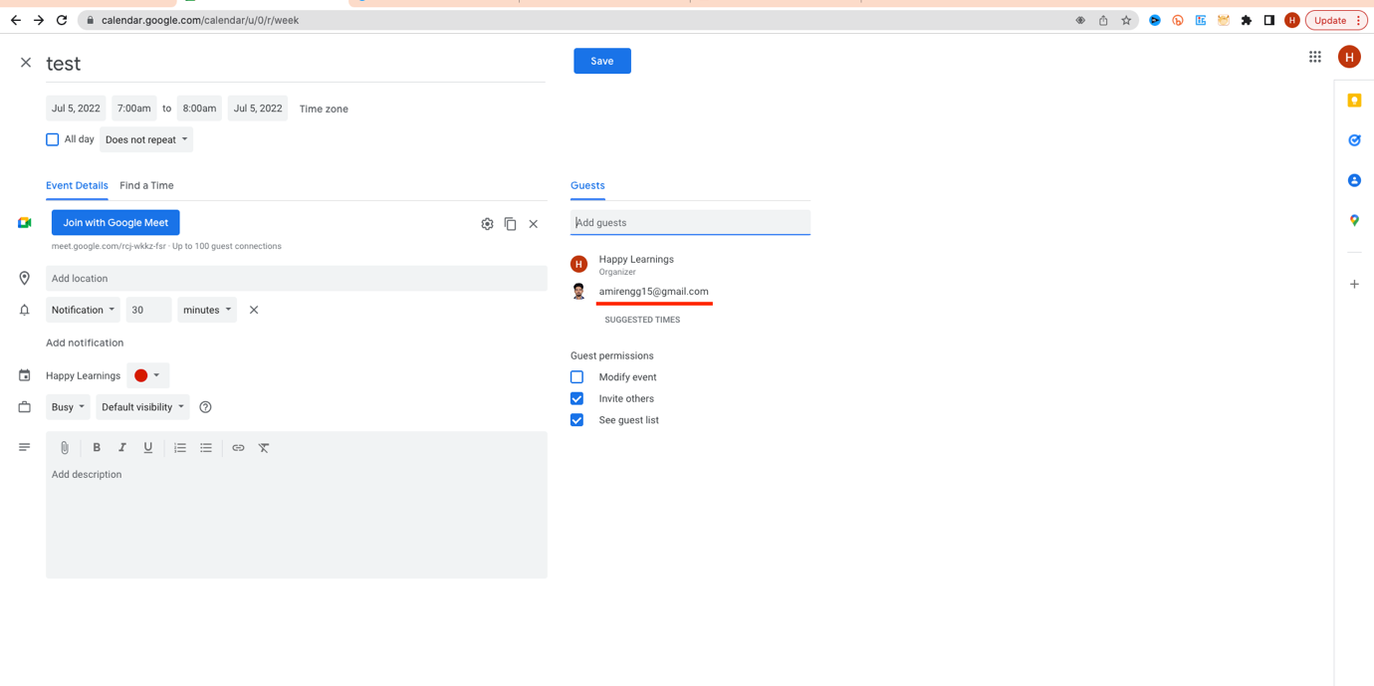

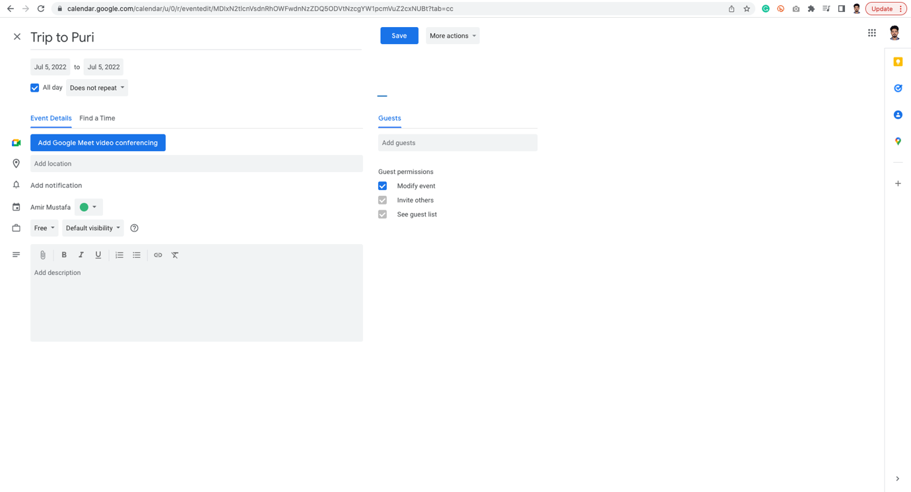

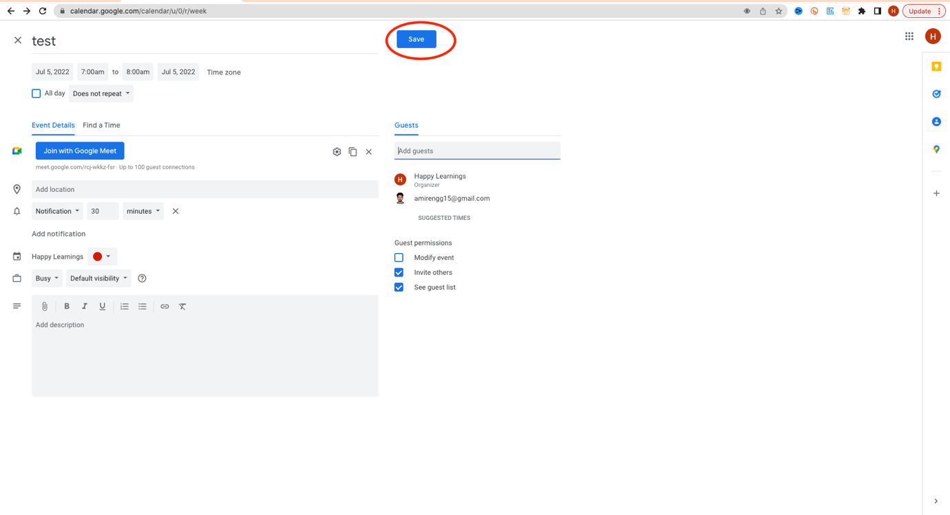

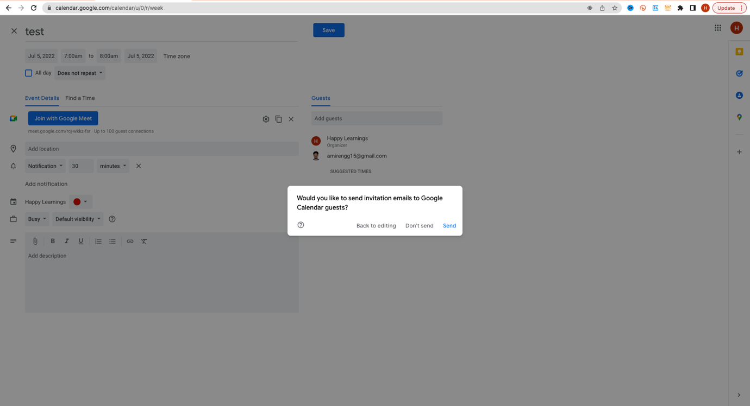

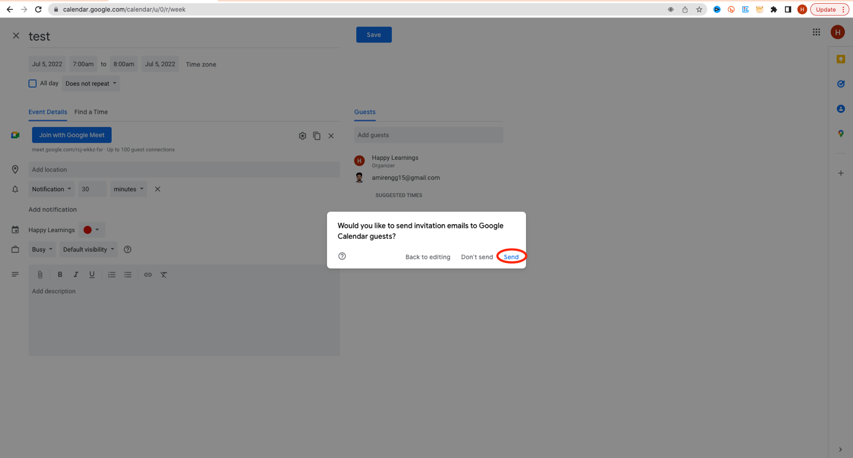

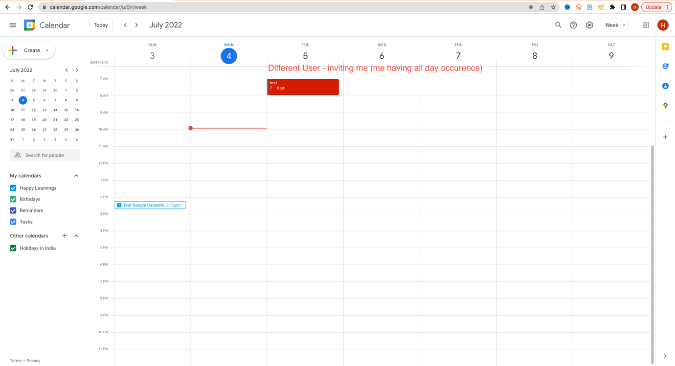

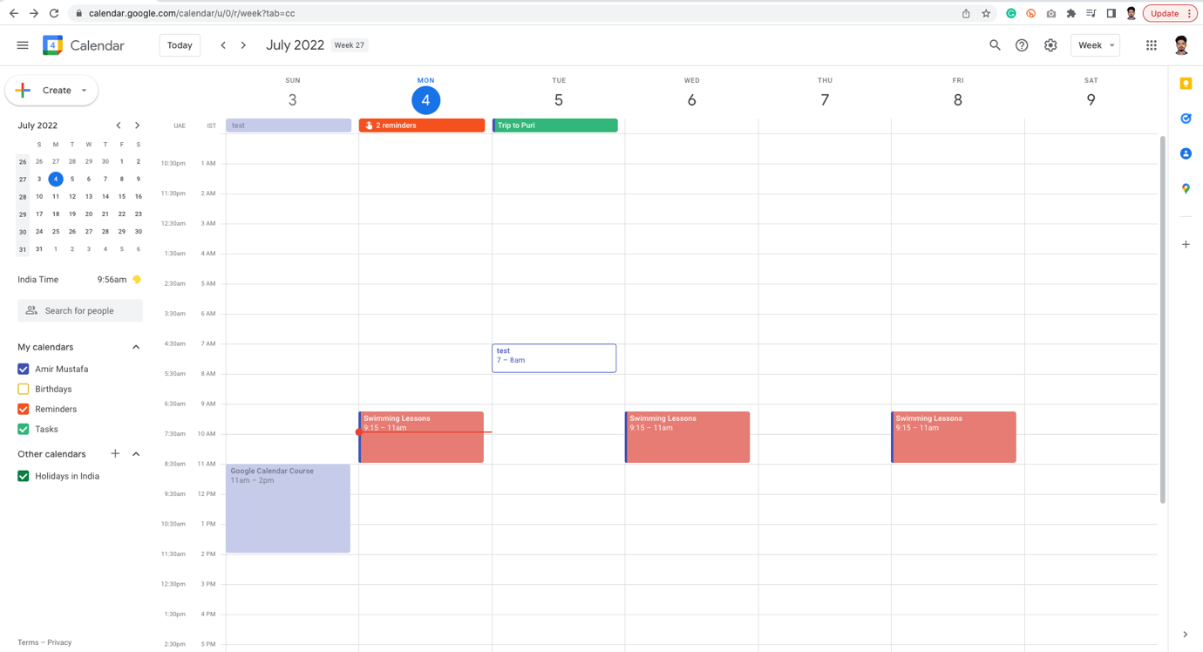

TRICK 2:

🡪 For creating daily events, we can also drag from left to right.

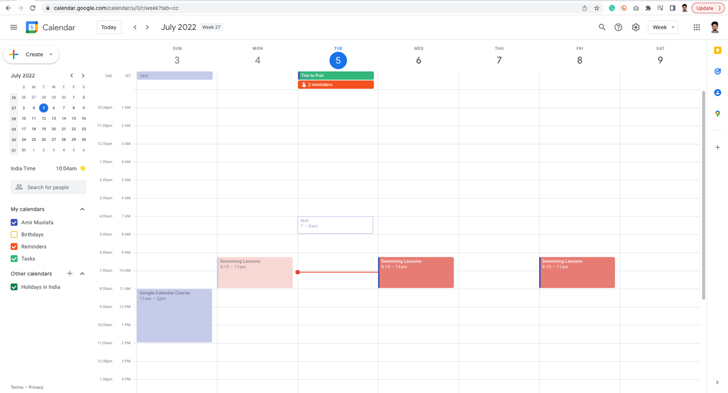

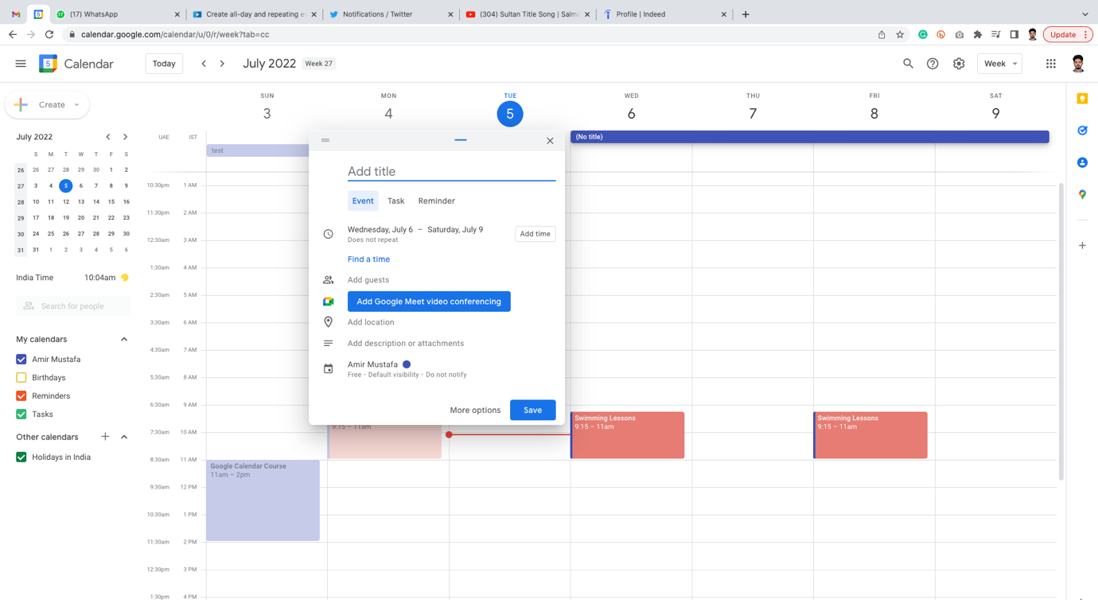

Multi-day All day event:

We can now create same way, by checking More option

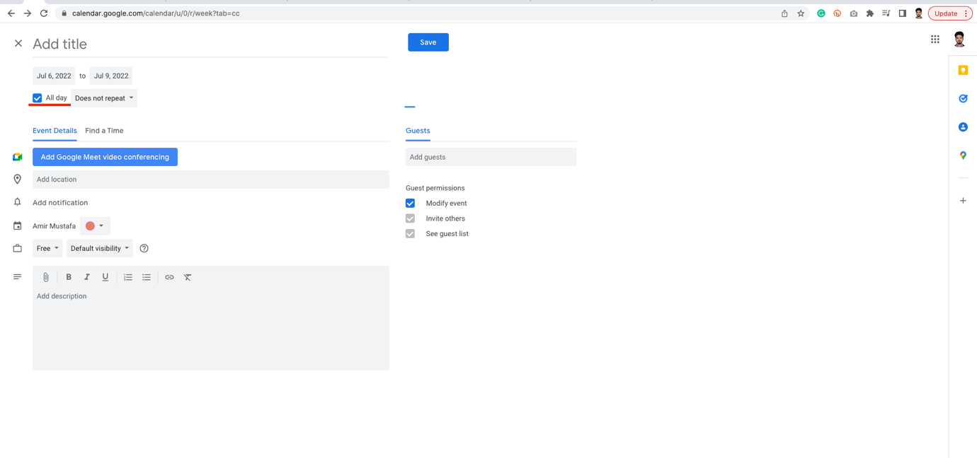

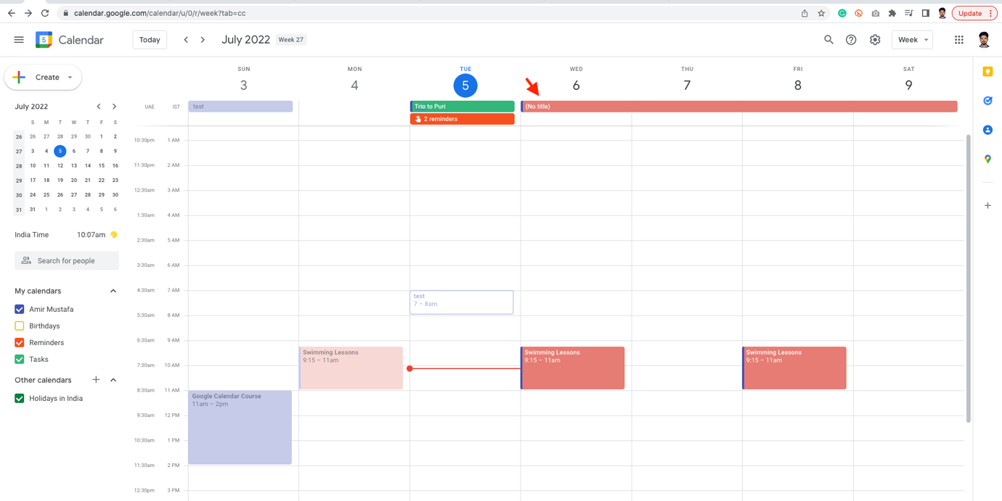

🡪 For deleting the event, click More option 🡪 Delete

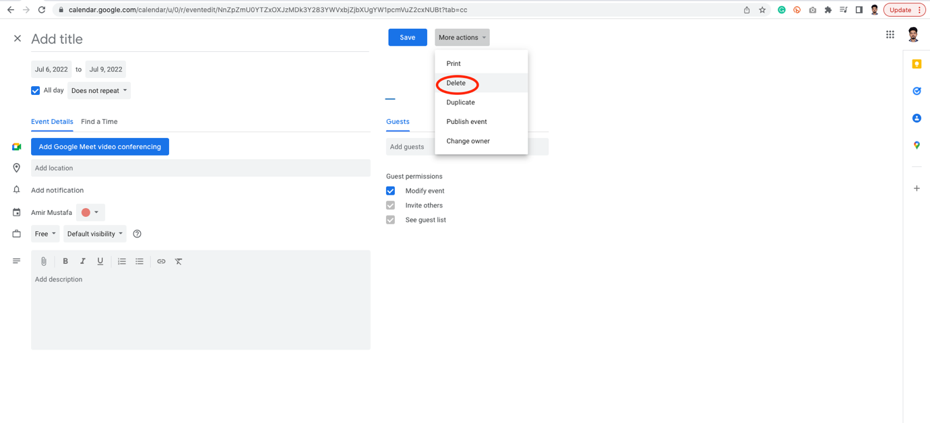

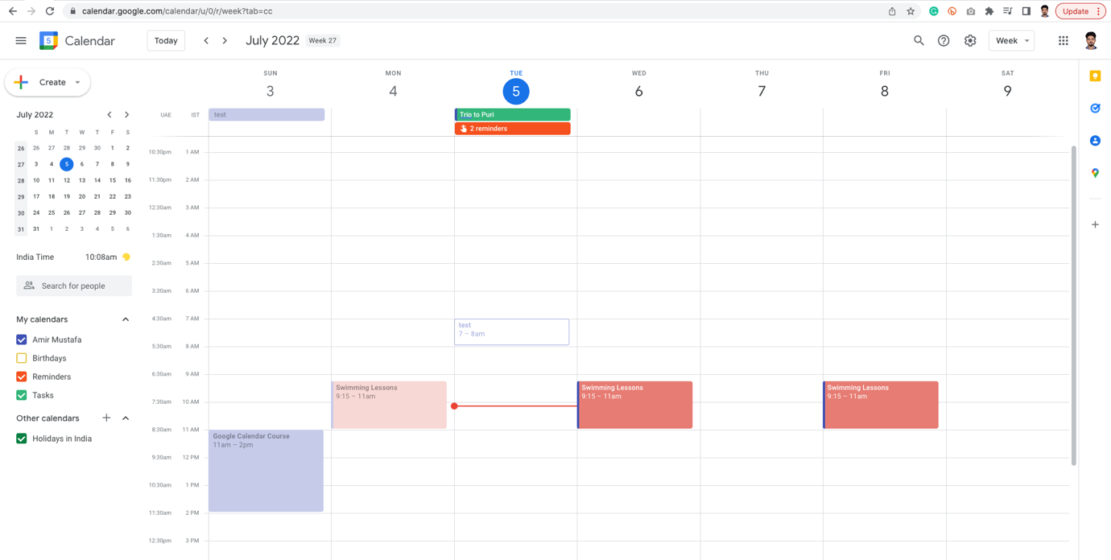

Create Appointment Slots:

🡪 This useful when someone wants to book your time slots for 15 mins, 30 mins, 1 hour, etc

🡪 Other people can directly meet on my google calendar for the time frame we specify.

🡪 This feature is not available in regular google account, only in GSWE account.

🡪 Two ways to identify this account:

1. Google logo in this accounts looks different

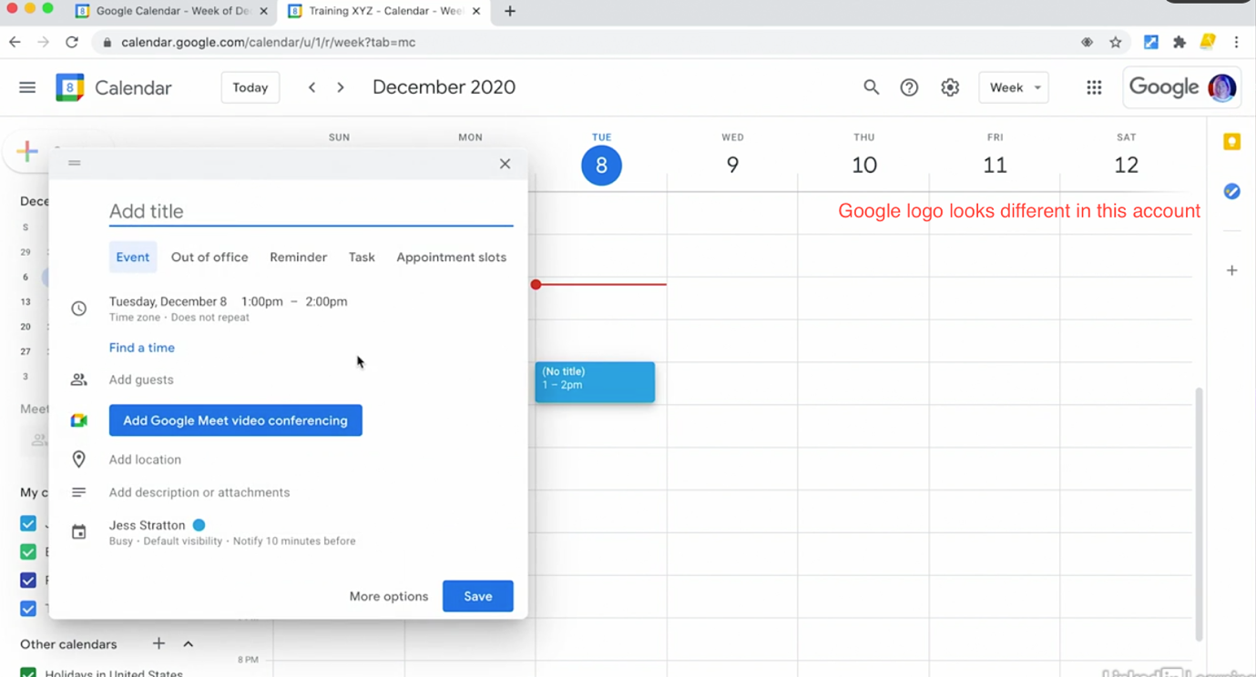

1. There will be more options in this meetings like appointment slots

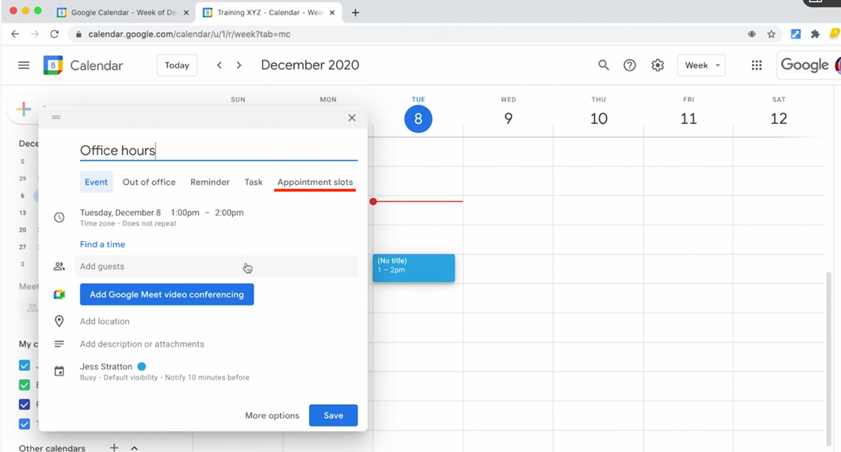

🡪 Let us create appointment accounts:

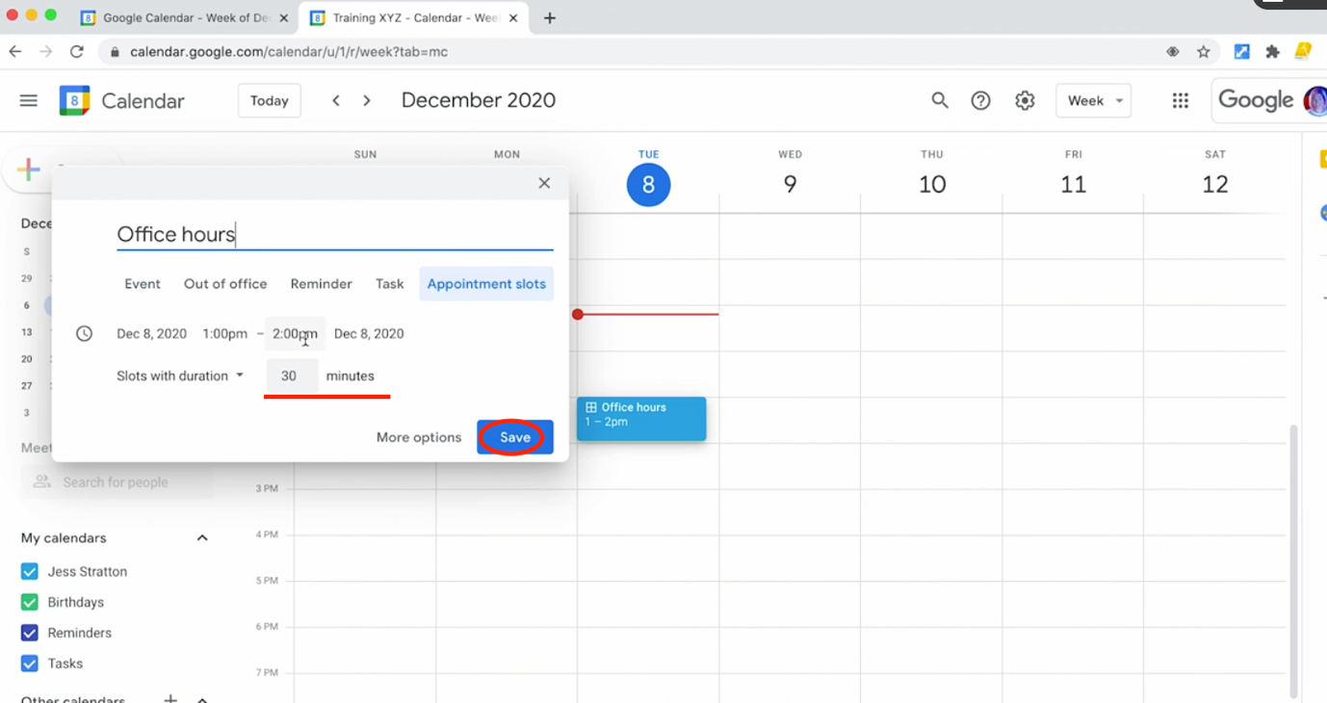

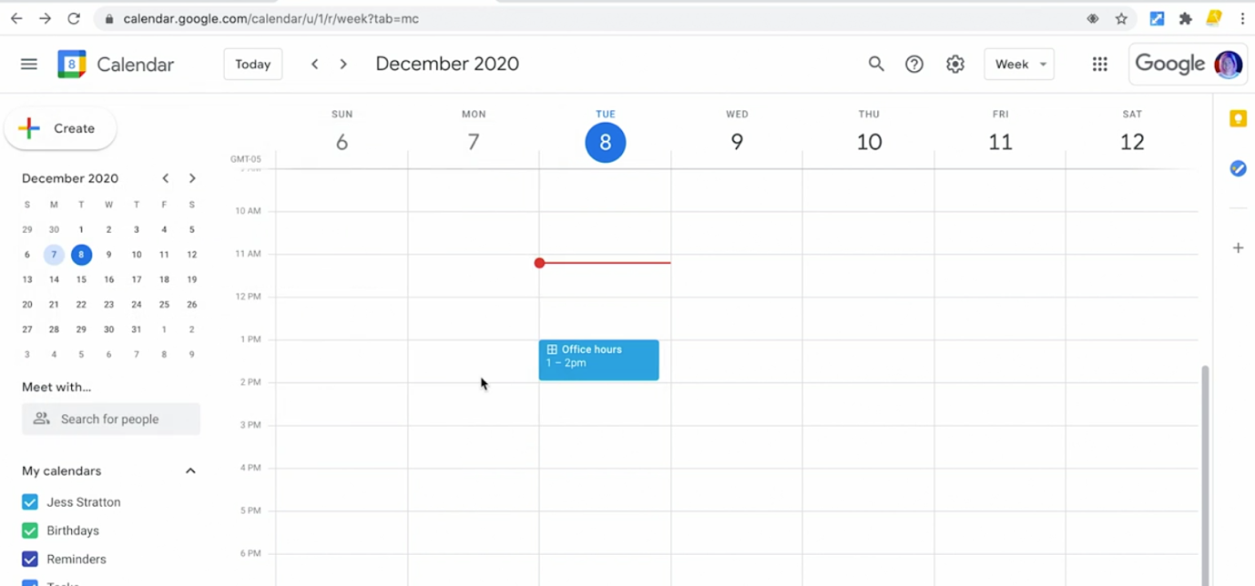

🡪 We can also drag more appointment slots from here

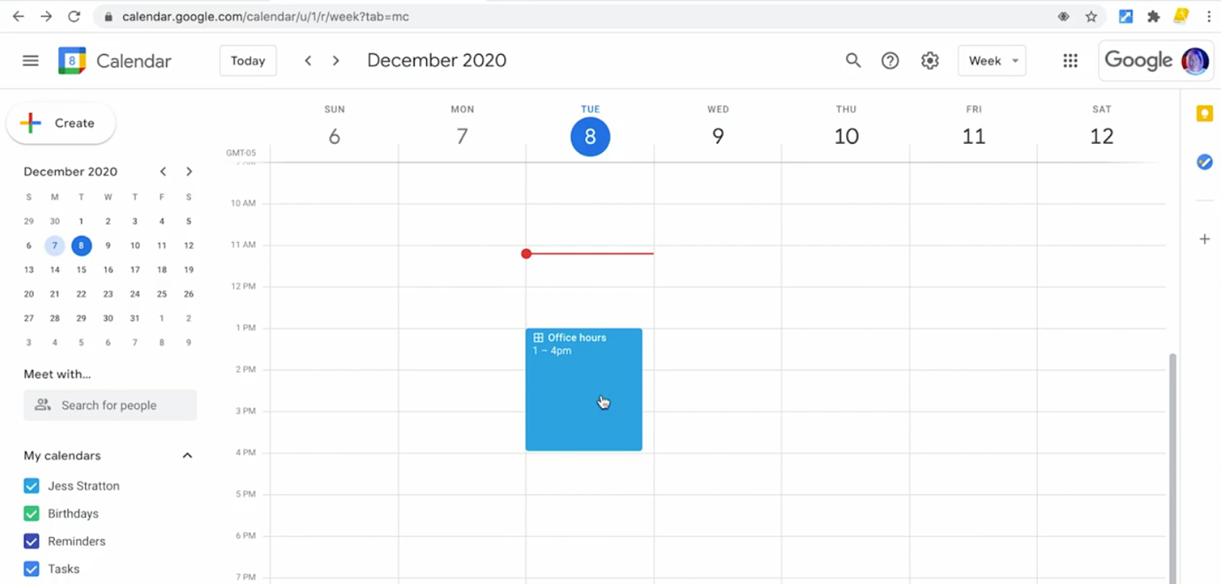

🡪 We can also add more information to this working hours, example location of appointments

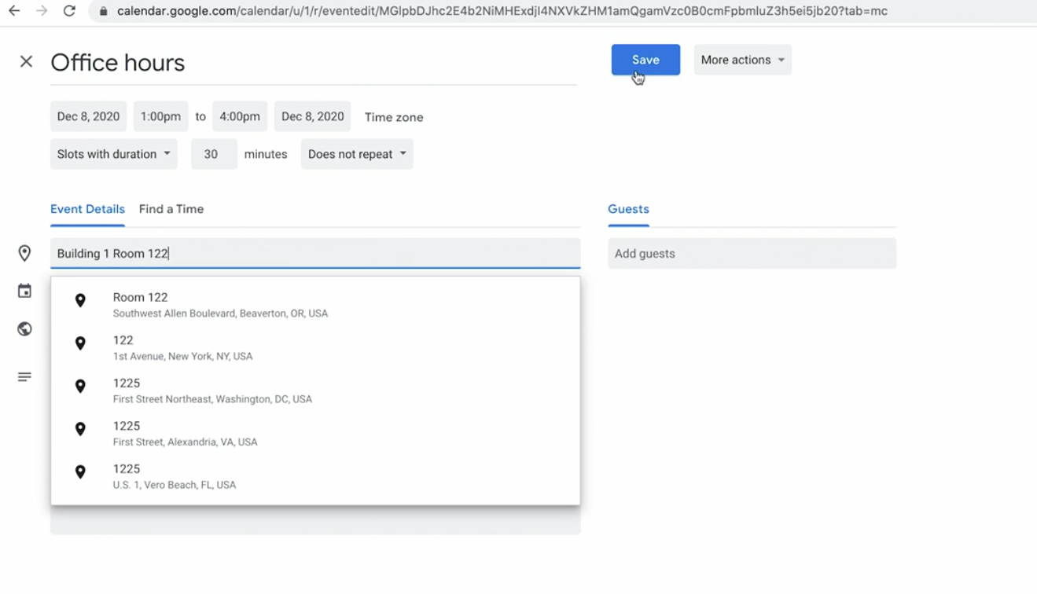

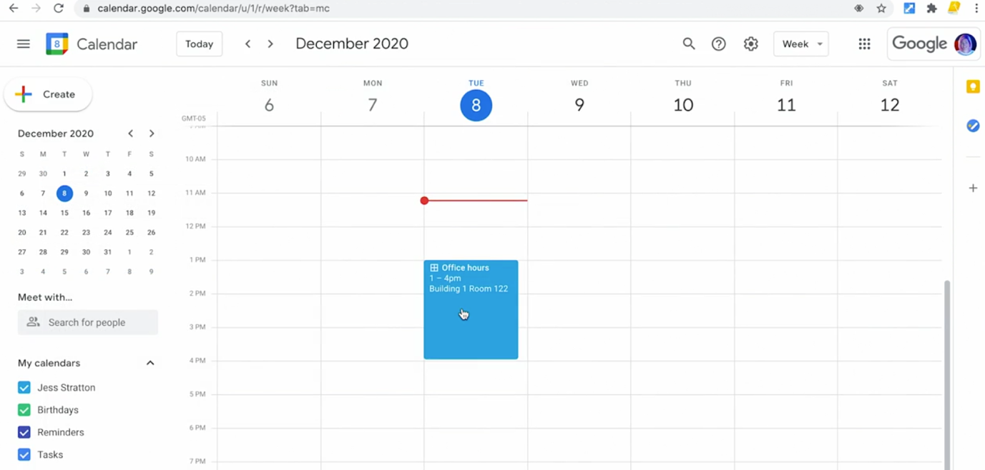

TRICK: Grid icon indicates they are appointment slots

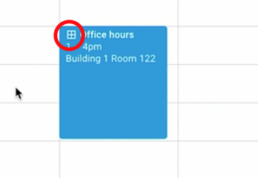

Booking Appointments:

🡪 To book an appointments 🡪 Click on appointments

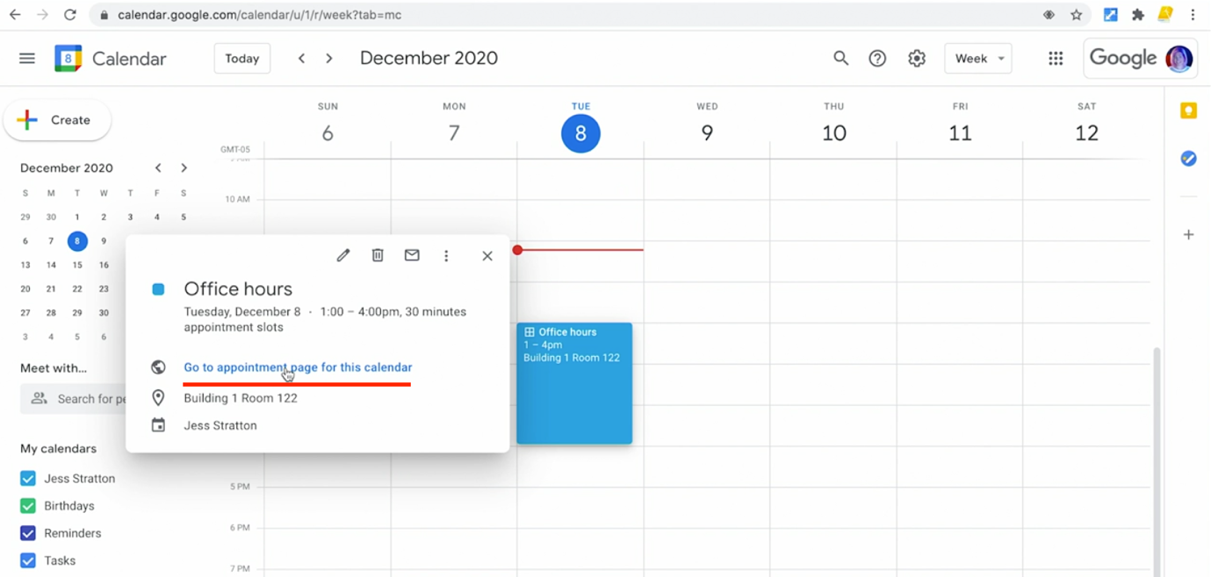

🡪 We need to send this link (Go to appointment link) to other users

🡪 Let is click the link

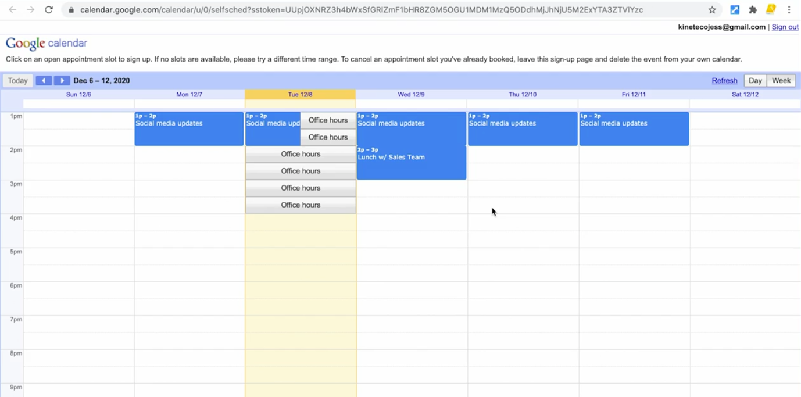

🡪 Click on the Office hours which is not overlaying (eg. from third i.e. not clashing other meetings).

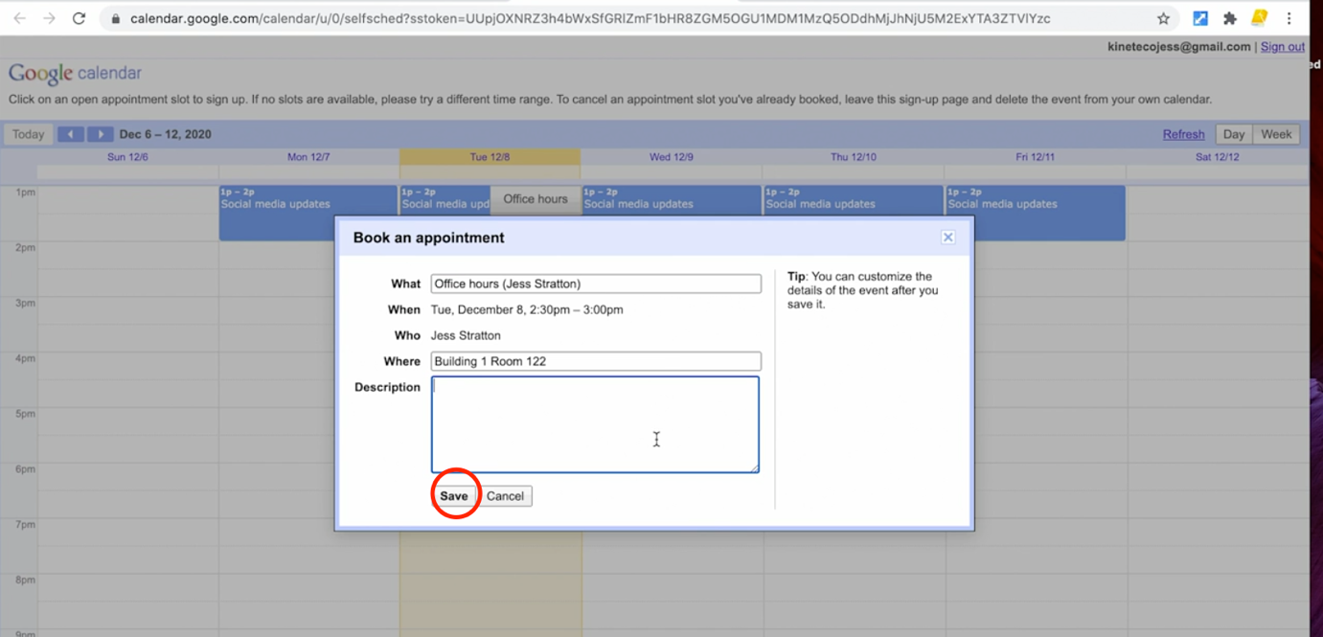

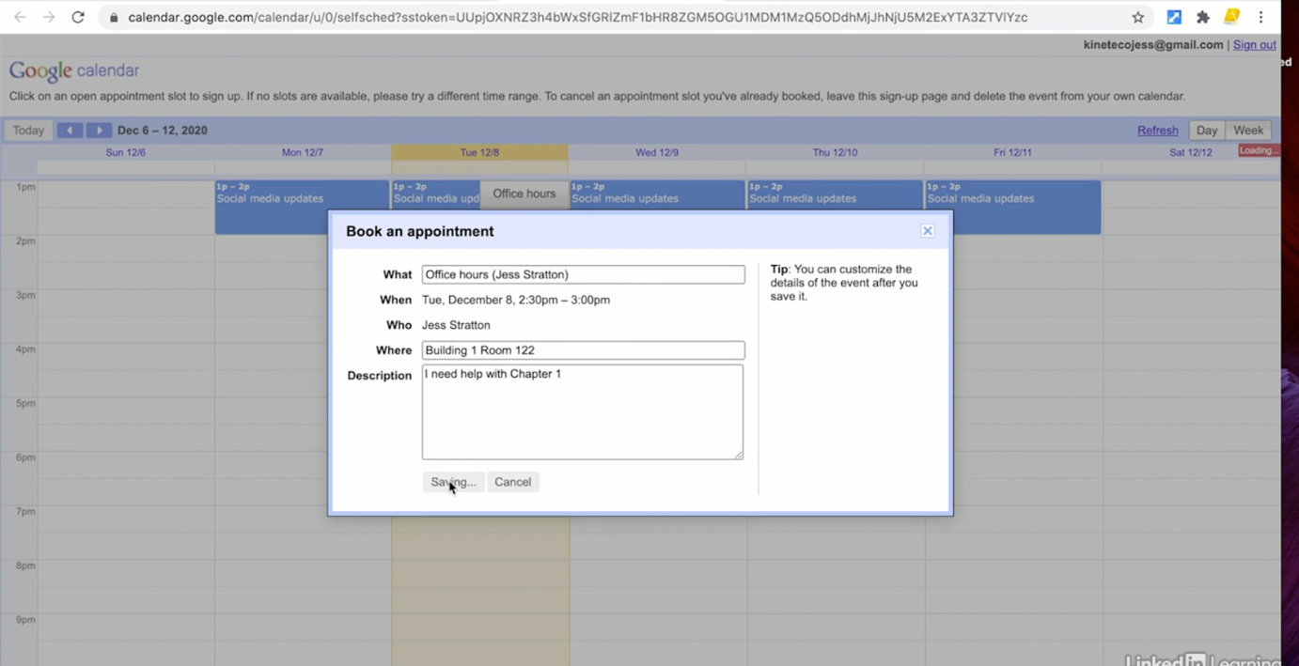

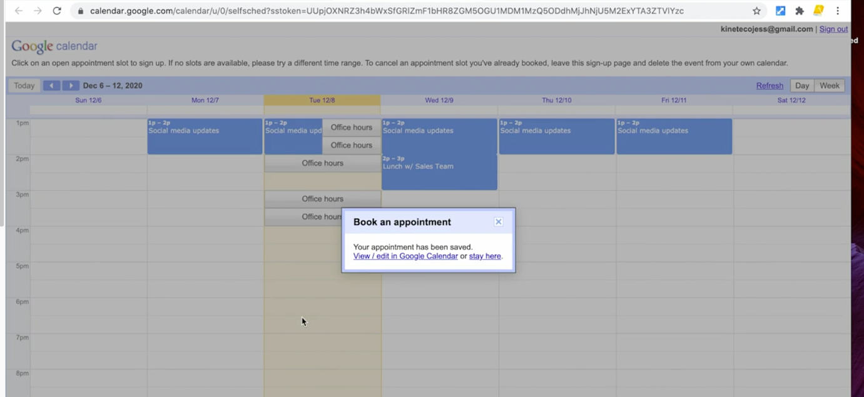

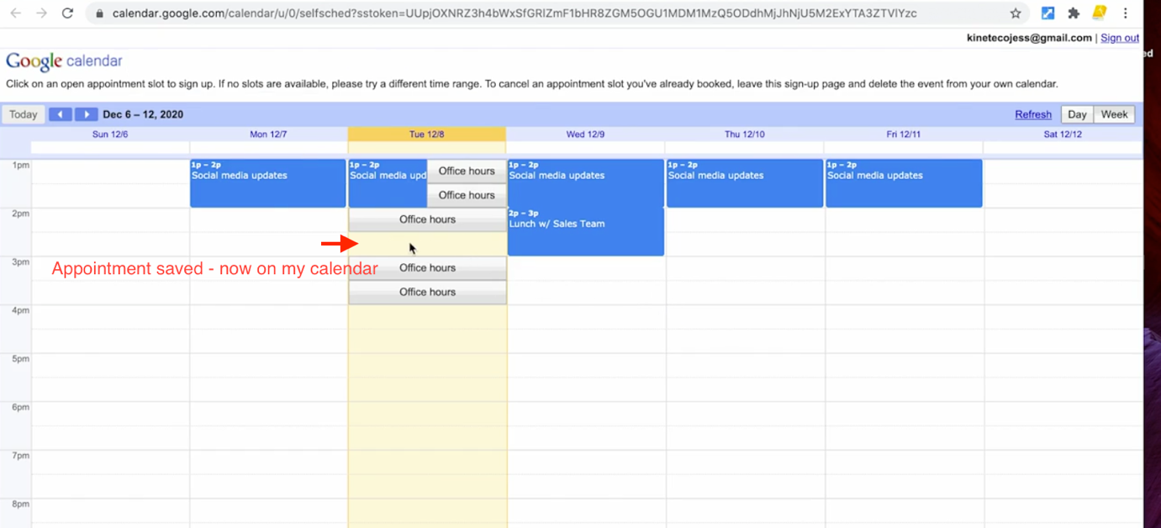

🡪 If we go to the original calendar, we will see appointment booked, who booked and other details.

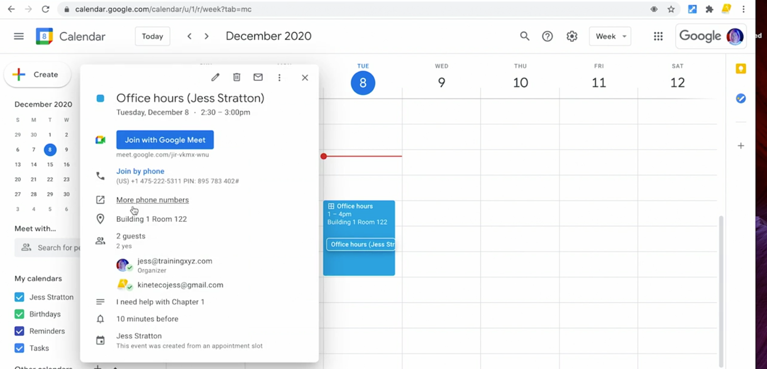

🡪 If we want to repeat it, we can edit the appointment and click repeat option

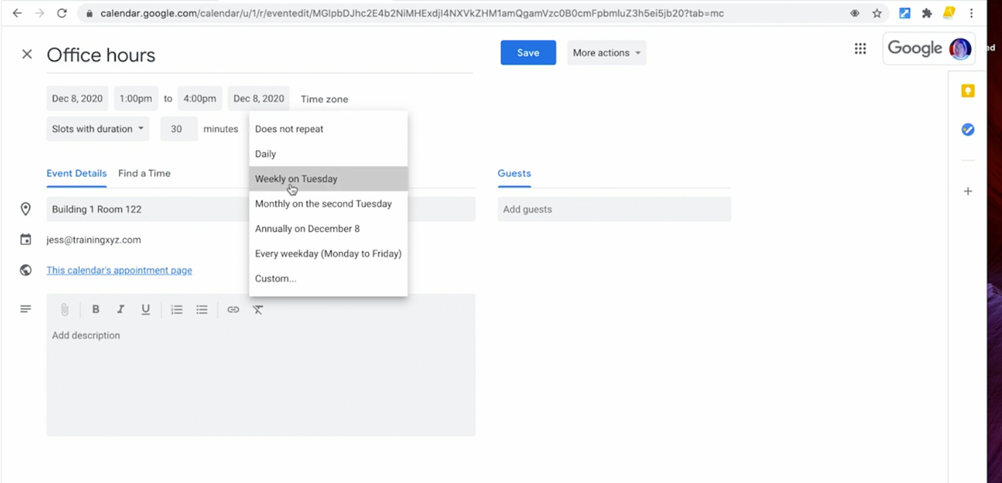

Edit or Delete Event:

🡪 We can drag and drop event in different timeslot/day

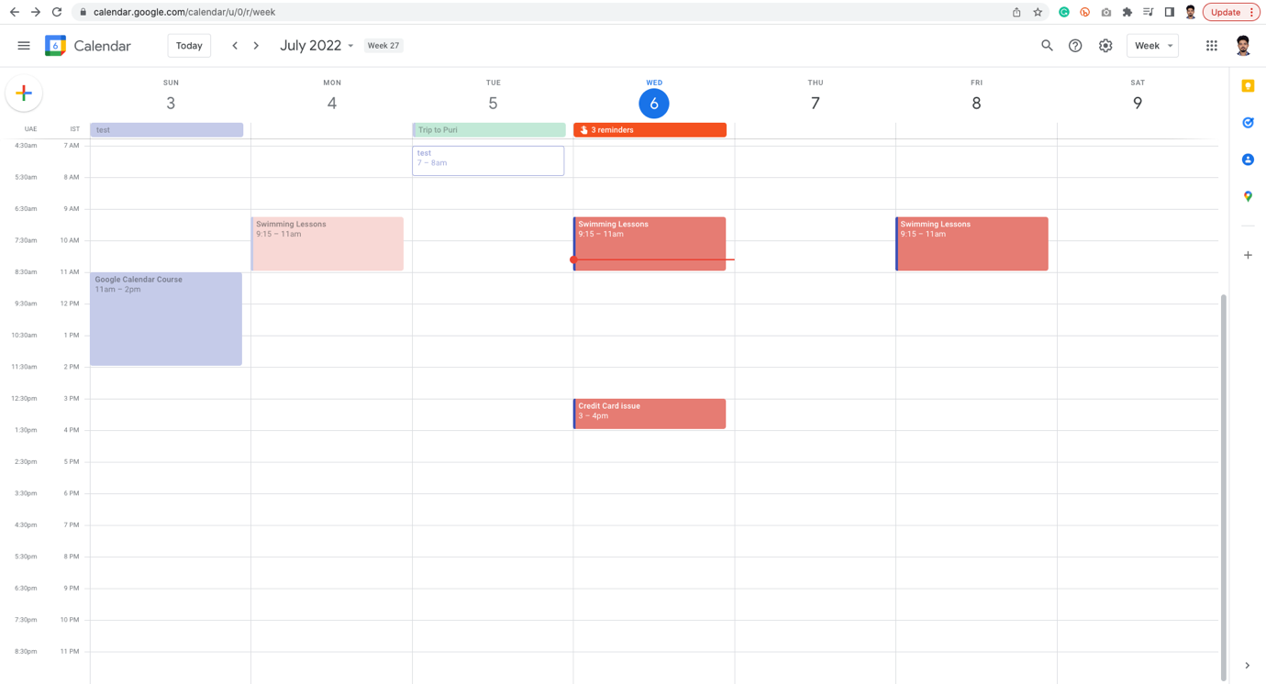

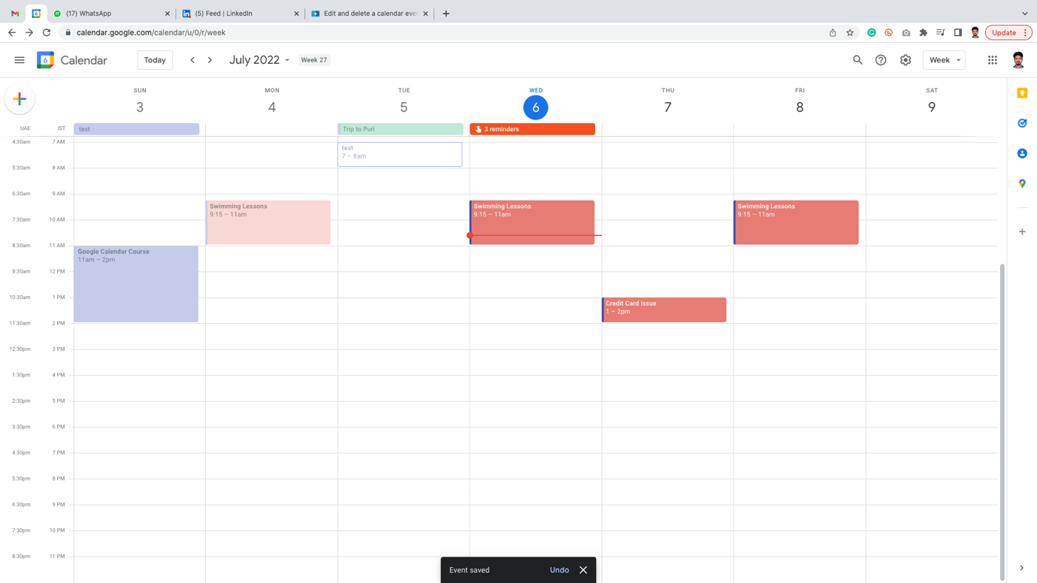

🡪 We can even increase length of timeslot by dragging more

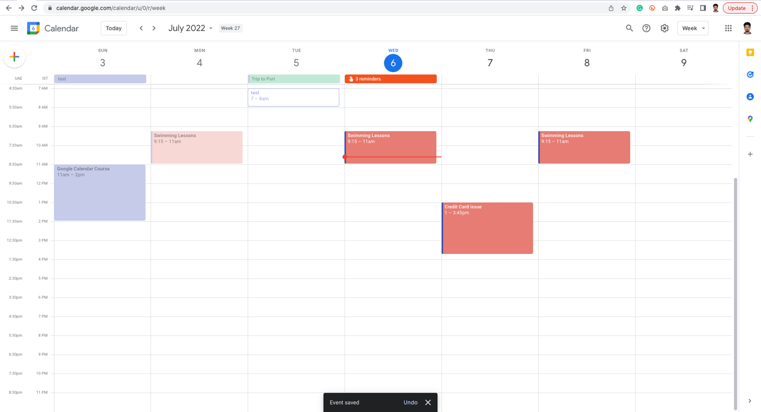

🡪 Right click on event 🡪 Click Delete for deleting the calendar

DELETE:

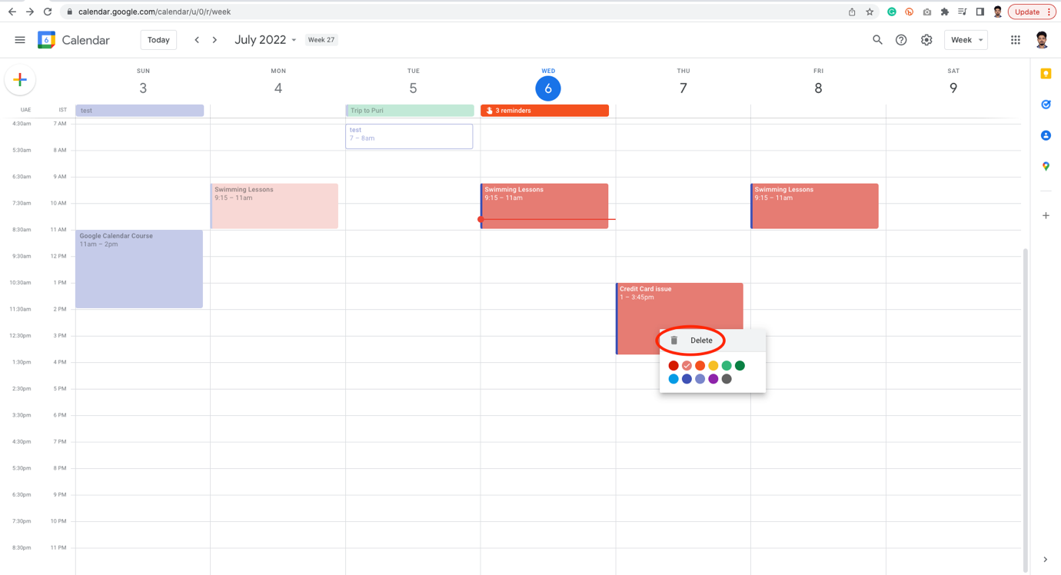

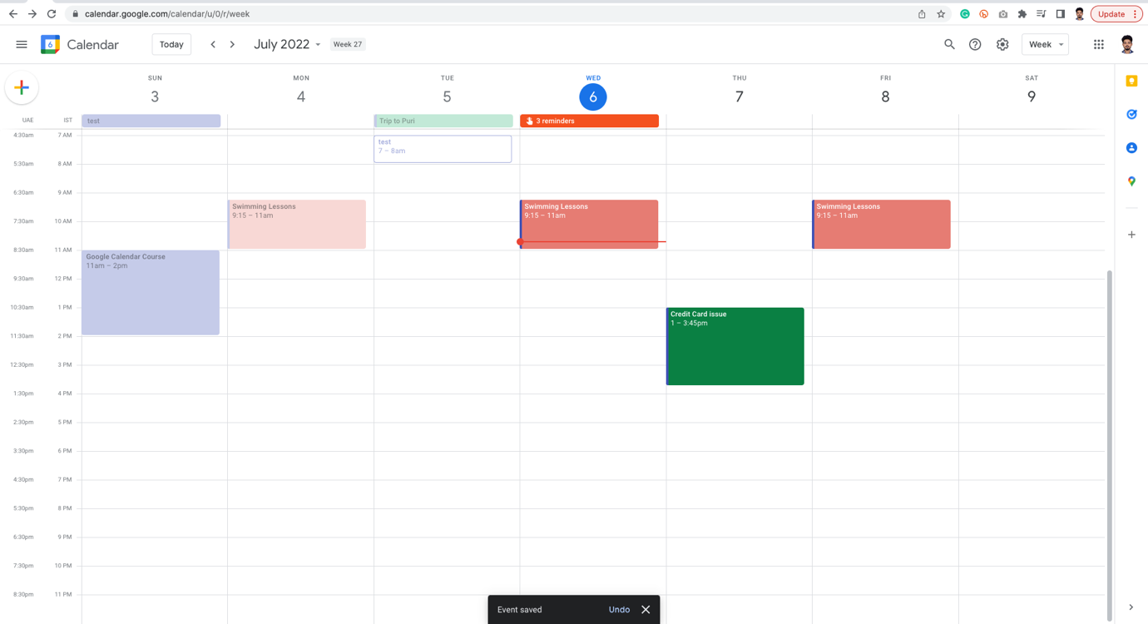

EDIT:

🡪 If we now click on the calendar the same mini tray opens

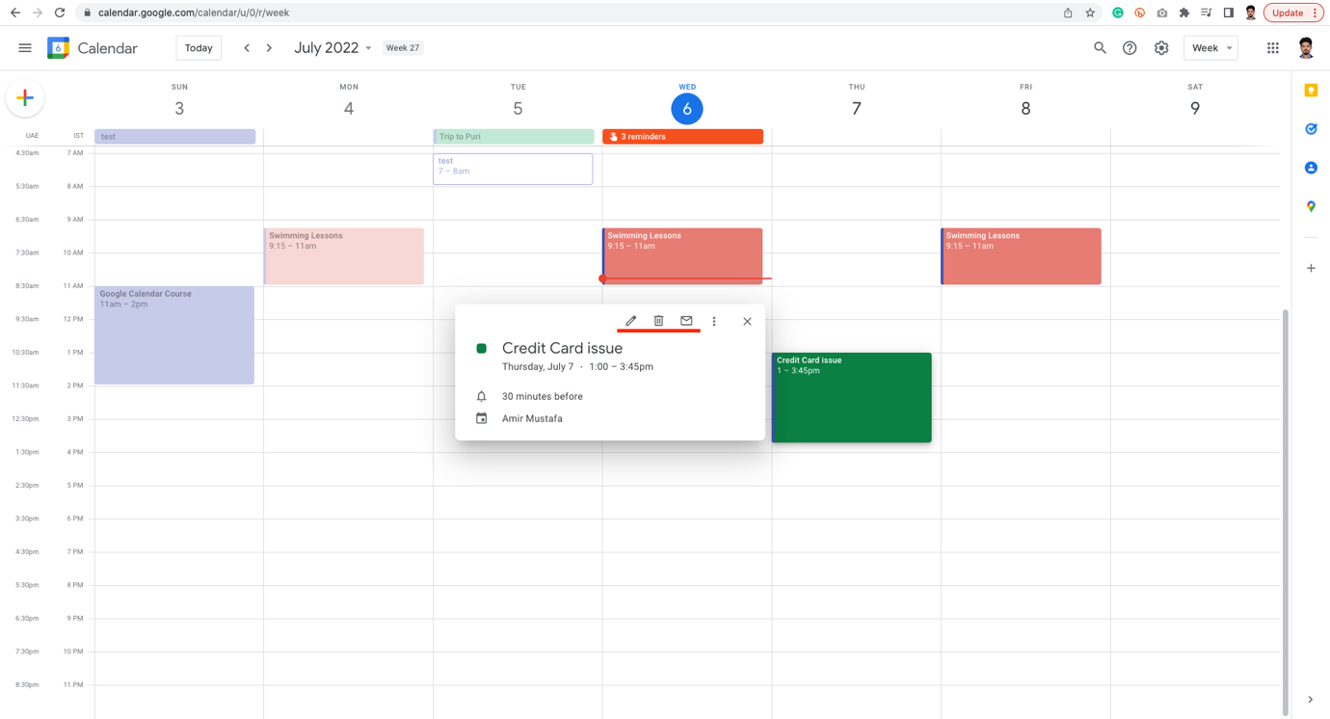

🡪 We can even publish to a website,

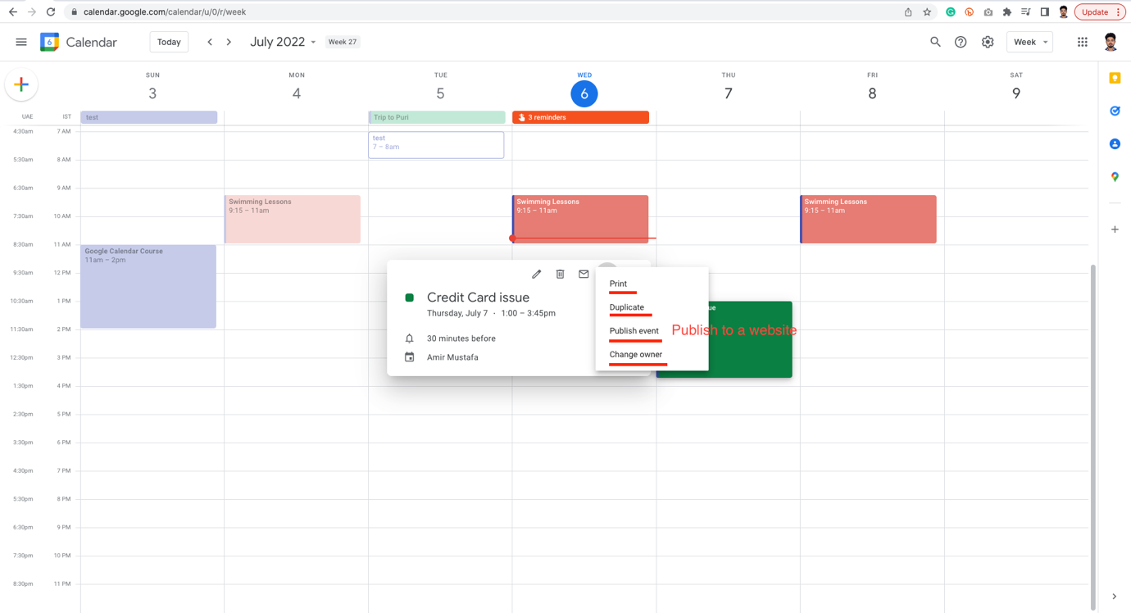

🡪 To go into the event, double click on it and will open a large version

🡪 Same facility is also available in larger version of event

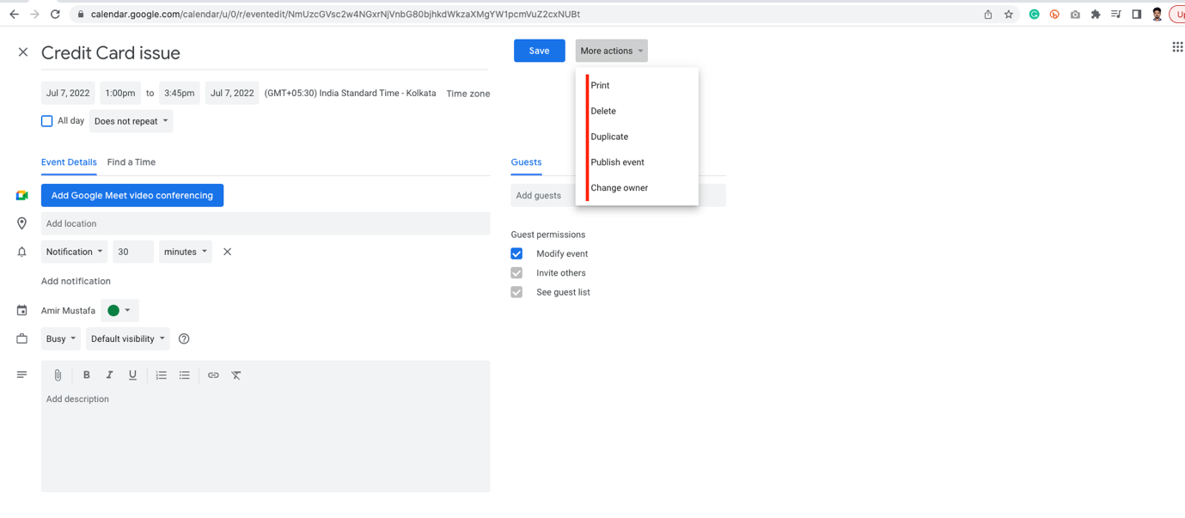

🡪 Suppose if we want to delete a specific event from recurring event eg. Swimming class in specific date 🡪 Right click Delete

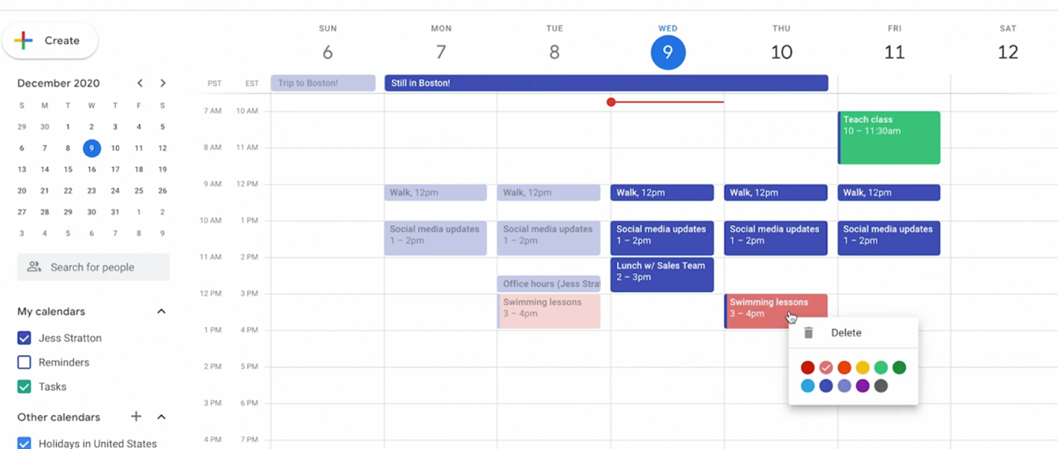

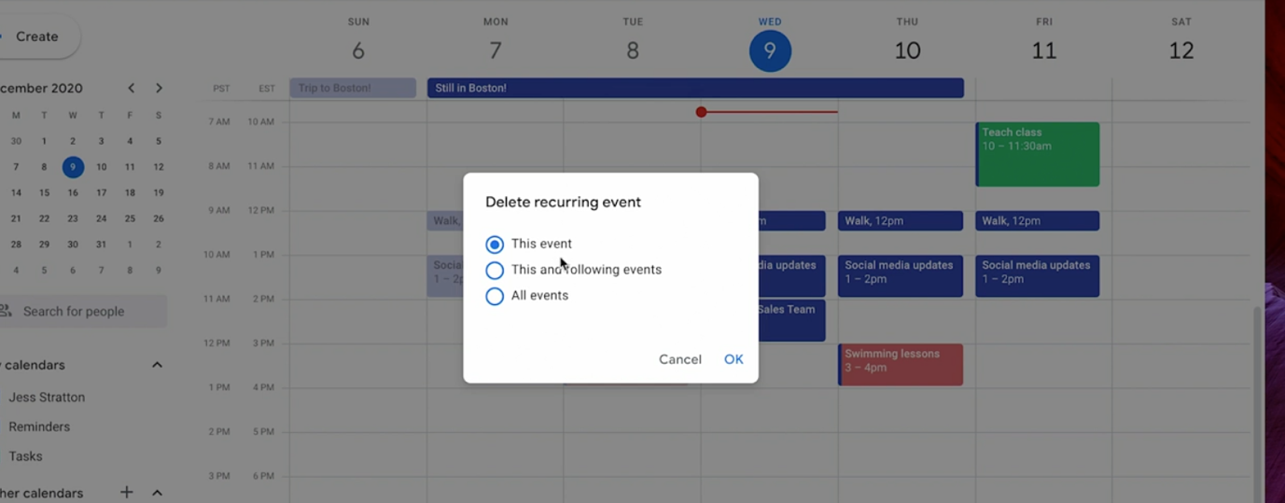

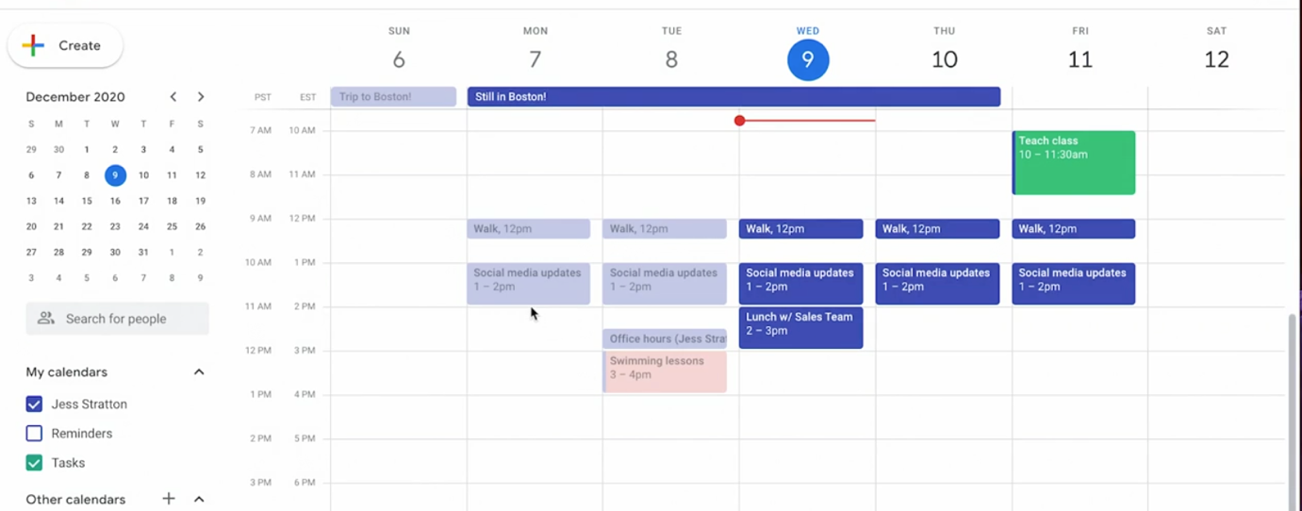

Edit a specifc event from Recurring event:

🡪 Same process, we need to double click event 🡪 A large pop up comes 🡪 edit something 🡪 change color

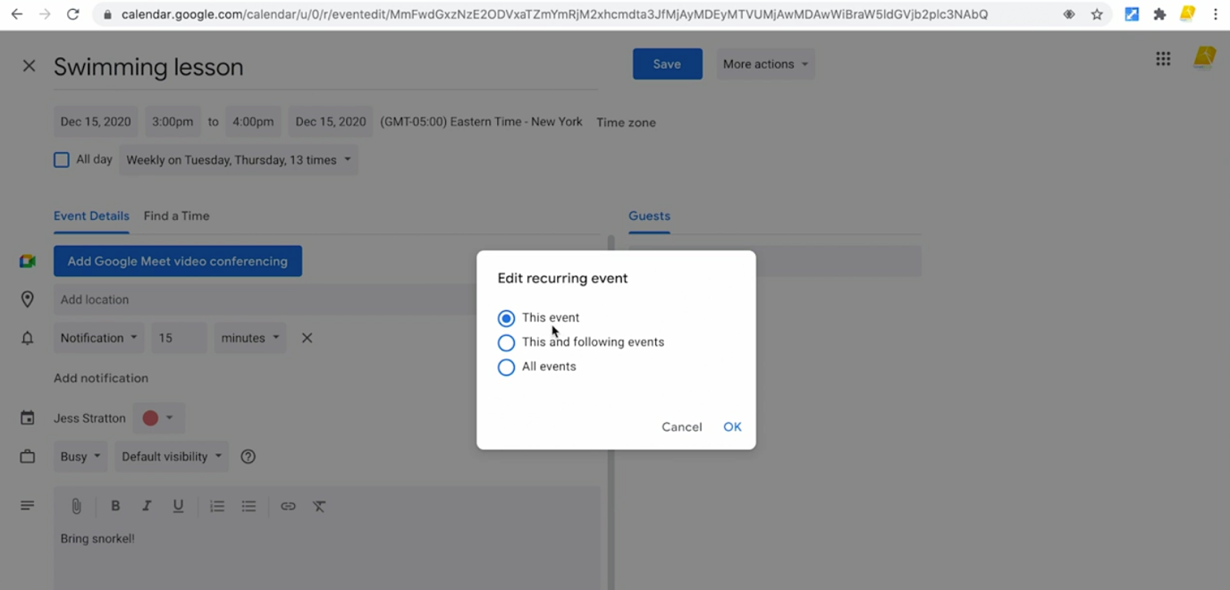

🡪 Chose specific event 🡪 Click OK 🡪 Specific event is updated

🡪 Suppose we have changed the title, we need to edit all events. Click second 🡪 click okay

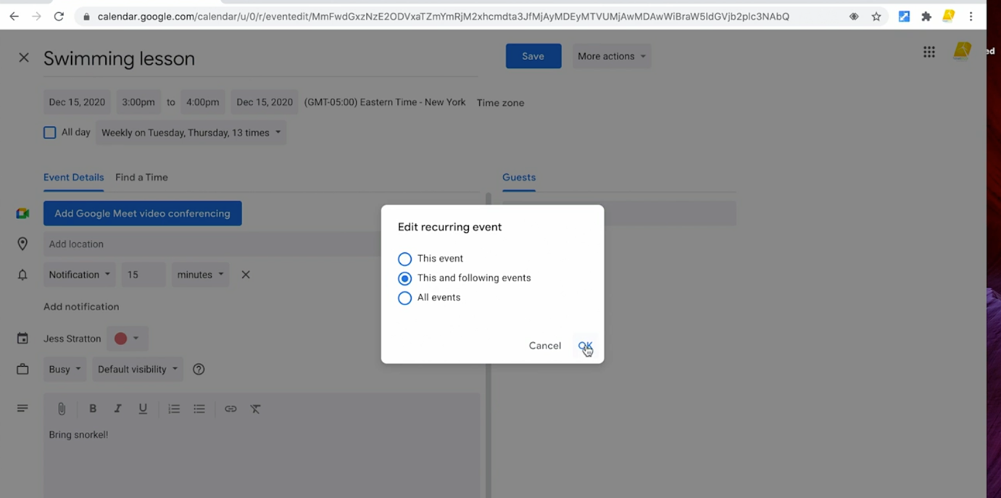

Invite Guest to an Event:

🡪 This helpful for the people for the meetings, fund raisers, etc.

🡪 Create event 🡪 Name the event 🡪 Click on the Google Meet button for the meetup video

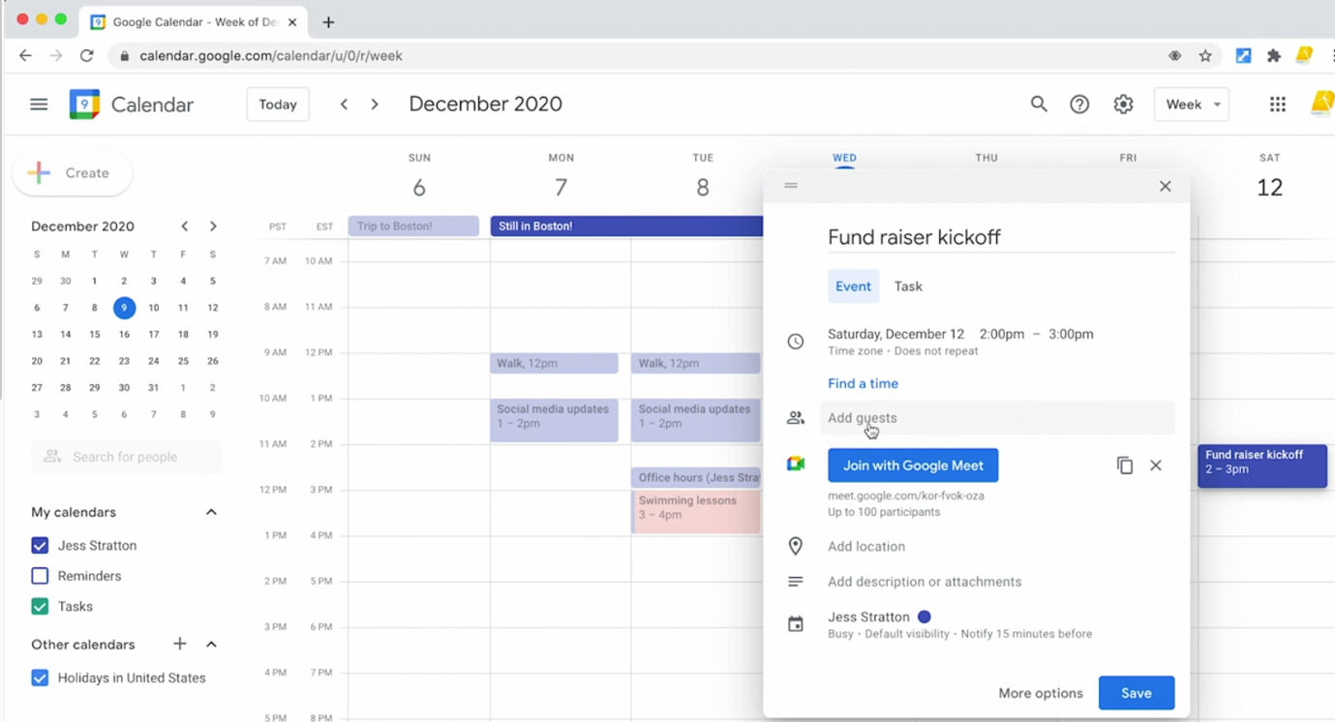

🡪 The invited user get special link to their email. From there can accept/reject the invite.

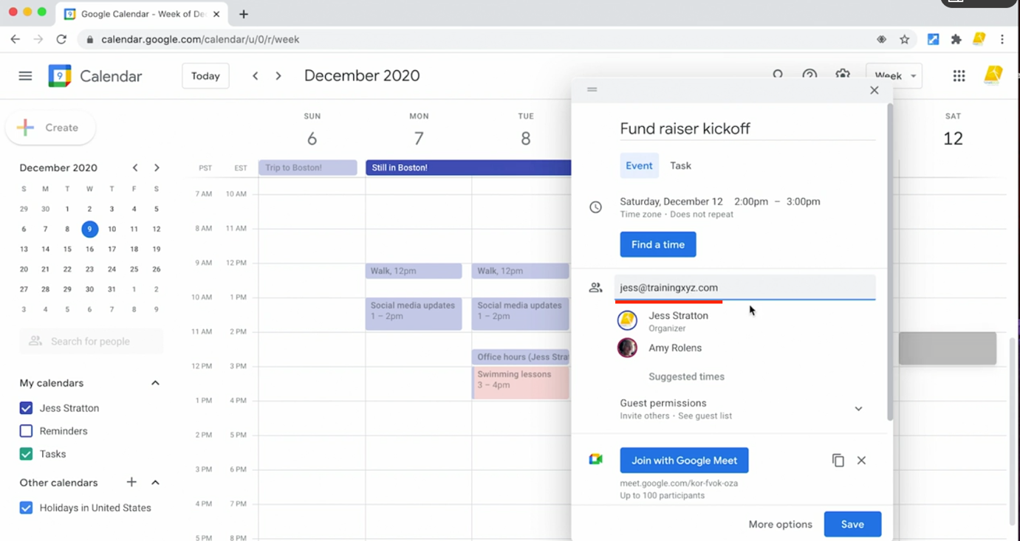

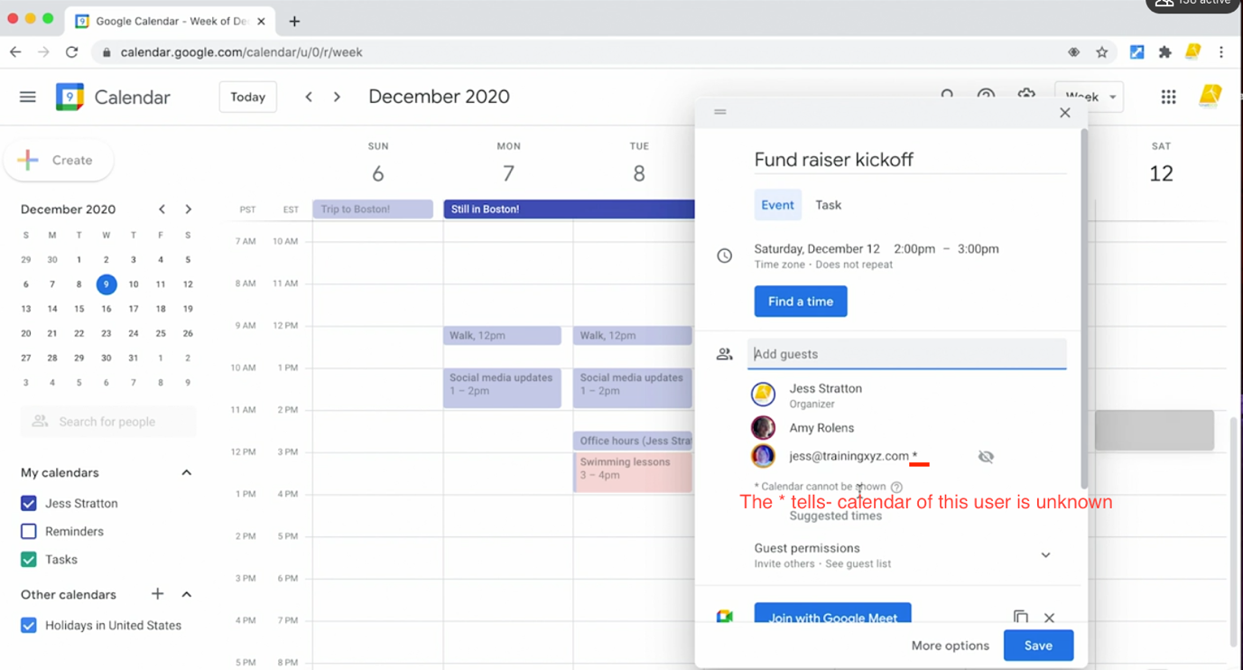

🡪 If the email ID has * beside them tells, calendar of this specific user is cannot be tracked – this person can be available or not.

🡪 Click on More options to see large version of the dialog box.

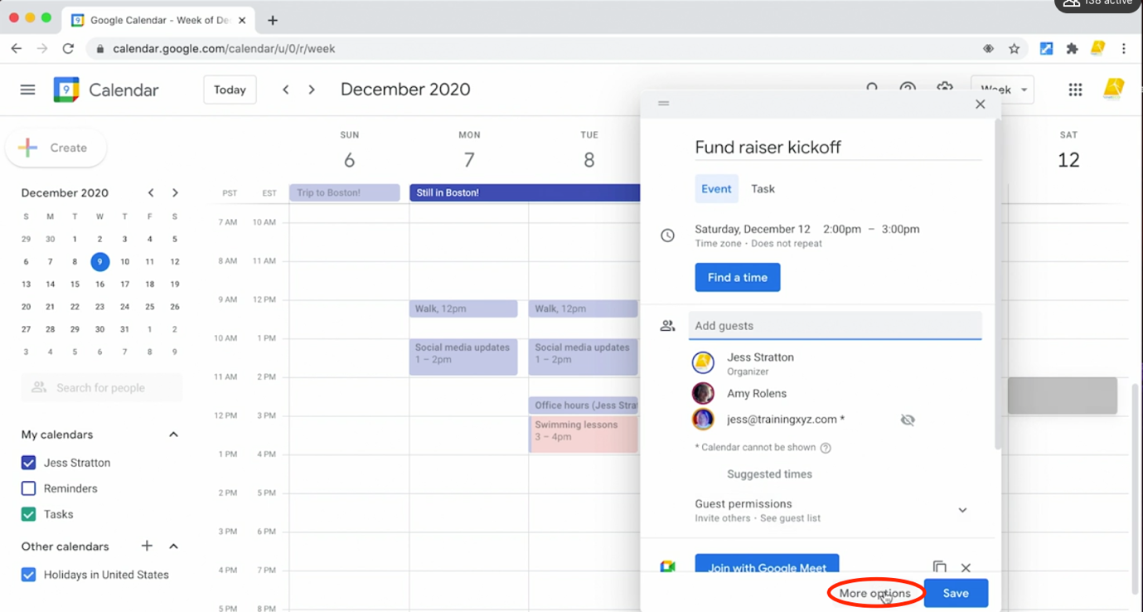

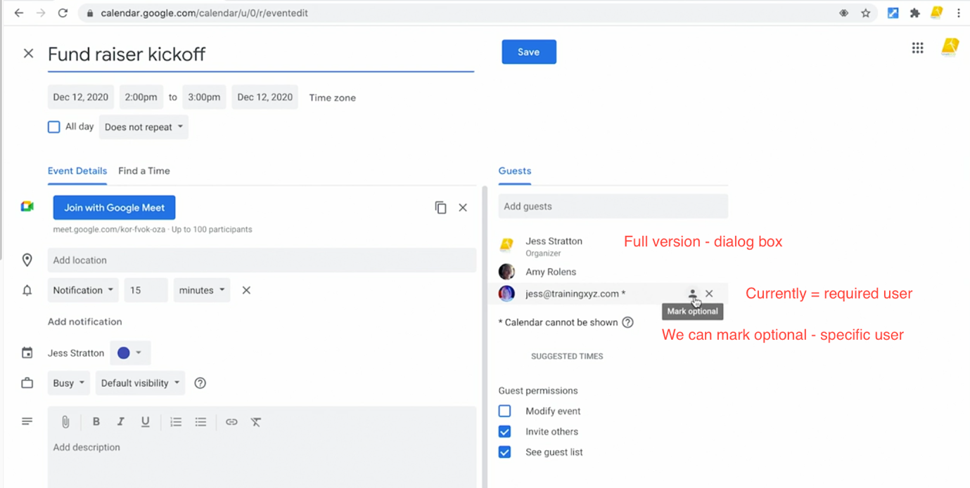

🡪 The third user is now optional i.e. nice to have this person

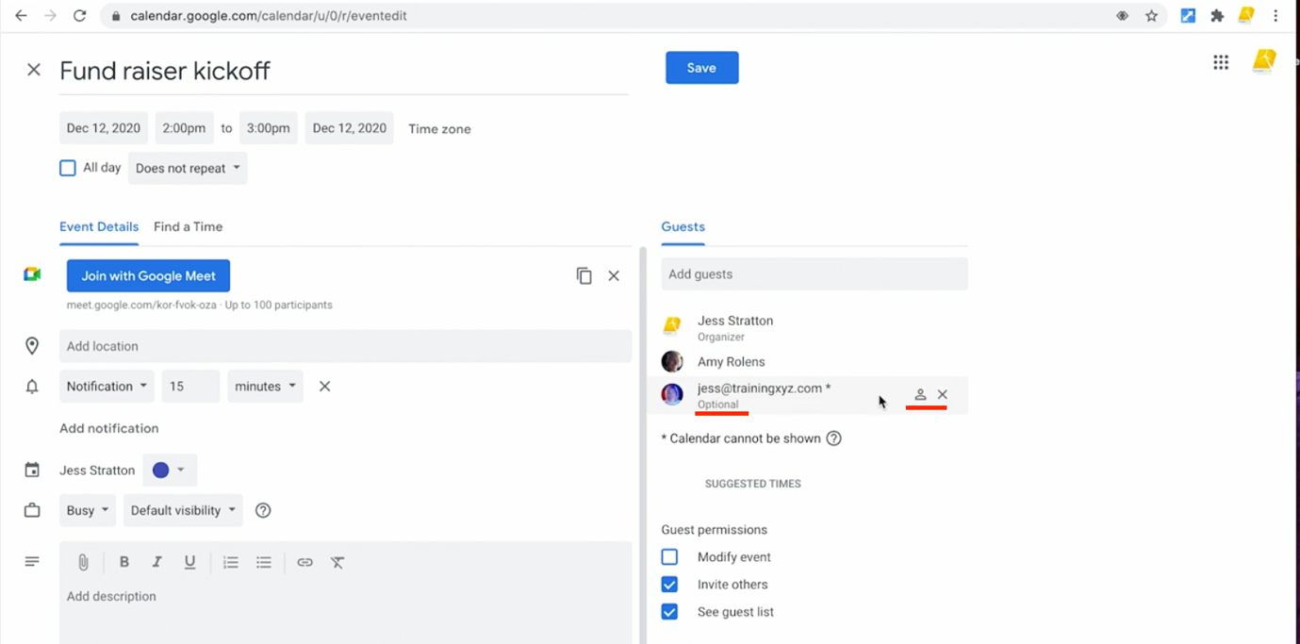

🡪 If we want to remove a person added by mistake. Click on the x

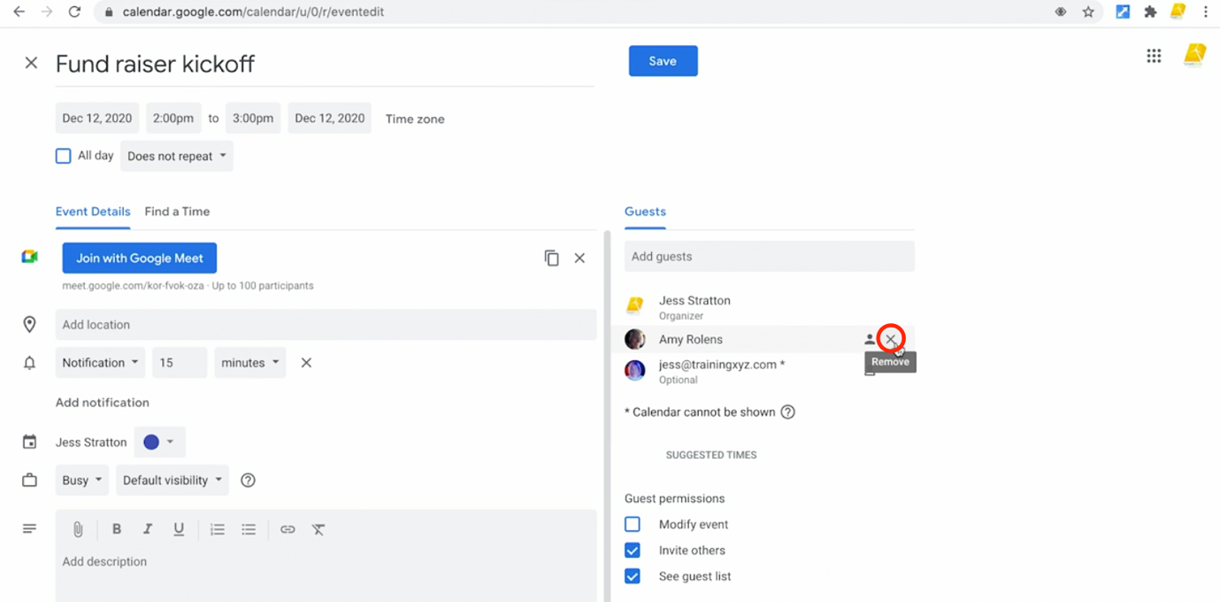

🡪 Guest Permissions:

🡪 We can add guest permissions

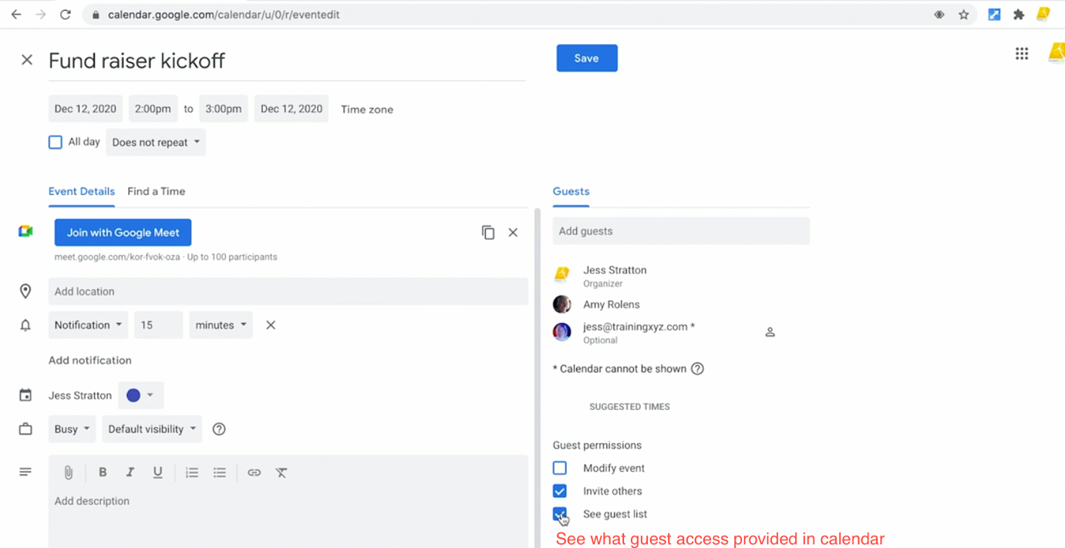

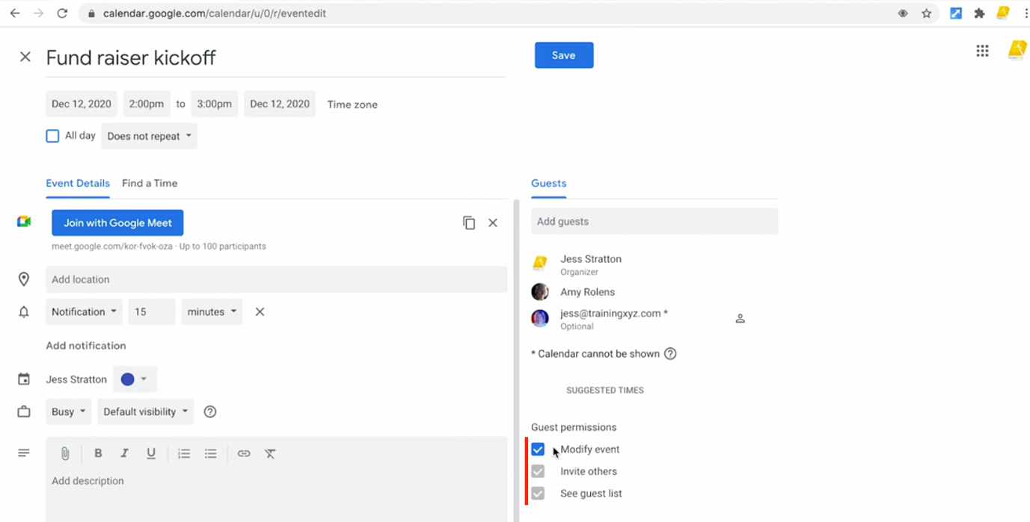

🡪 When done with the meeting, click on the Save 🡪 Send

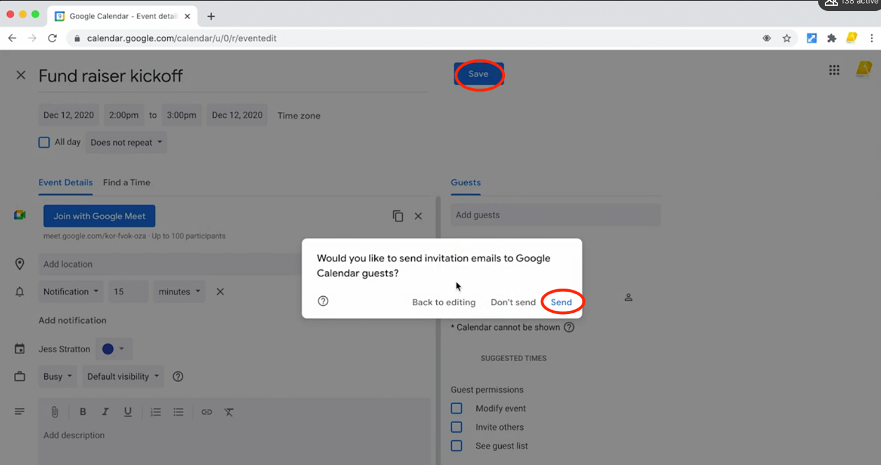

View Guest Availibility:

🡪 For seeing guest availability, suppose:

Happy Learnings – Creates Meeting Event

Amir Mustafa – Guest invited

🡪 If Happy Learnings wants to see Amir Mustafa’s calendar availability

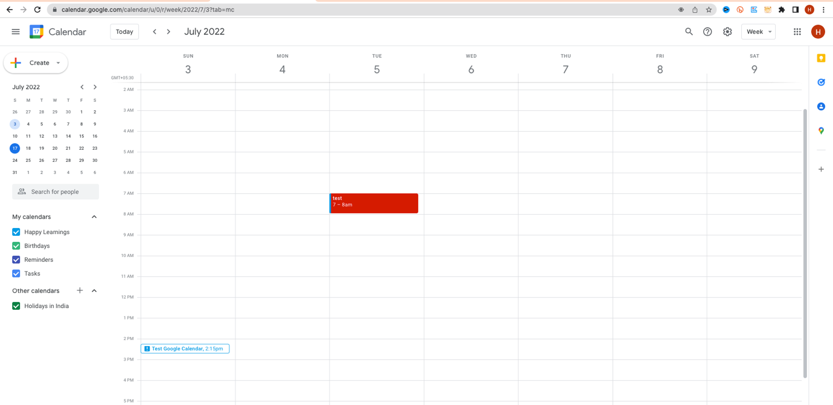

🡪 Double click on calendar event. On right hand side, we get guests.

🡪 Click on the second tab. Find the Time

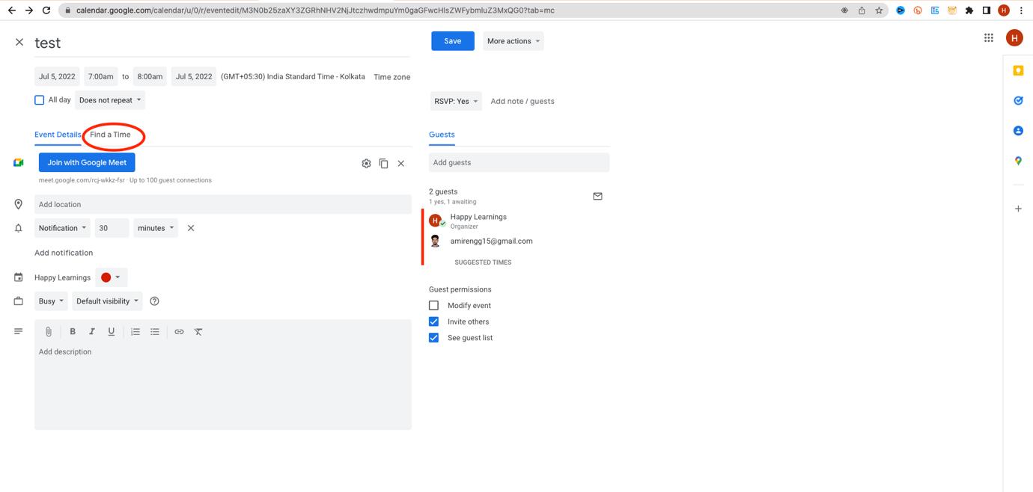

🡪 We see mine and guest calendar side by side

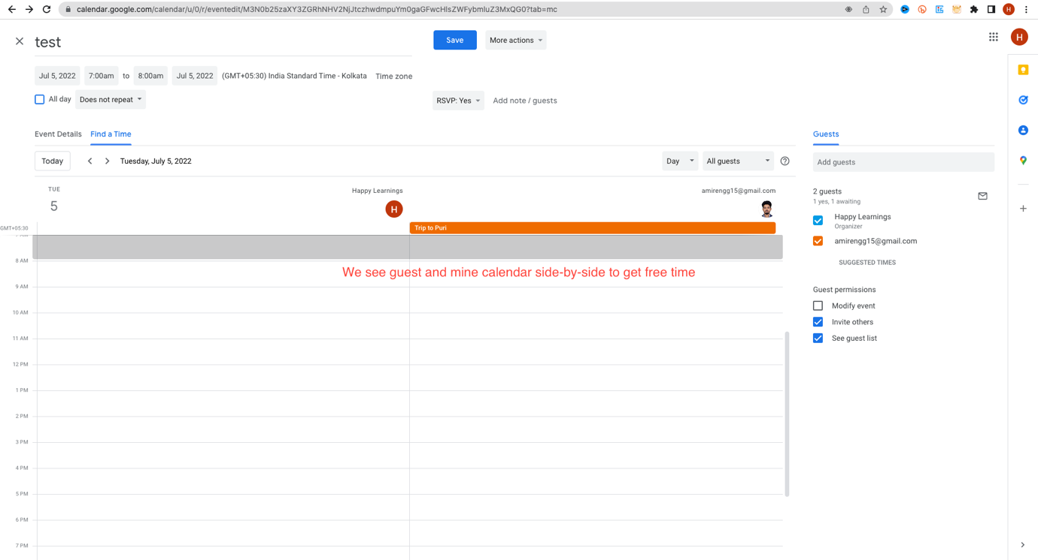

🡪 Now we should select time slot accordingly.

🡪 We can flip between the calendar clicking < or > arrow

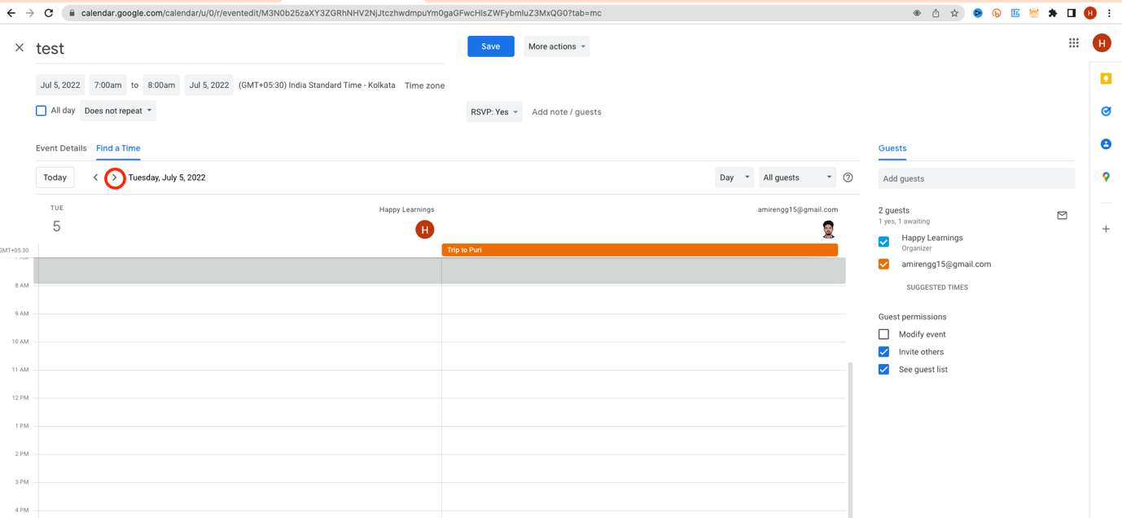

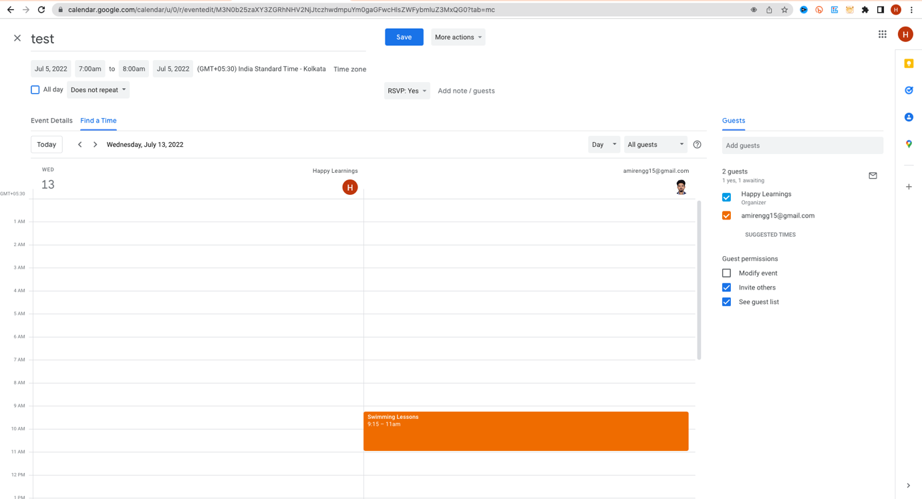

🡪 Currently the user is able to see what user is doing in the calenda eg. Swimming

🡪 User can set permissions level to show only **Busy message instead of exact activity for external users.**

🡪 Suppose we have large number of guests, and some of them are optional.

🡪 We should not waste time checking optional person calendar.

🡪 For that click on the optional person calendar.



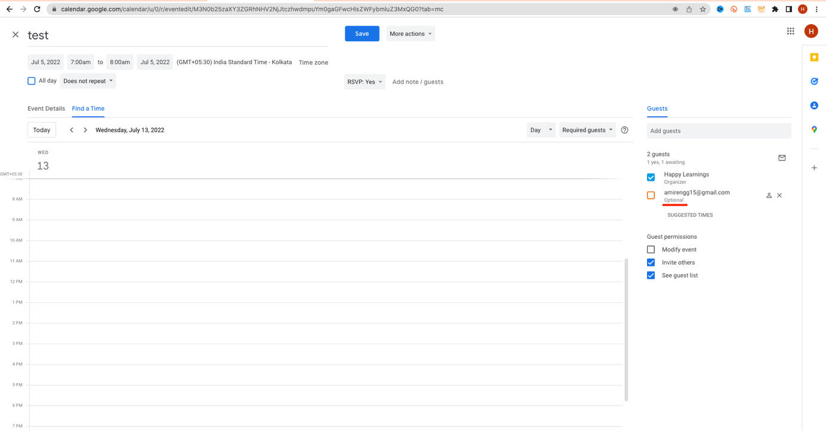

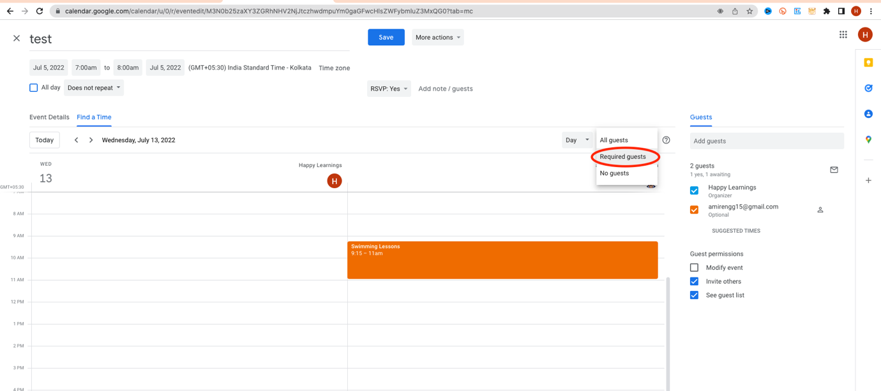

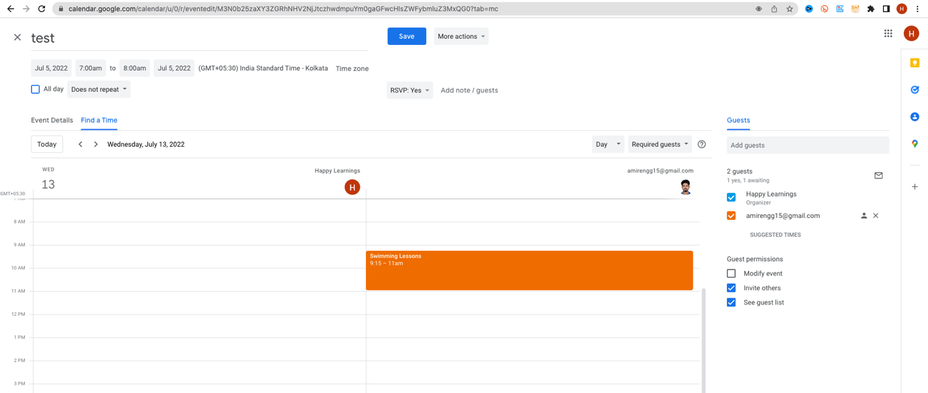

🡪 Even without manual calendar inspection, Google provides auto suggested inspection.

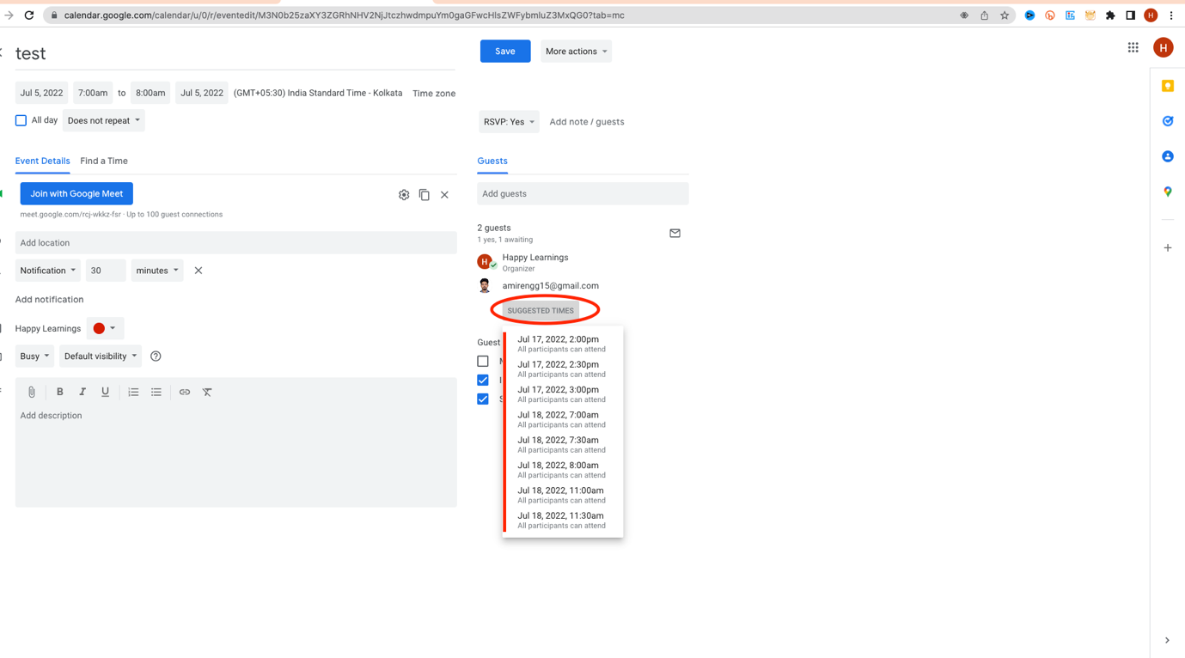

🡪 Click on any time eg. July 18, 7 AM, click save button

🡪 We see time immediately reflected. Click Save 🡪 Send

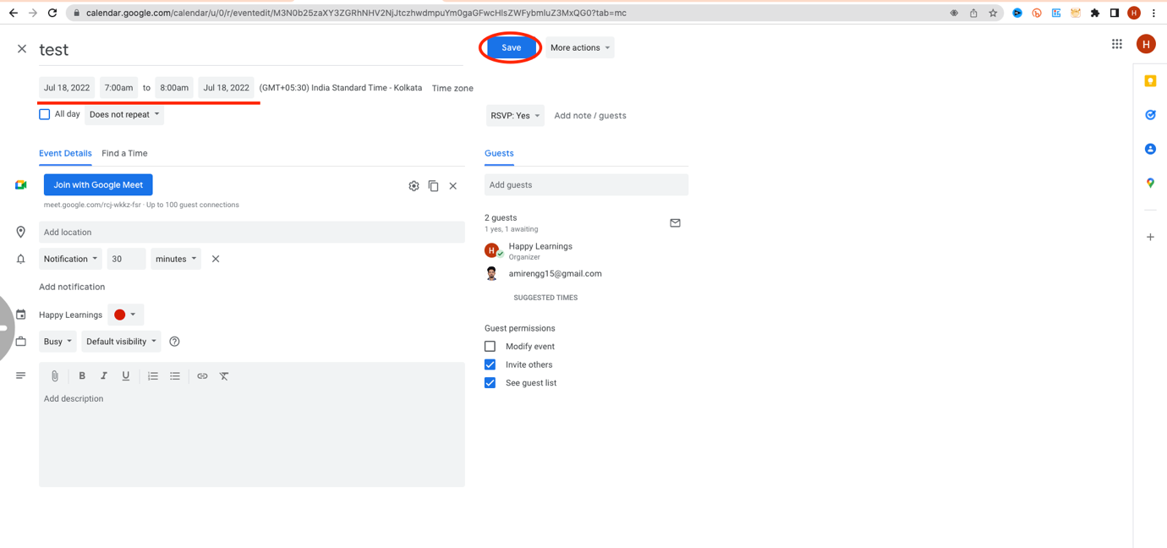

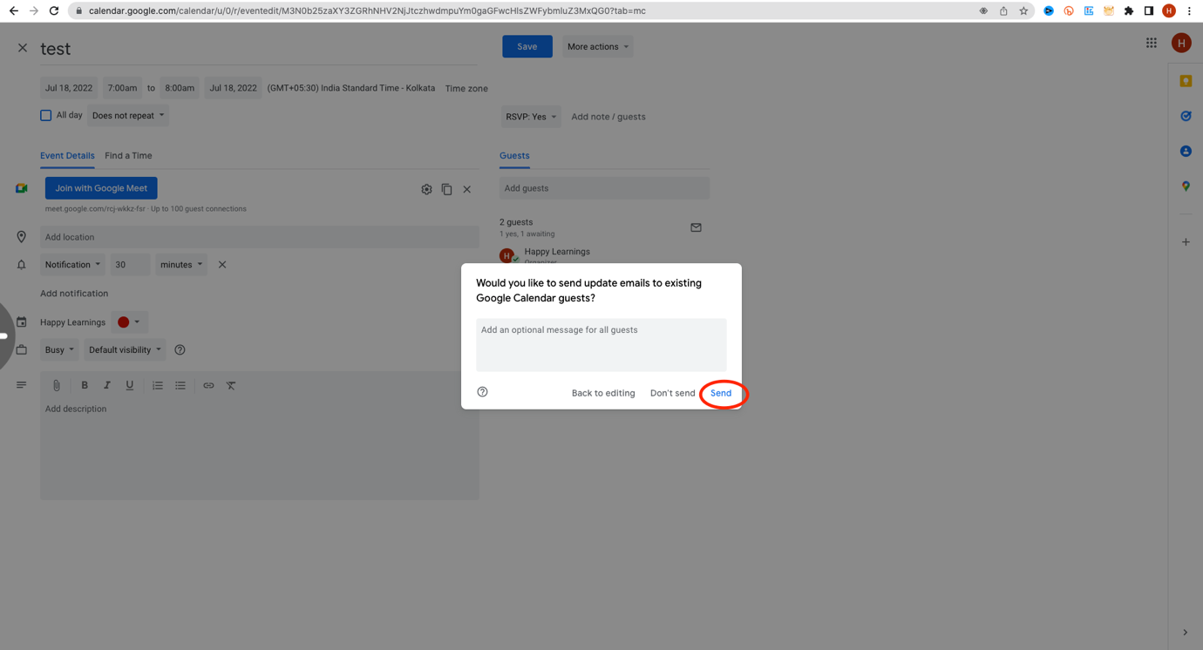

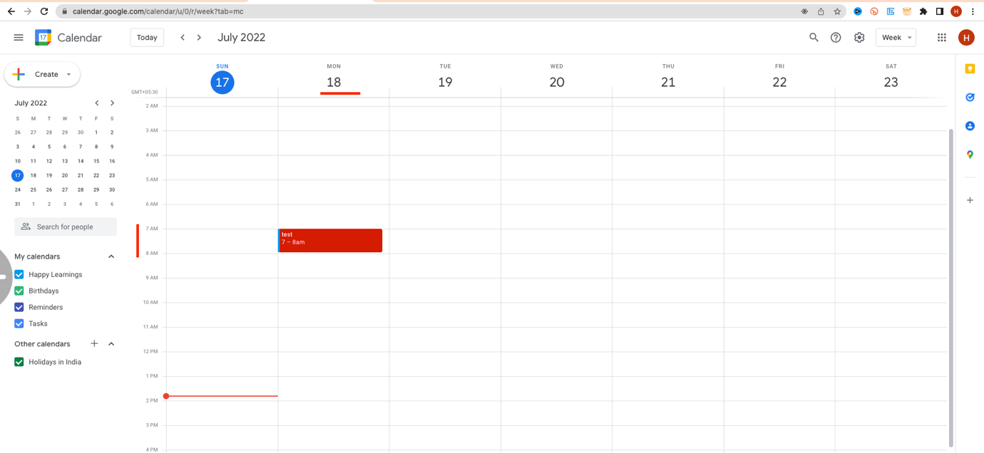

🡪 In side Guest Calendar – he/she sees it – Accept, Decline, Maybe

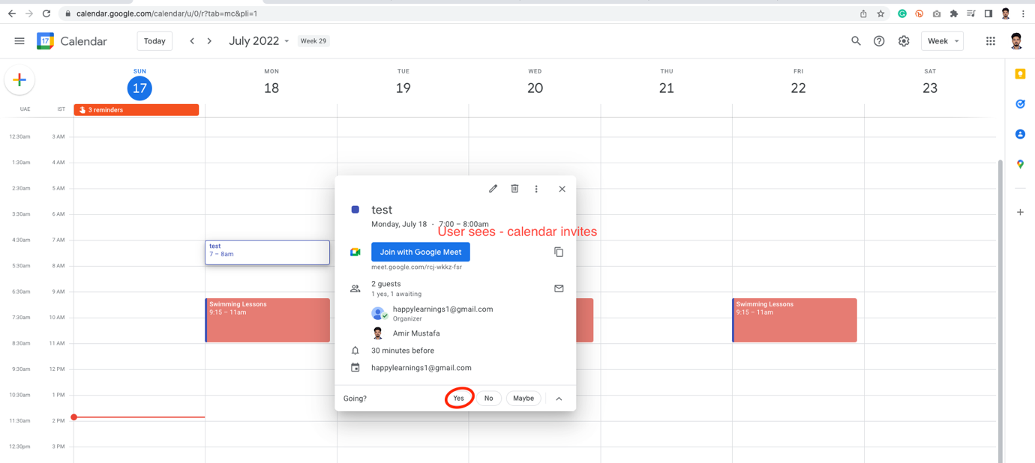

Add a Room Resource to Google Calendar:

🡪 This facility is only available for **GSWE Account (Paid Account)** and **not Free Users**

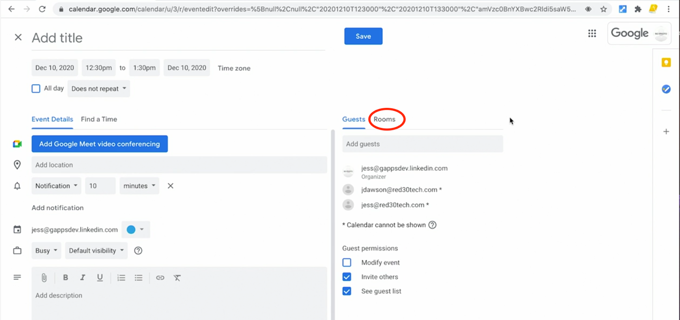

🡪 Only designated admins can create rooms, where user may know some people are waiting for a particular timeslot.

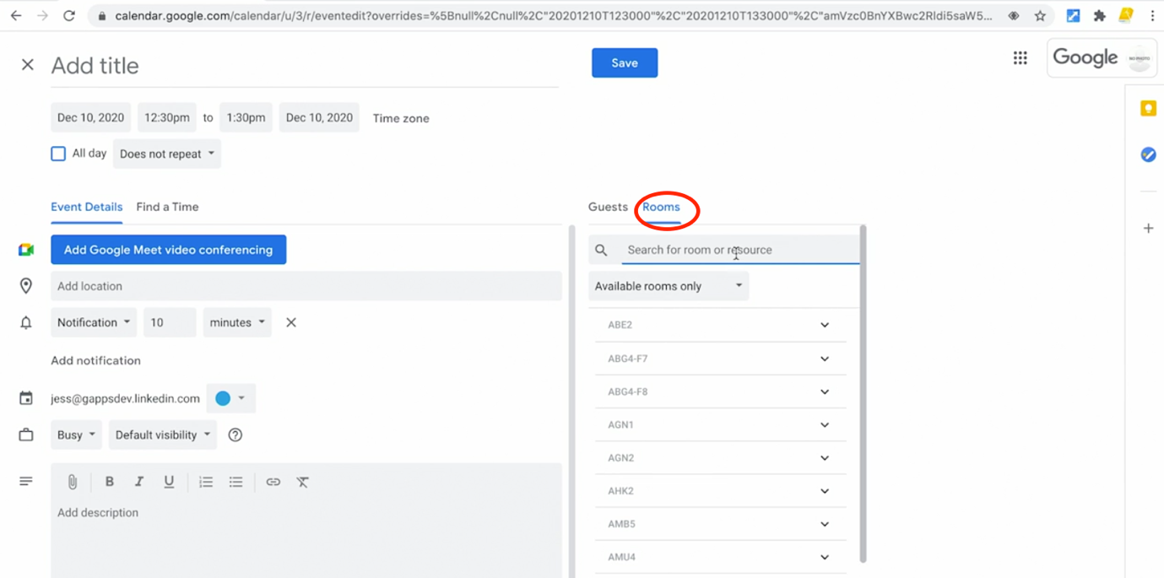

🡪 Choose a room name inside building

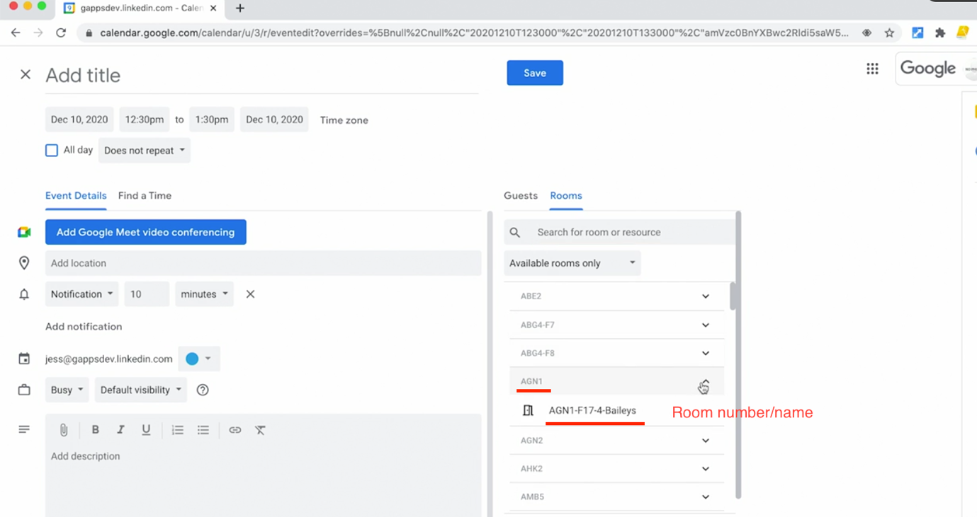

🡪 Click the conference room. Go back to the event.

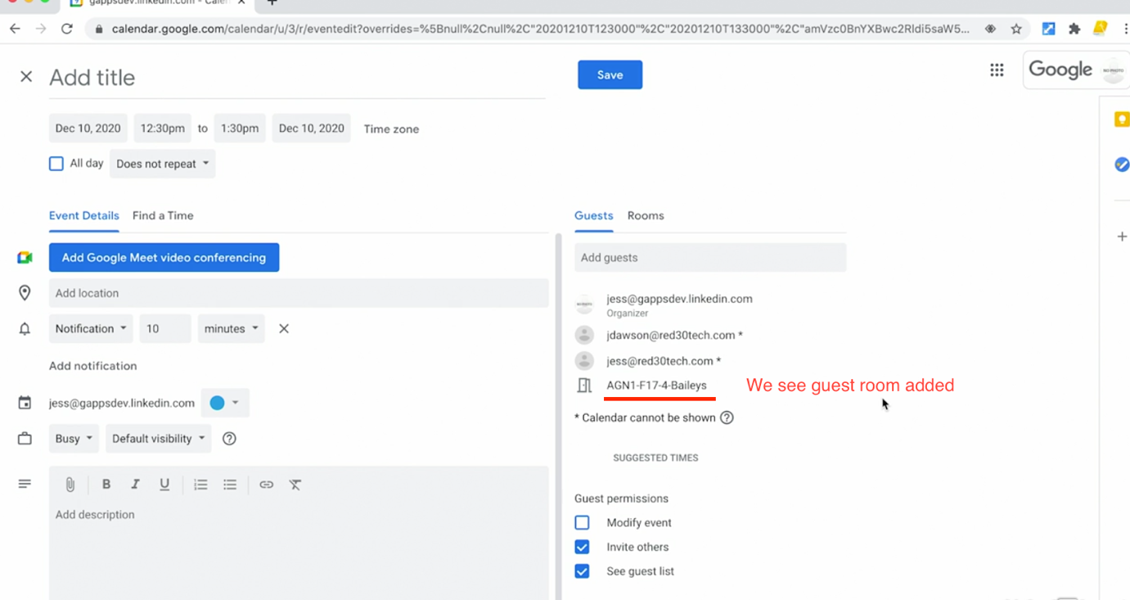

🡪 The room will also show in calendar

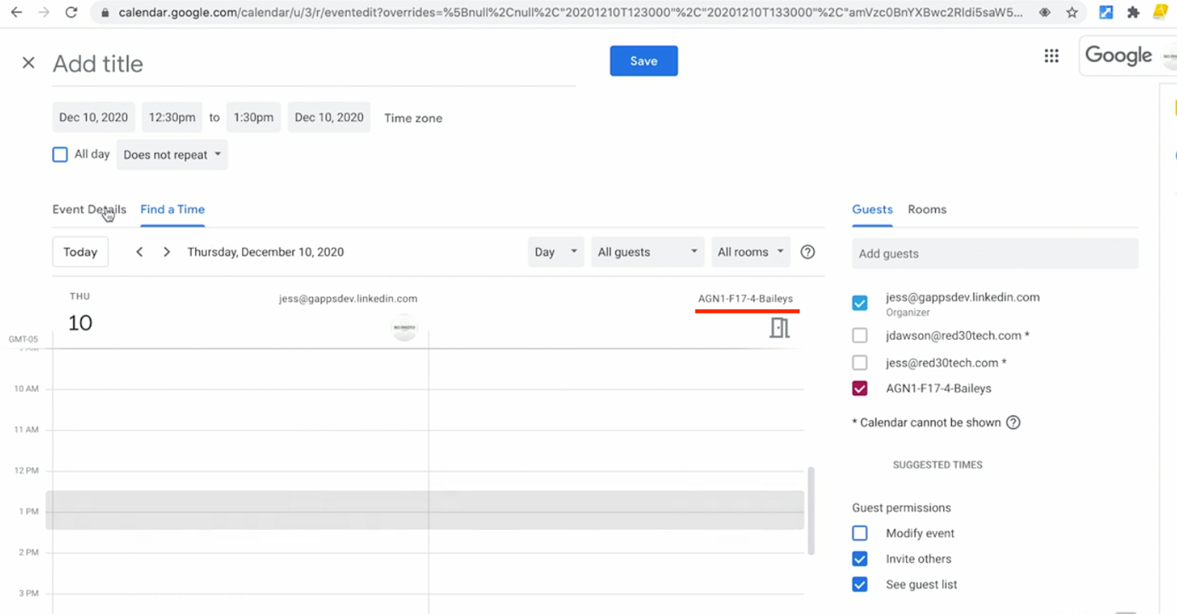

🡪 The user gets notification that conference room is reserved in my name.

Work with Notification and Alarms:

🡪 We can be notified when we have upcoming events before the meeting.

🡪 We can get email notification or calendar message pop up for each of the users.

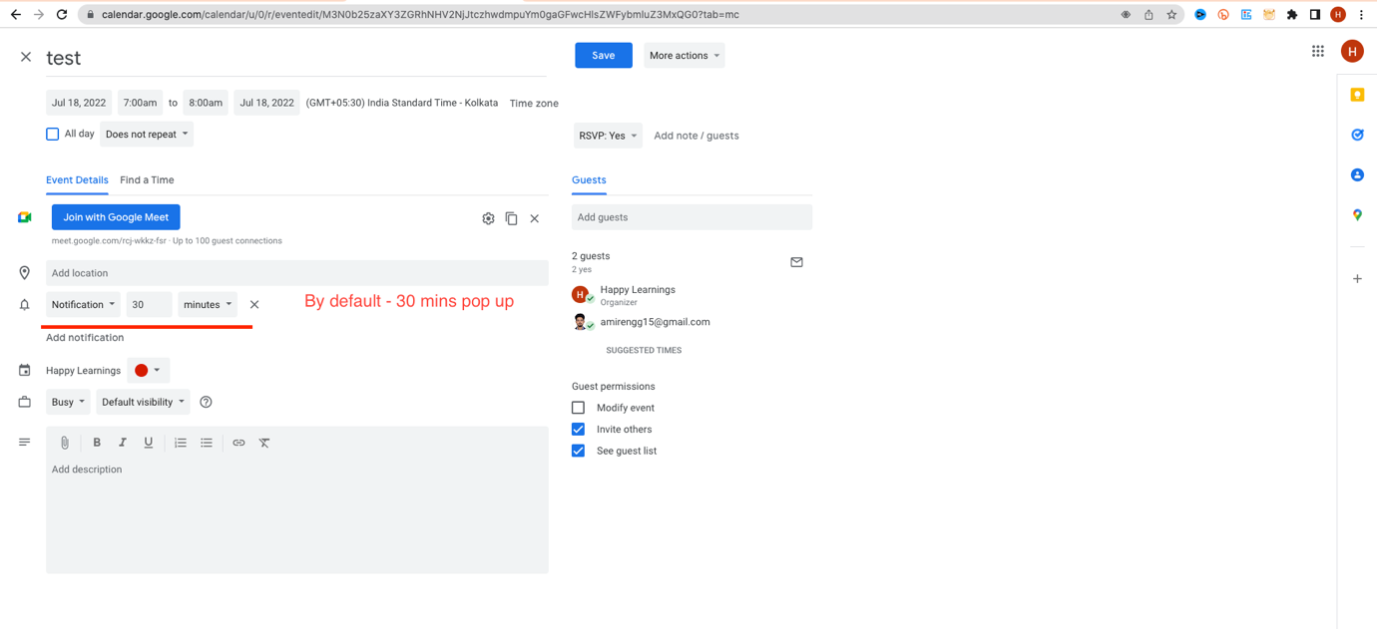

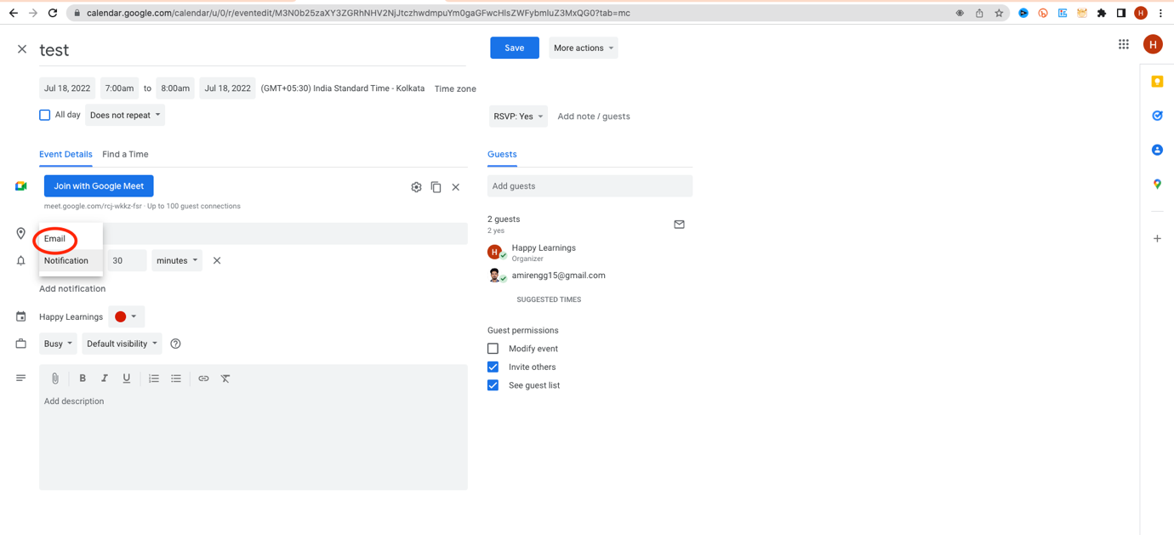

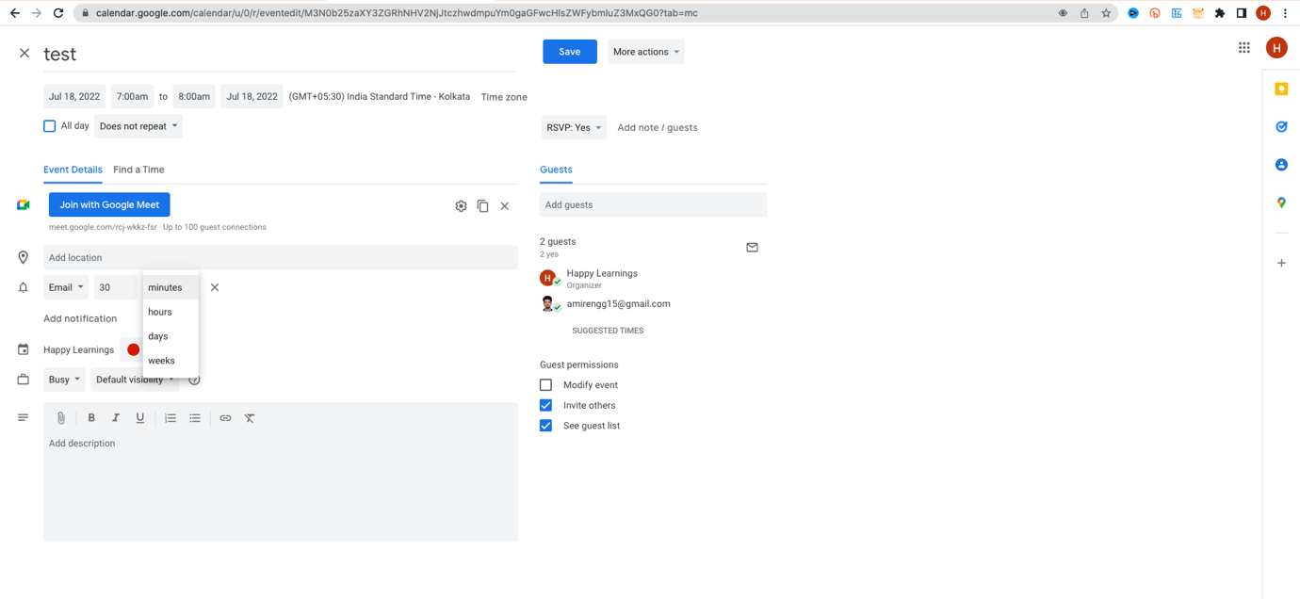

🡪 We can add more that one notifications: Popup and Email

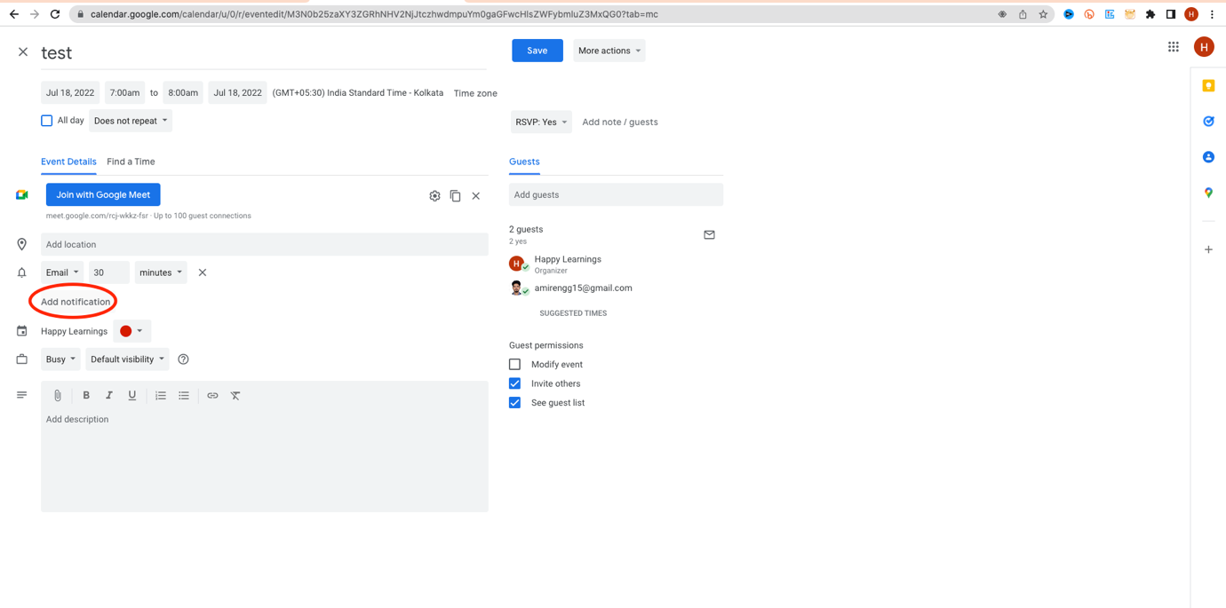

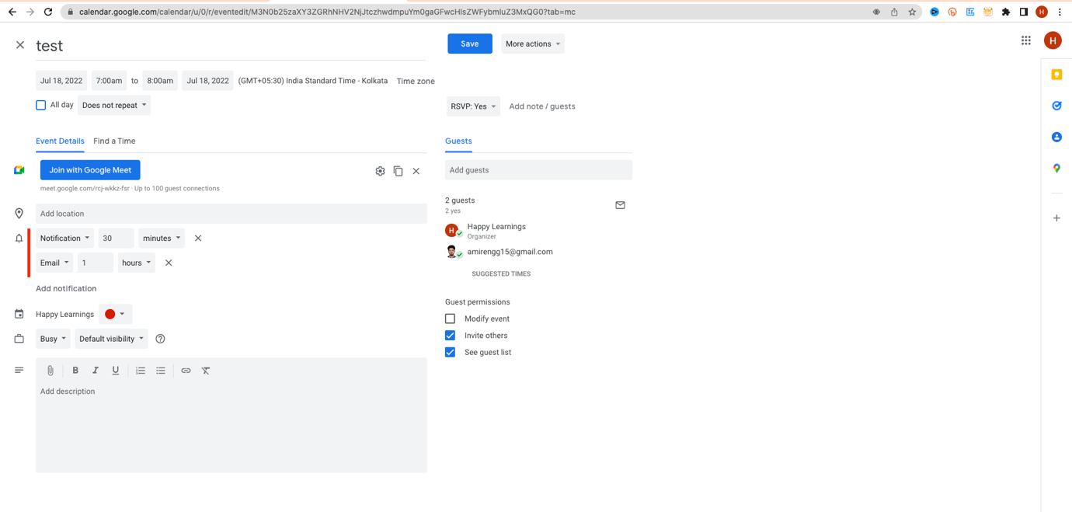

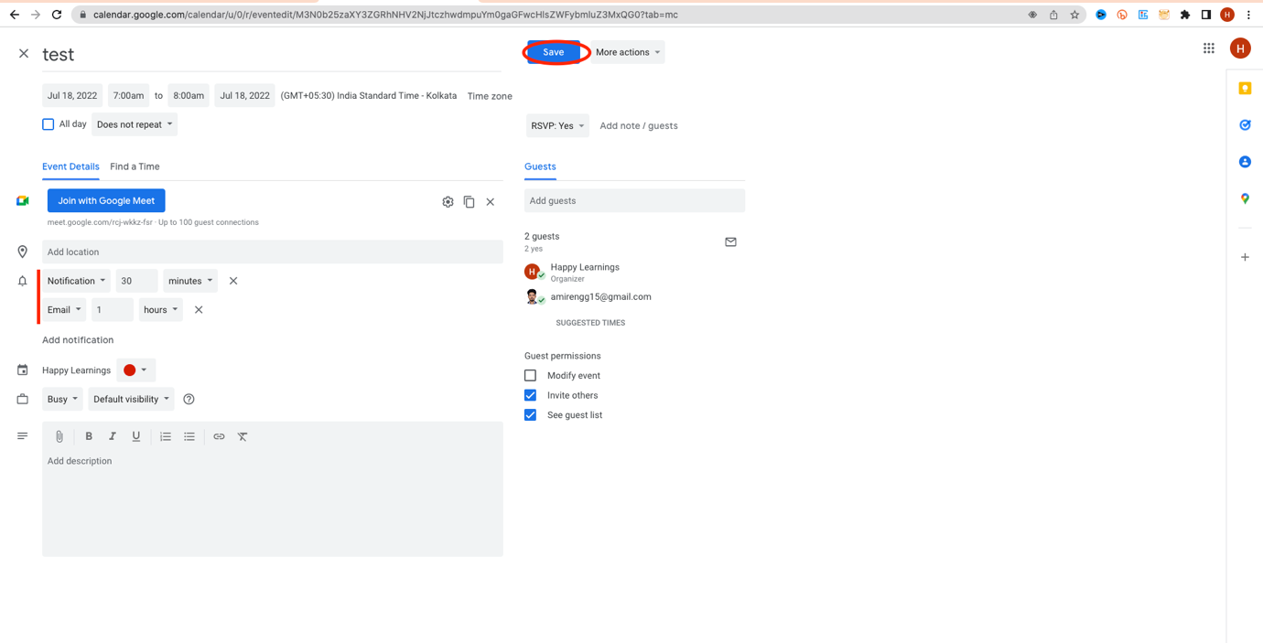

🡪 Guest user now gets Email notification 1 hour before:

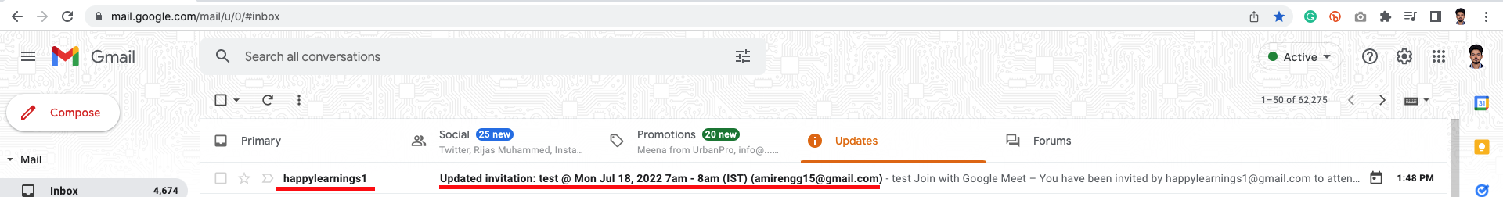

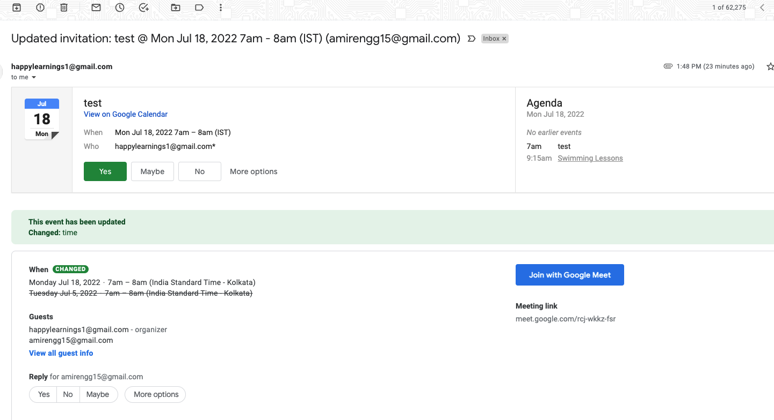

🡪 Now we have to do the same – for every event, Instead we can set default notifications – Email and Popup

🡪 Click Gear icon 🡪 settings

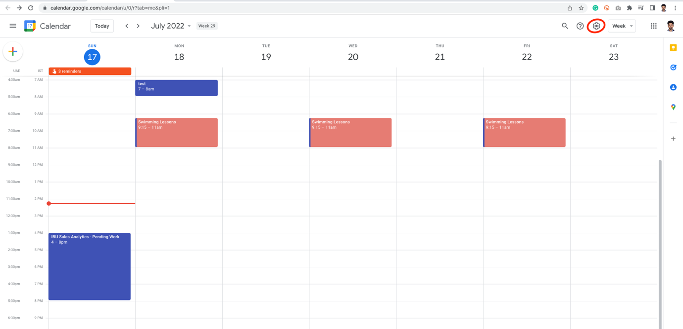

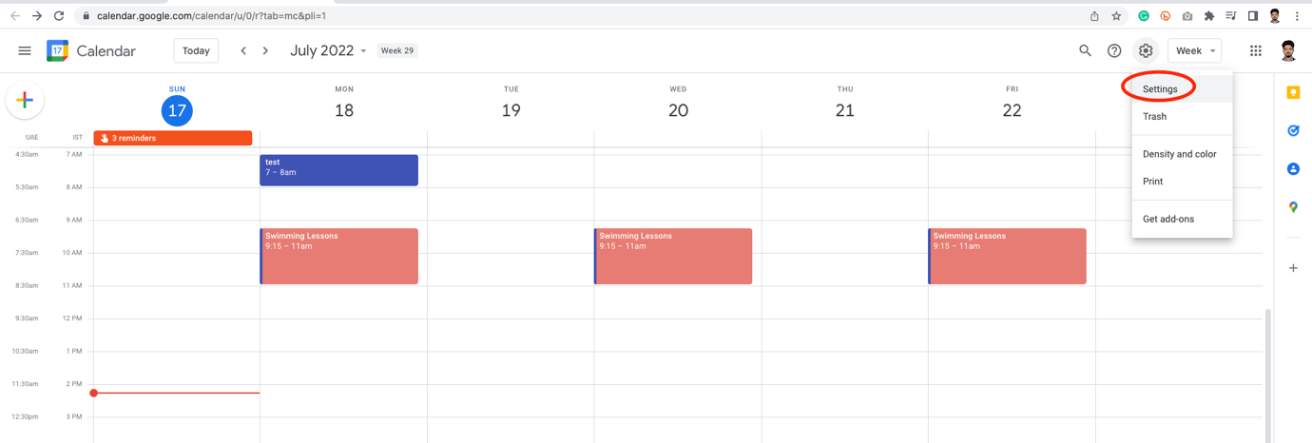

🡪 Click your name in calendar from left 🡪 Click Notification

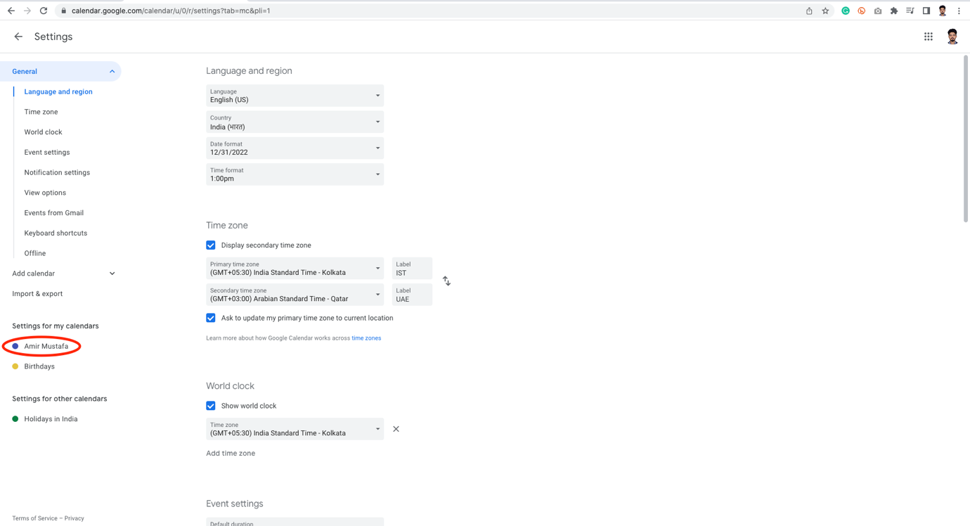

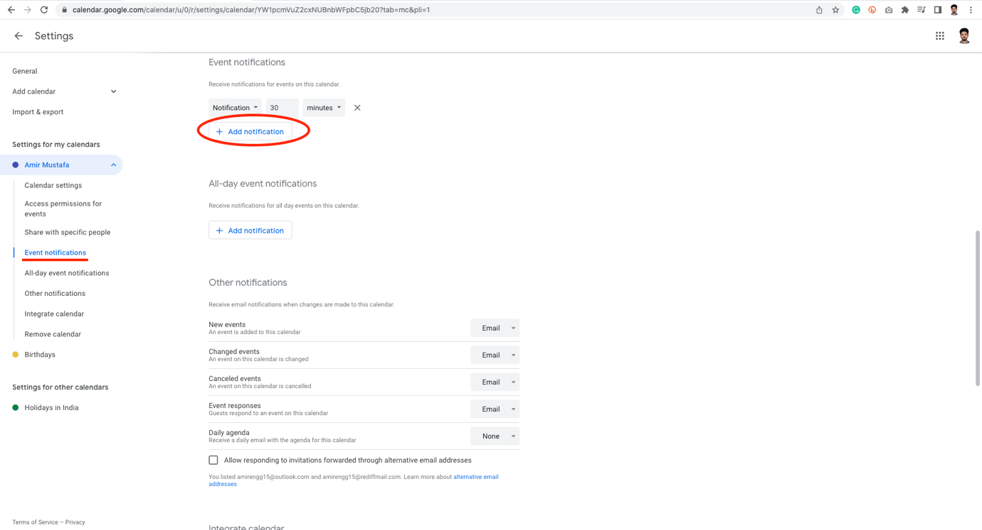

🡪 Here we can stack notifications – Email and popup before 1hour, 30 minutes – email / popup

🡪 We need to set for two settings – specific time event and All day event:

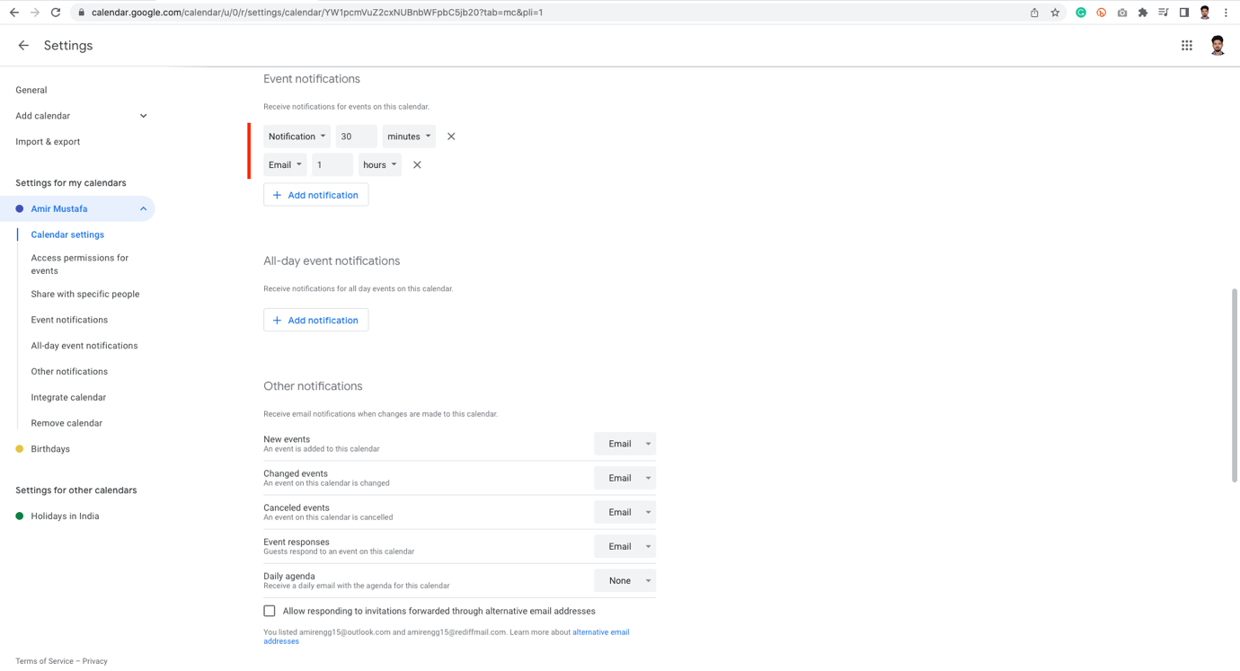

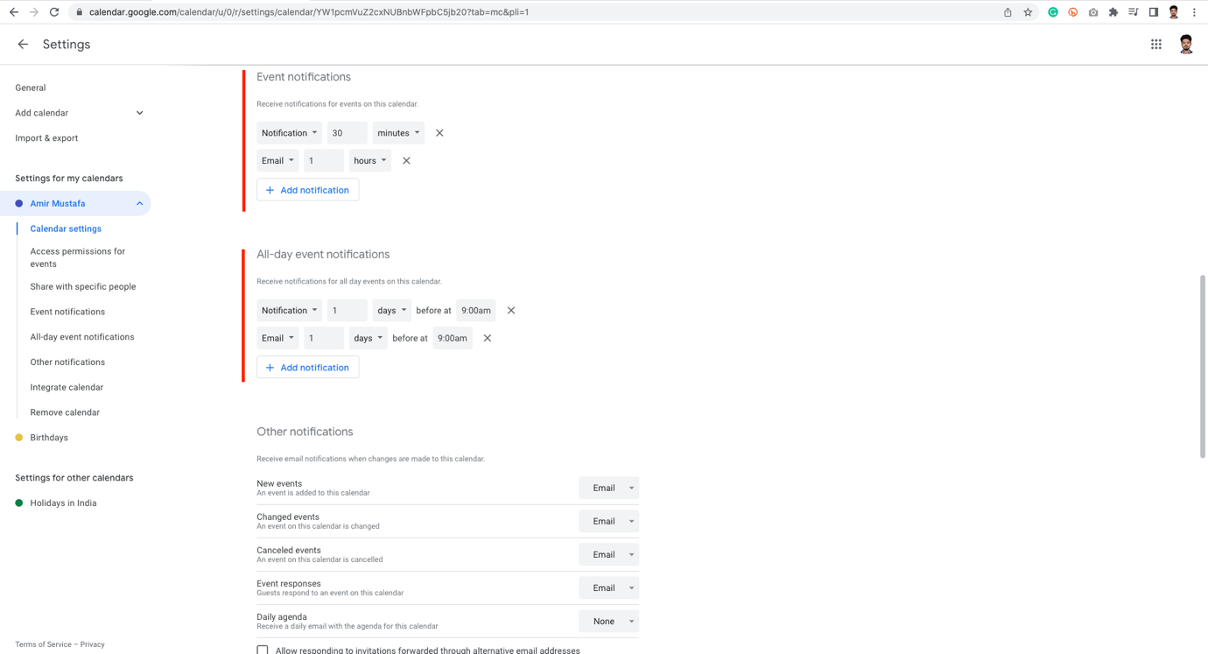

🡪 There is one option called Daily Agenda -that send mail at 5 AM morning for today’s task

Respond to Invitation:

🡪 Go to your Google calendar, if there are unfilled calendar just with outline, we have to respond it.

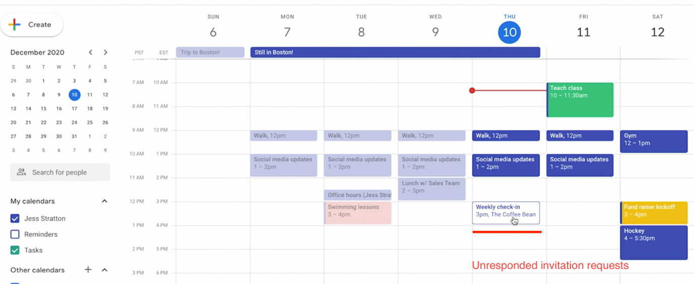

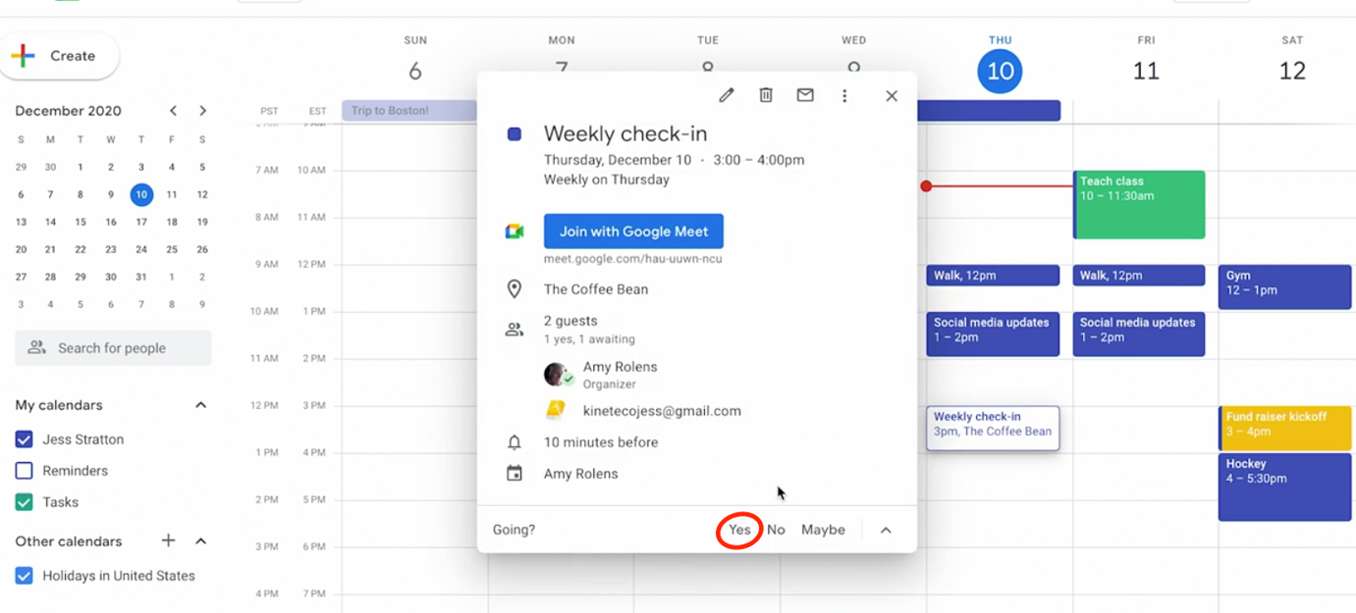

🡪 Here we can chose – Yes, No or Maybe

🡪 We can also propose - a new time or a note – to the original person who sent the invitation

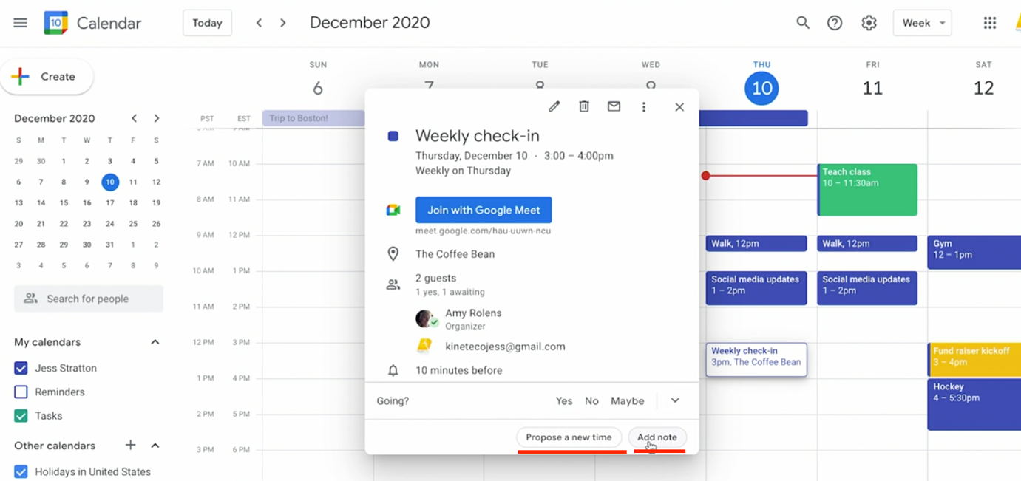

Case a: If selected maybe – black diagonal lines inside

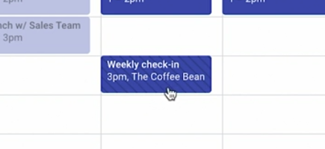

Case B: If selected – Yes

Double click on the calendar. Click Yes

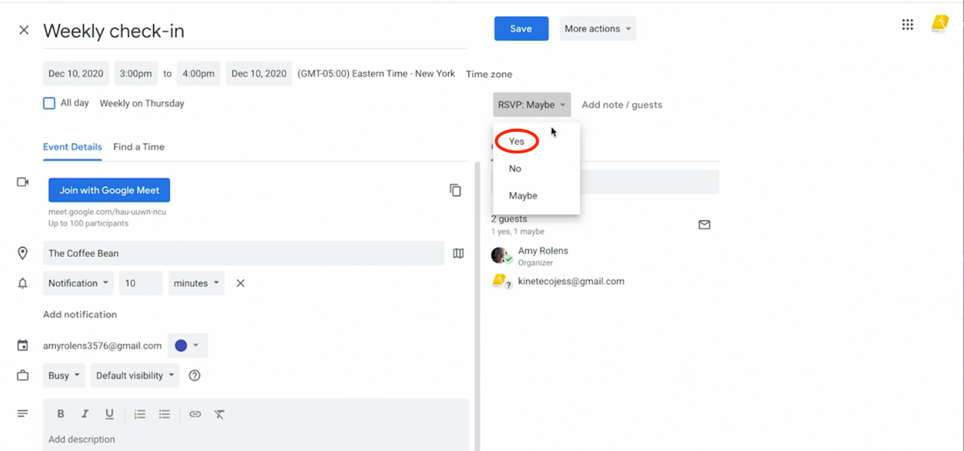

🡪 Case B: If selected – No.

🡪 We can add a note saying why we are declining it.

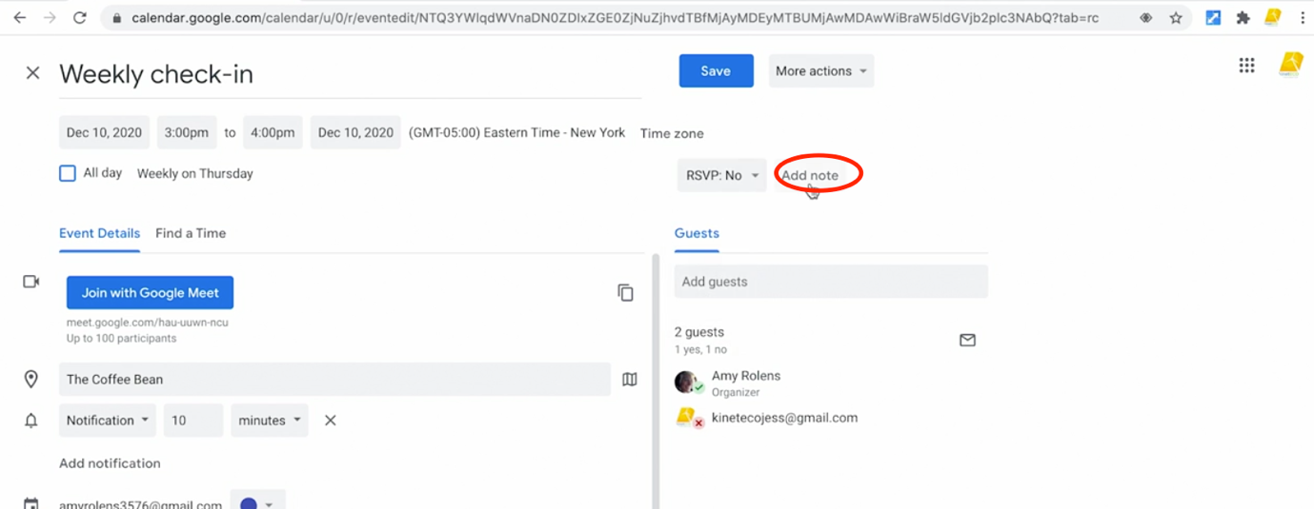

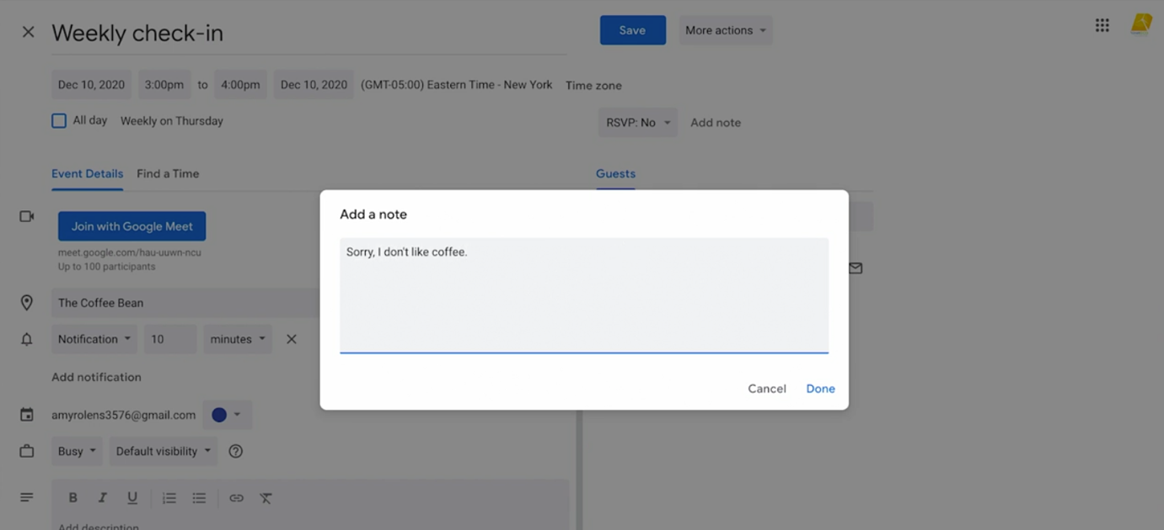

Calendar View after declining:



Email Accept:

🡪 We also see the same in mail: Yes, No or Maybe button

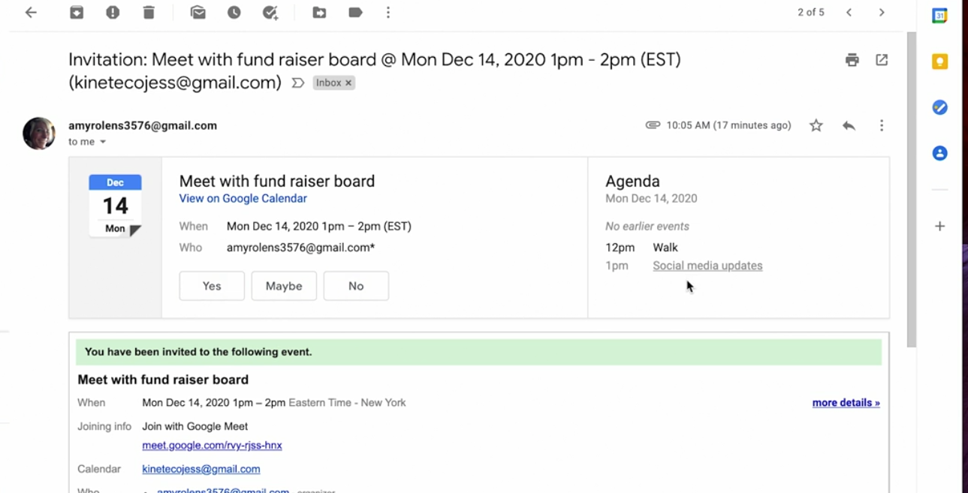

🡪 There is also one easier way to accept from email:

Click on RSVP dropdown 🡪 Select Yes

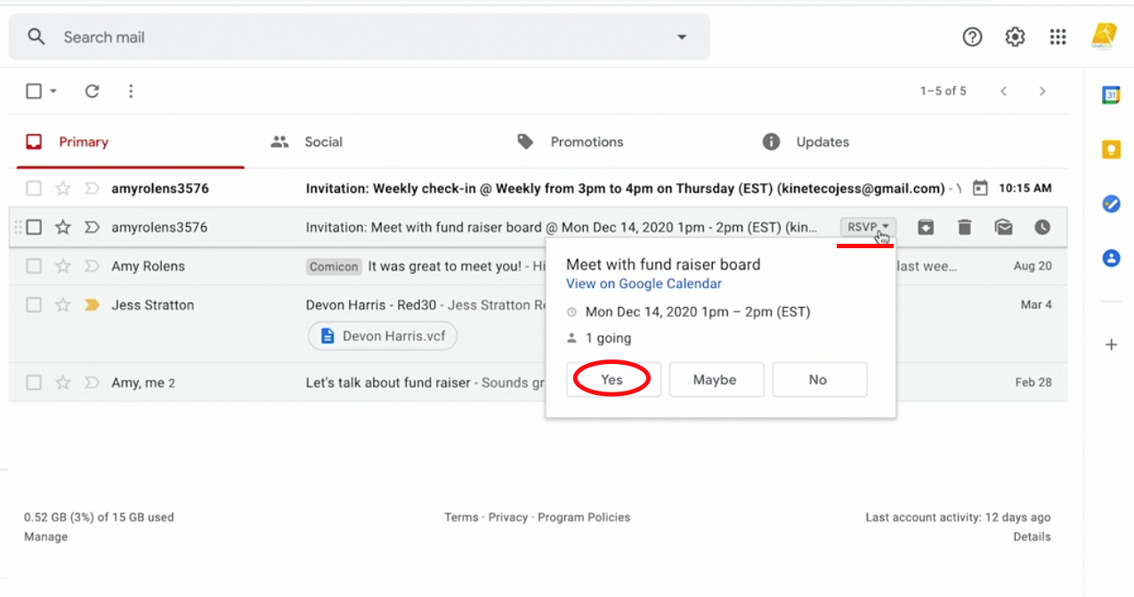

🡪 We can also go to the calendar and view changes

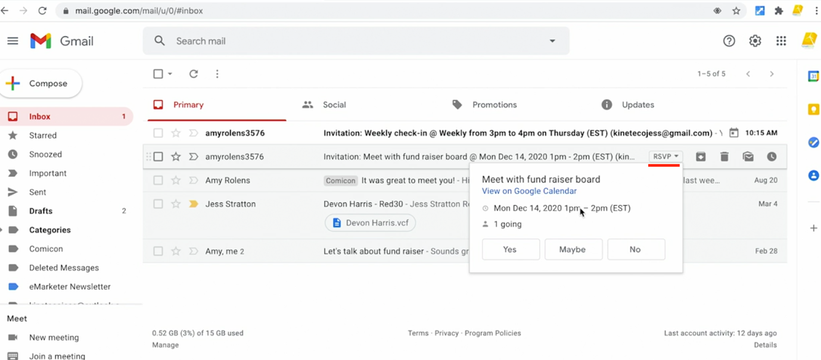

🡪 If I am the person inviting meeting – we can check status in calendar:

Green Tick – Yes

Red Cross – No

? - Tentative

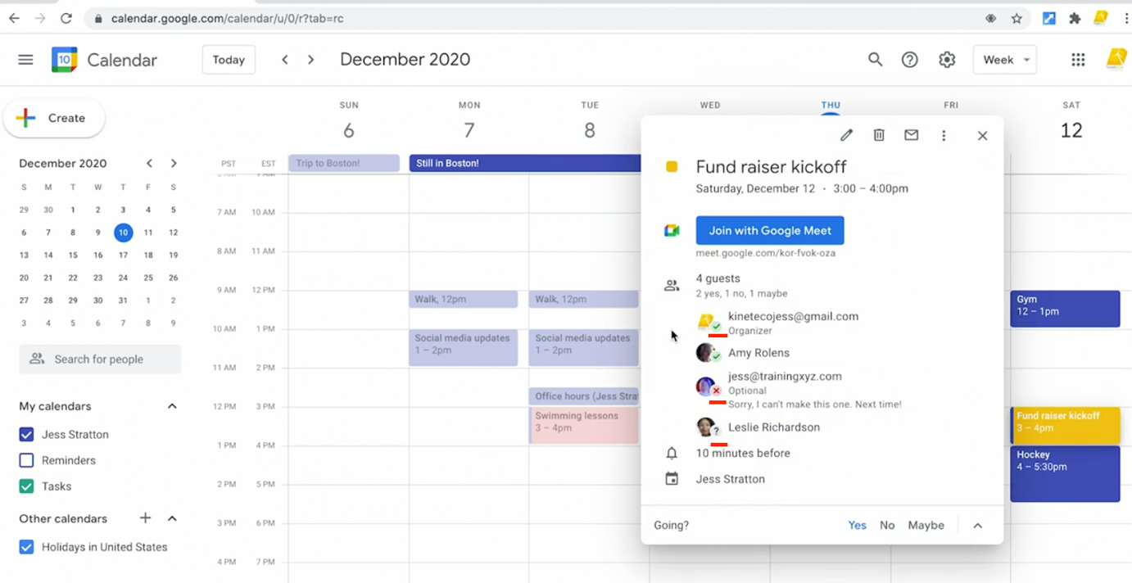

🡪 We can see reason for decline meeting – their Note

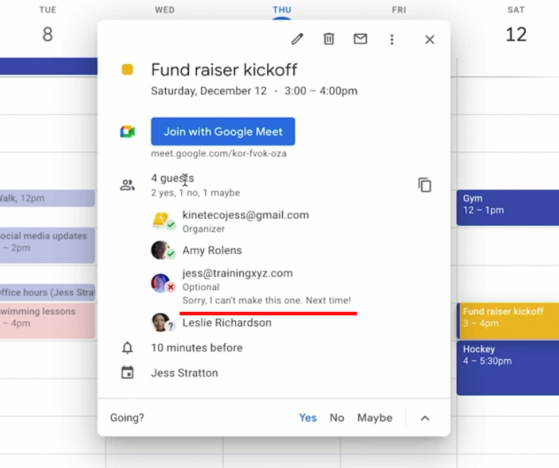

🡪 We can send Email reminders for all the three type users – suppose bring their copy of document. Click Email image

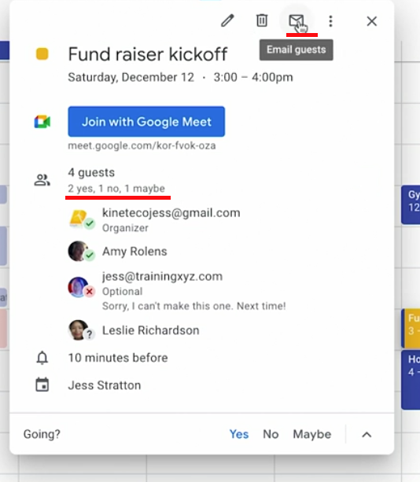

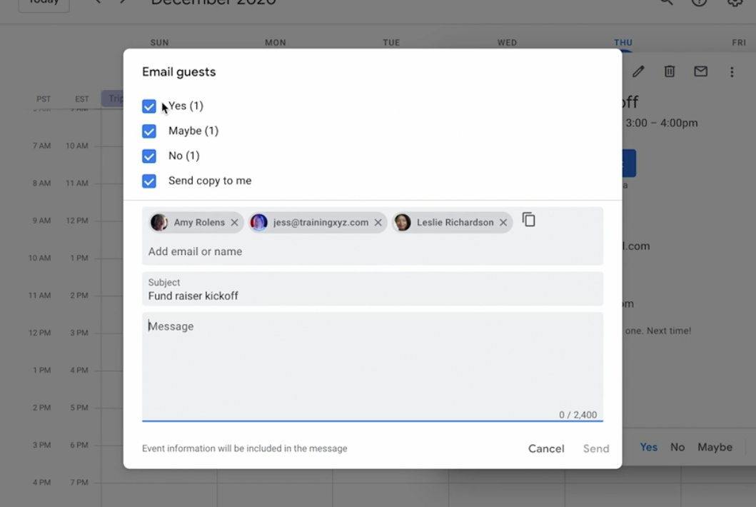

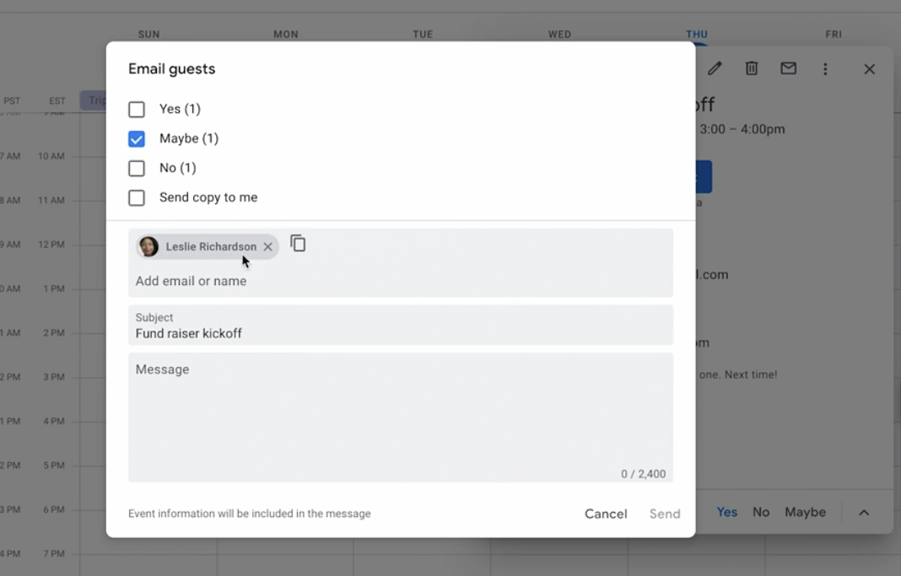

🡪 When done – we can click Send or Cancel

Create Additional Calendar:

1. Create a Secondary Calendar

🡪 Google provides us to manage multiple calendars.

🡪 For example – Professional and personal

🡪 Let us say we create family calendar – for personal

STEP 1 – Click plus button 🡪 Create New Calendar

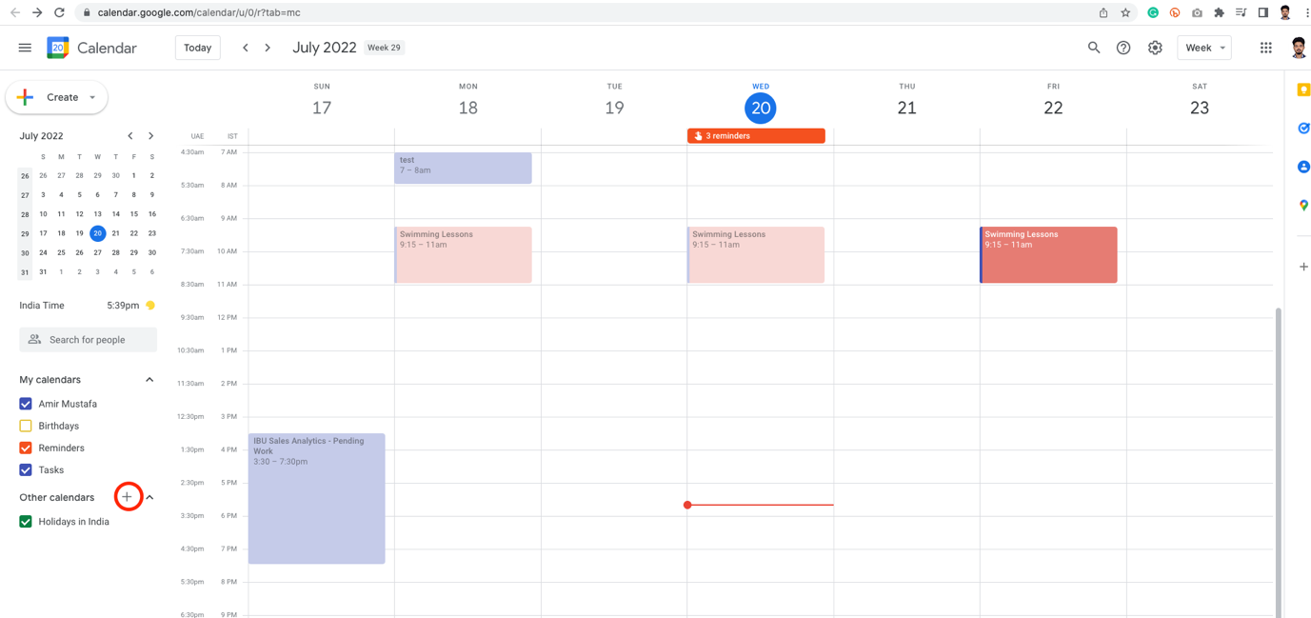

Click Create new calendar

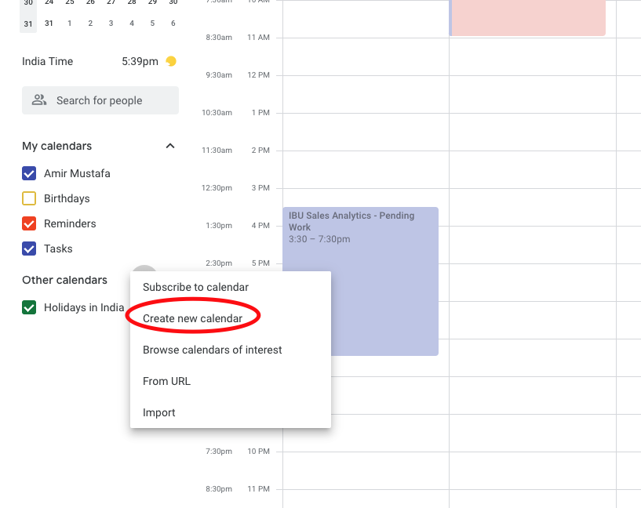

🡪 Write your new caledar name eg. Family

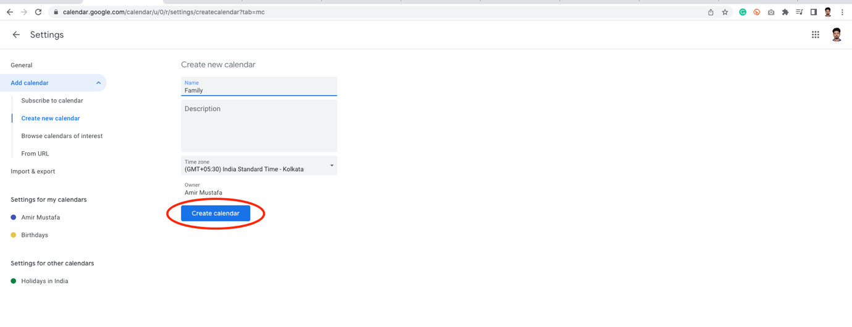

🡪 Click back arrow before setting, a new calendar is created

STEP 2 – Change New Calendar Colour Code

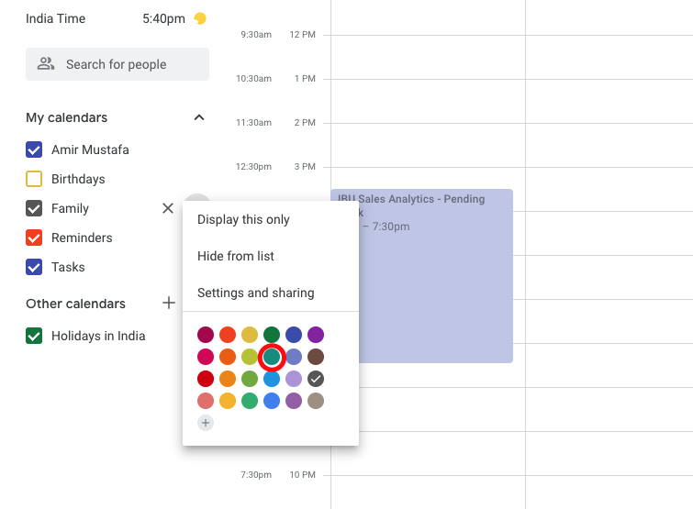

STEP 3 – Every calendar have their own calendar settings. We can click + icon on calendar and Settings

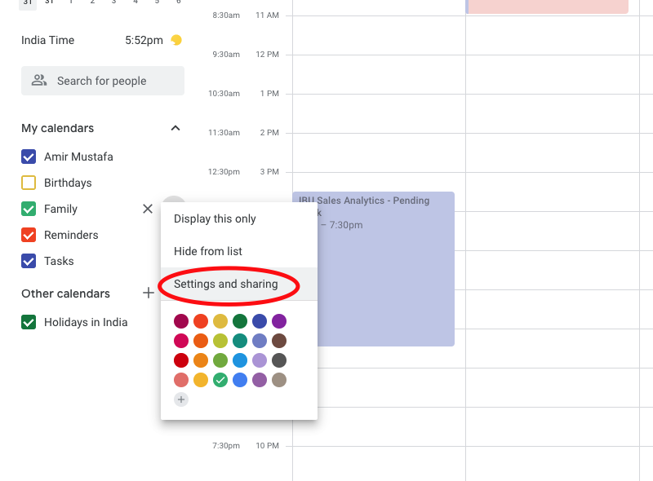

🡪 This setting is only for Family calendar. We can turn on Email notifications.

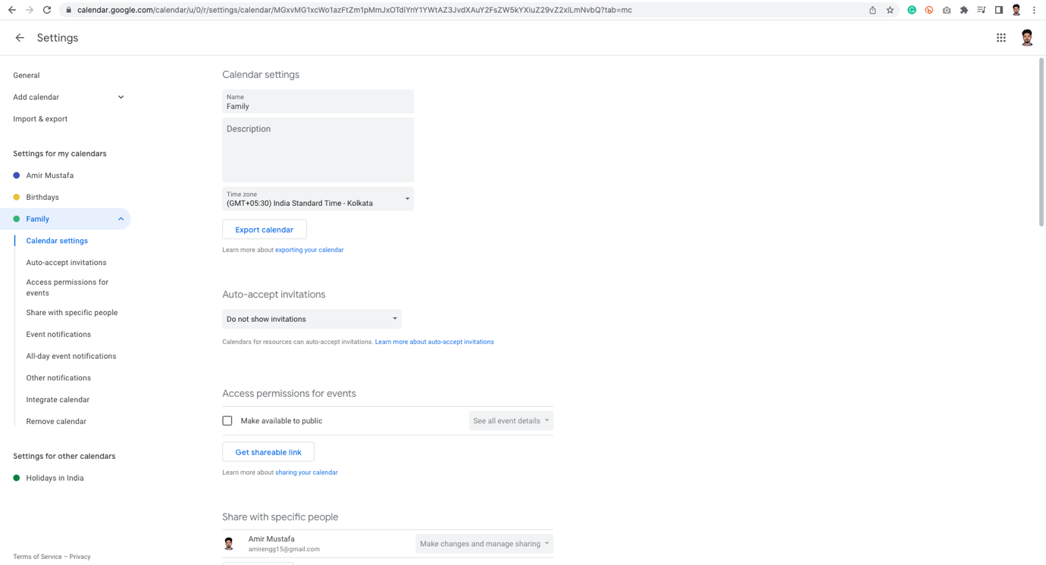

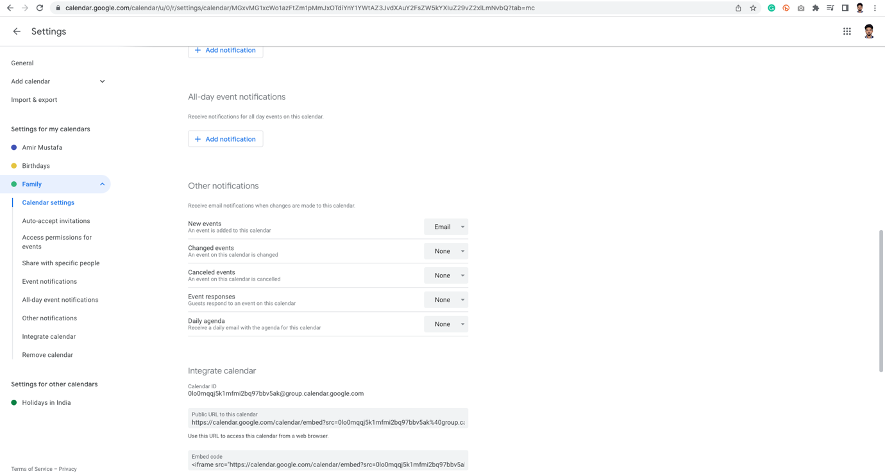

🡪 Once we have done with this setting, click on left arrow before Setting to reach main calendar screen.

1. Create Events with New Calendar

🡪 Click on time slot – add your event name 🡪 Chose new calendar from dropdown (i.e. family)

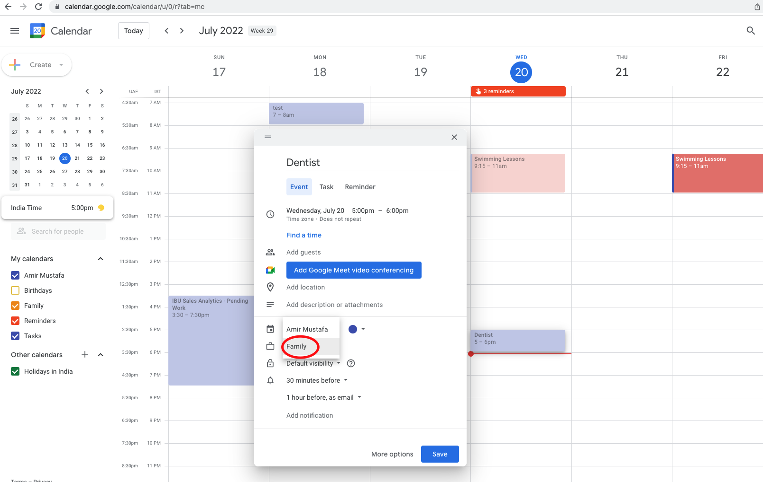

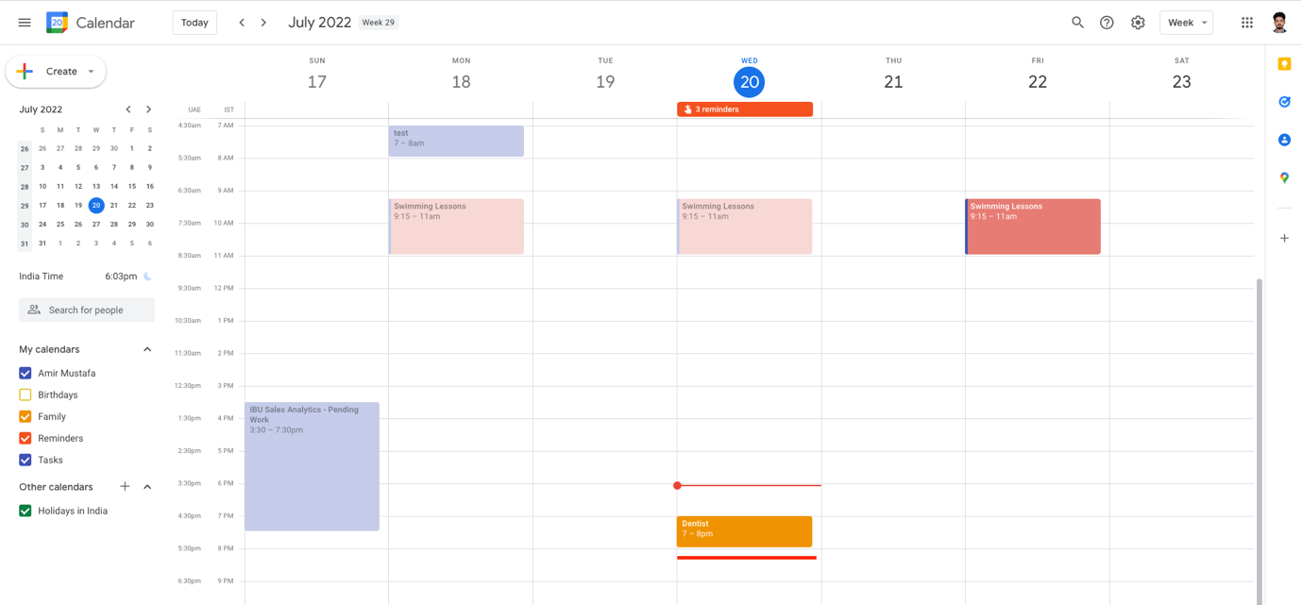

🡪 The colour code is same of that of our new calendar.

🡪 Suppose we want to override the colour. Double click on it 🡪 Choose colour 🡪 Click Save

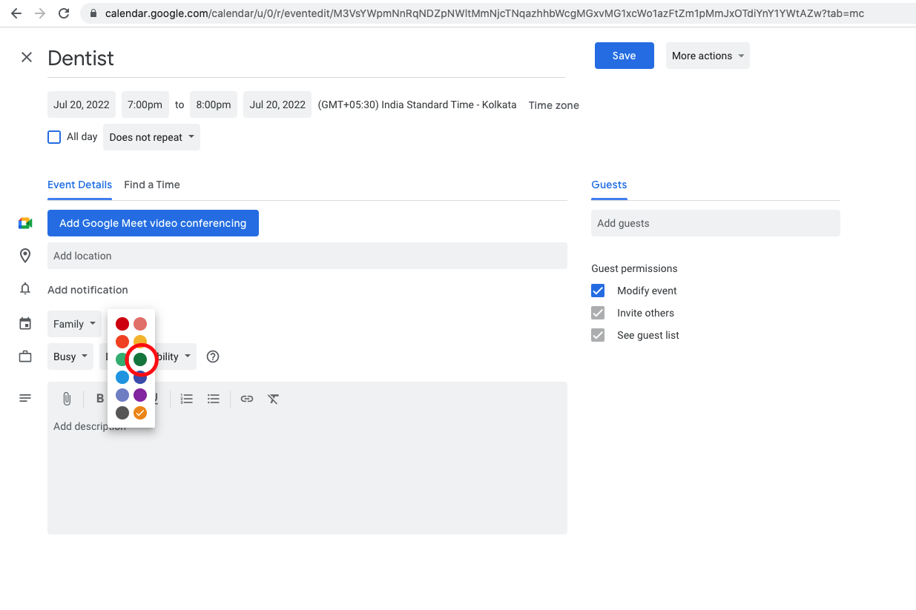

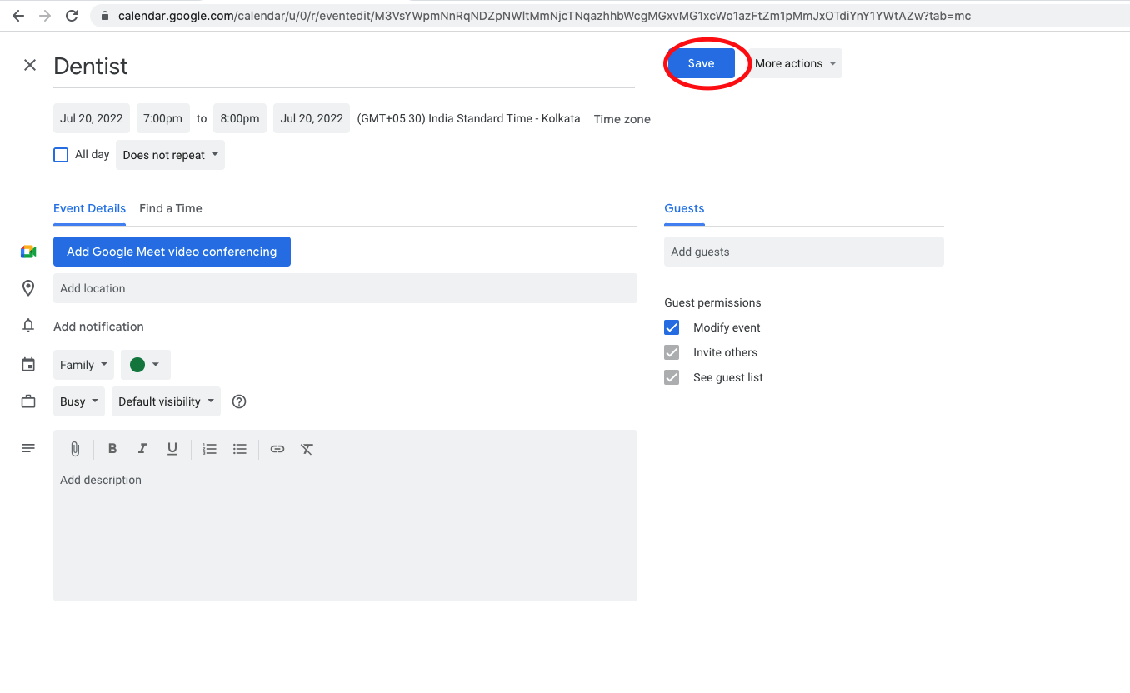

🡪 We can now see updated color.

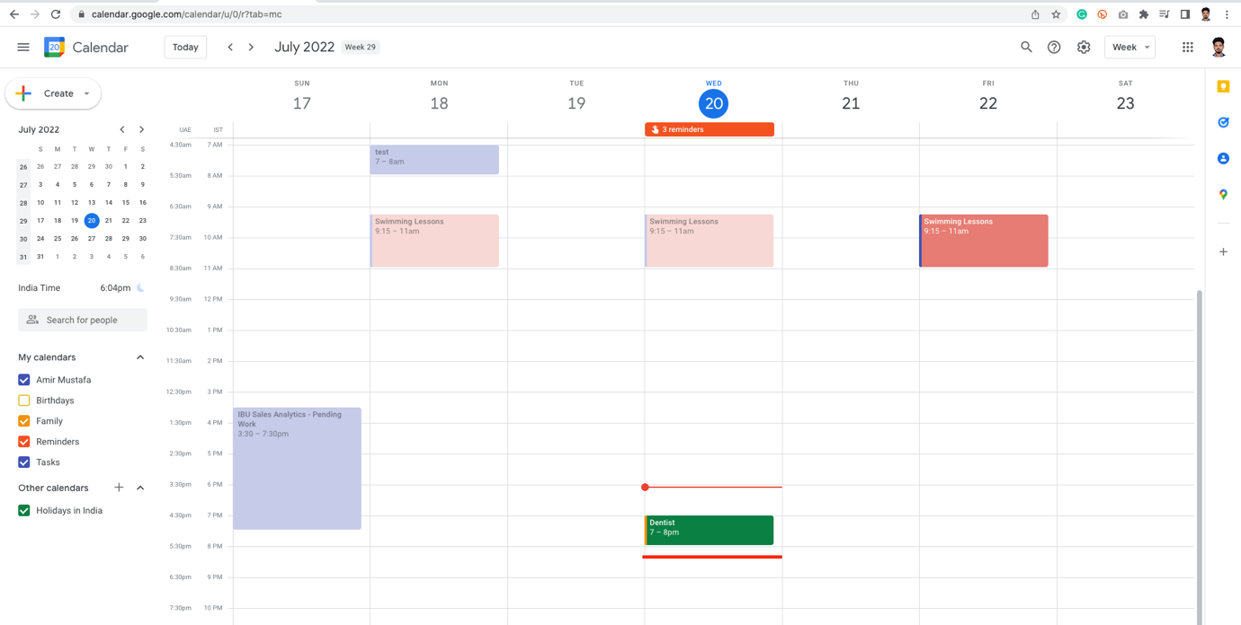

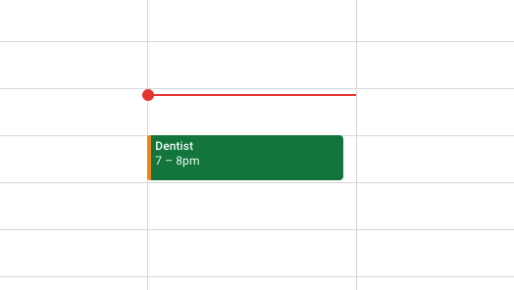

NOTE: The little orange band in left – tells is root calendar colour i.e. Family

🡪 The same can be done for edit case calendar 🡪 Double click on calendar 🡪 Change dropdown to right calendar

Create All Day Calendar – Copy to Other Calendar:

🡪 Suppose we create all day – calendar for three days

🡪 Drag in all day section for the vacation days 🡪 Add your details to work calendar 🡪 Save

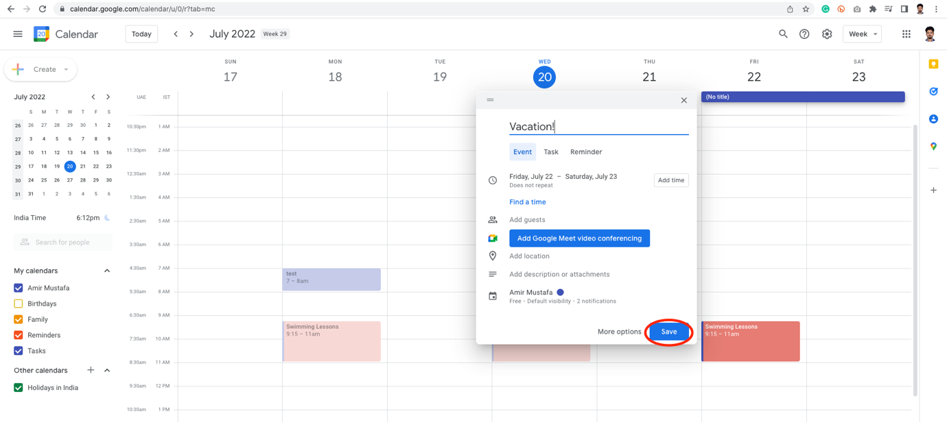

🡪 Click on the vacation calendar 🡪 Click three vertical dots 🡪 Copy to Family calendar.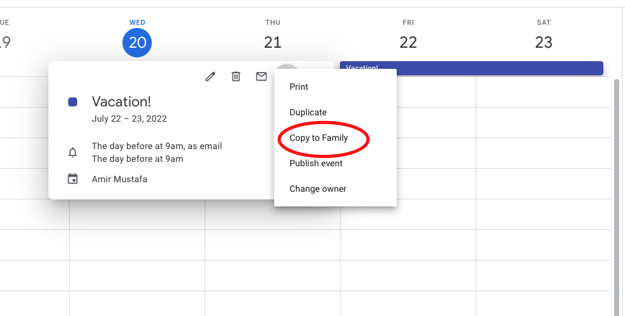

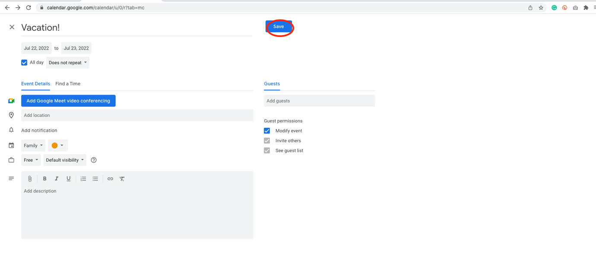

🡪 Now Vacation event shows in both calendars – Amir and Family

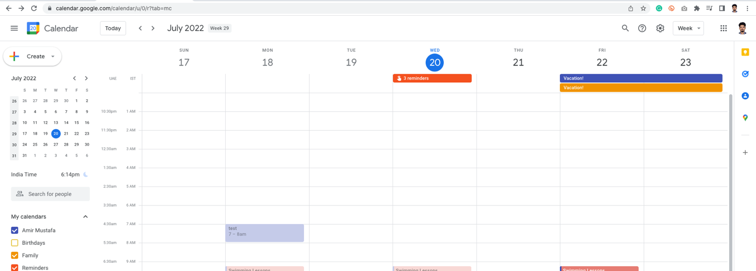

b. Hide and Create Other’s Calendar:

🡪 Sometimes we want to see only specific calendar, without actual deleting it

🡪 For this we click on three dots in calendar to be only visible 🡪 Display only this

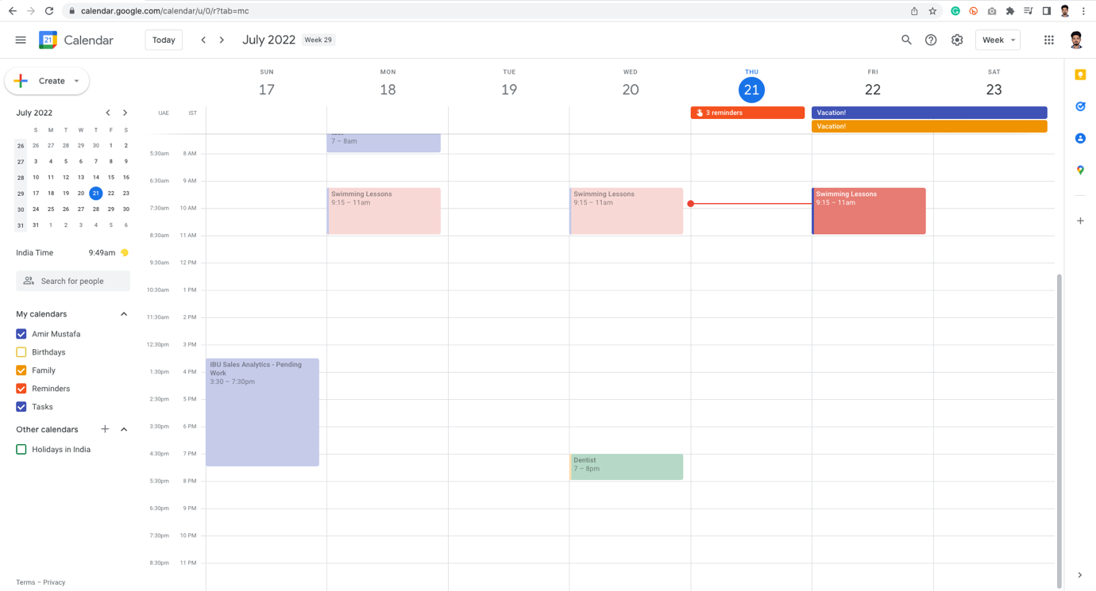

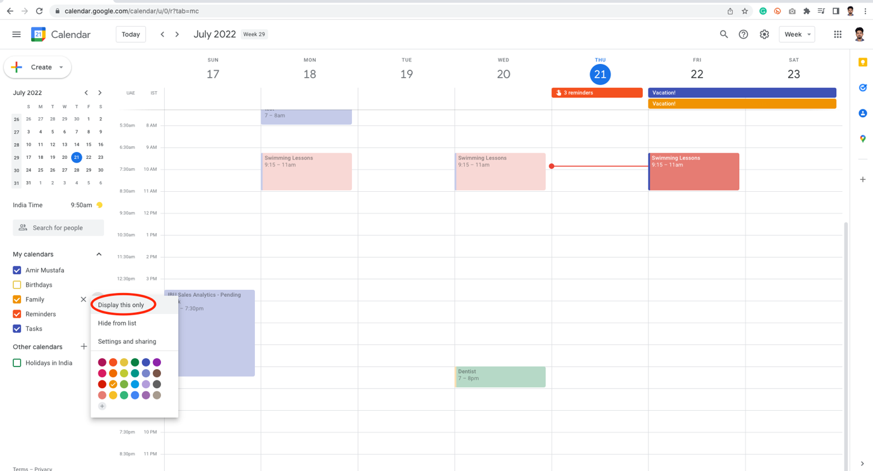

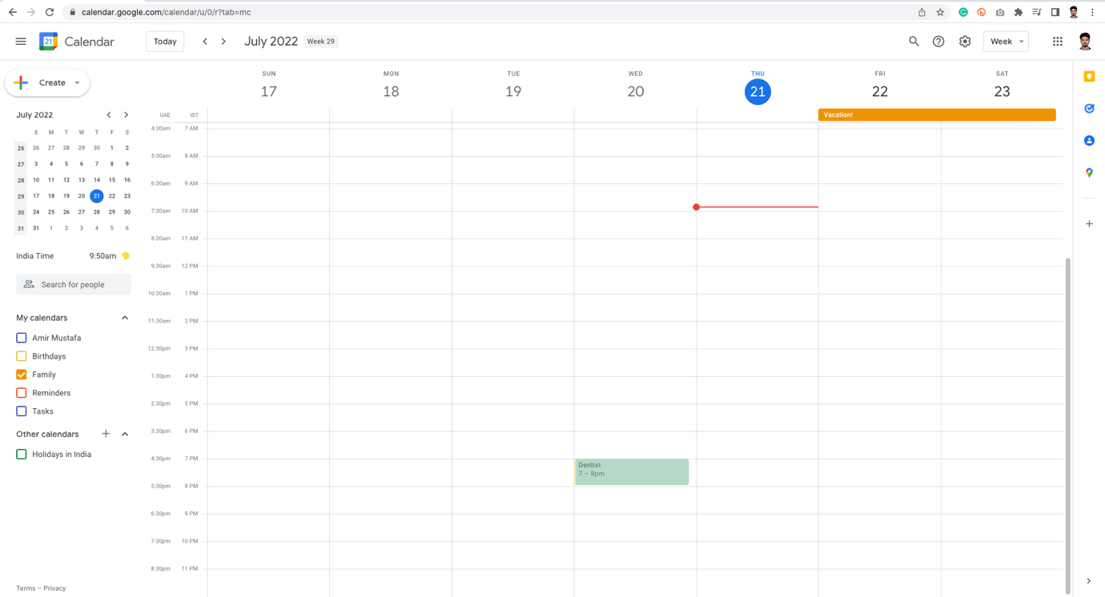

🡪 We can also toggle between calendars, by checking them directly

Hide from List:

🡪 Suppose we want to hide something from the calendar list 🡪 Click three dots 🡪 hide

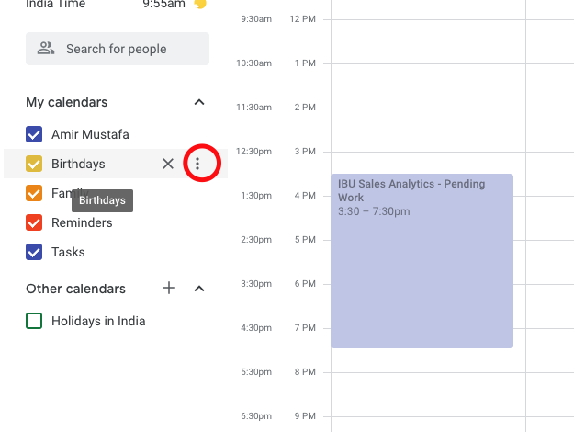

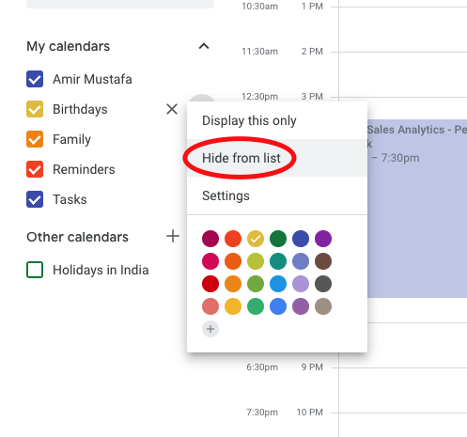

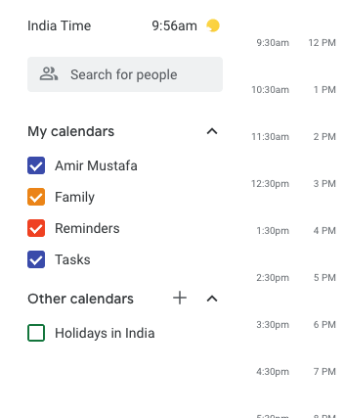

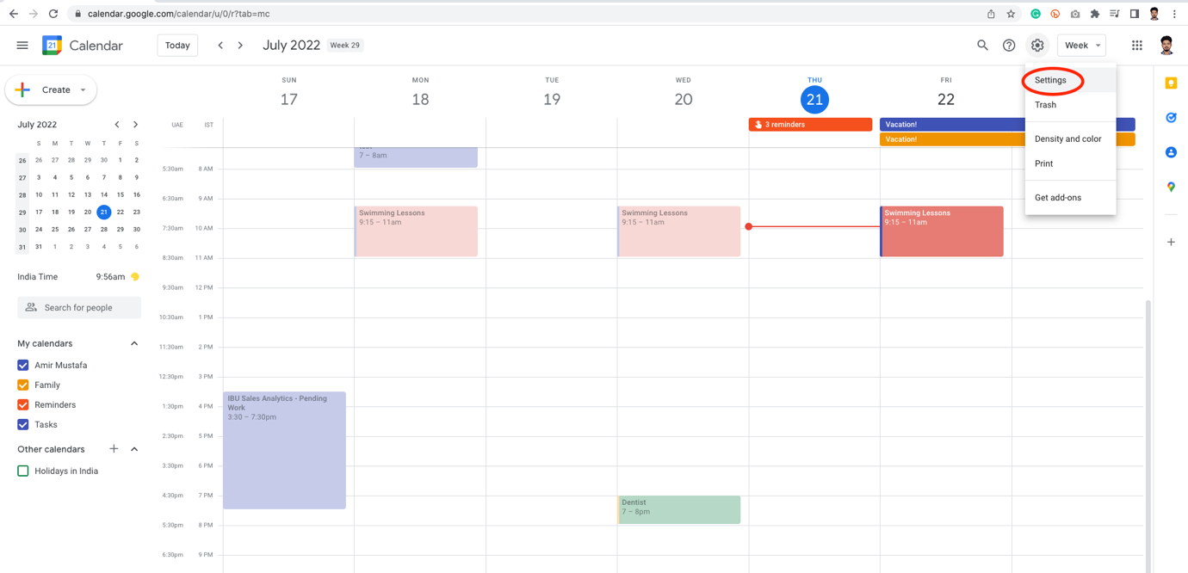

🡪 Click on eye icon to enable it

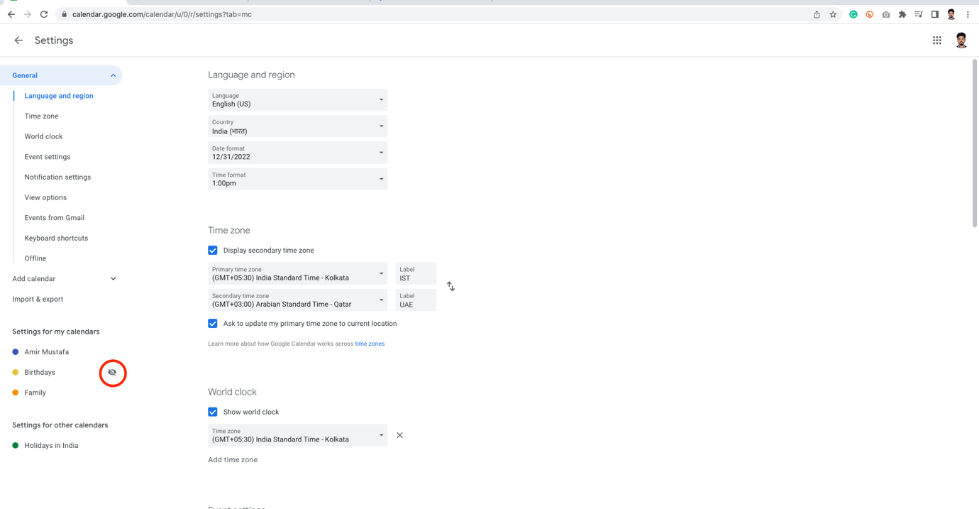

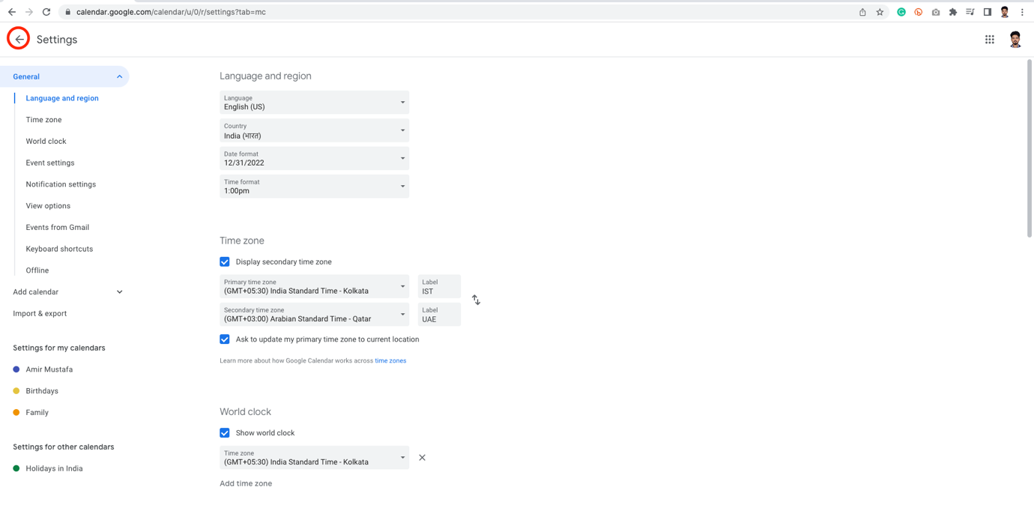

🡪 We now have our Birthday calendar back, which we hid initially.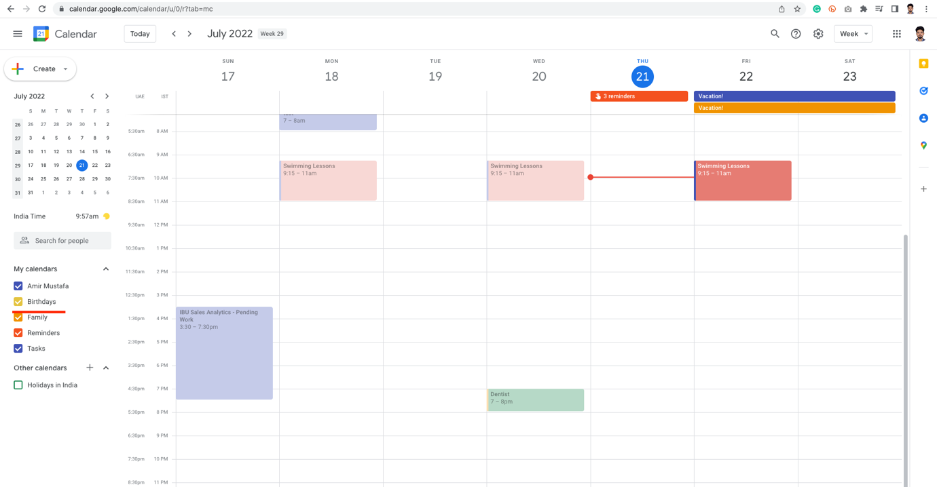

Searching a calendar for event:

STEP1: Click Magnifying glass:

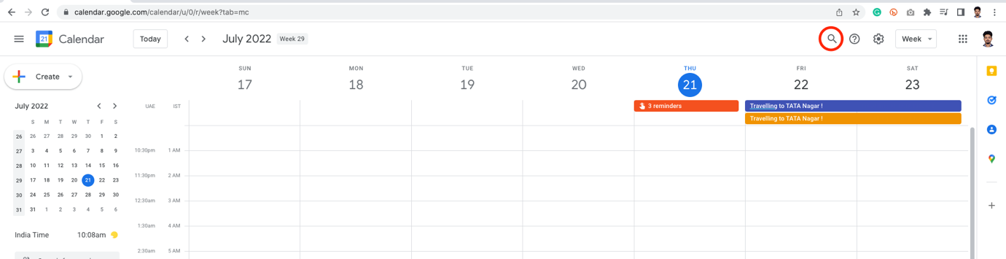

STEP2: Search some name of events eg TATA

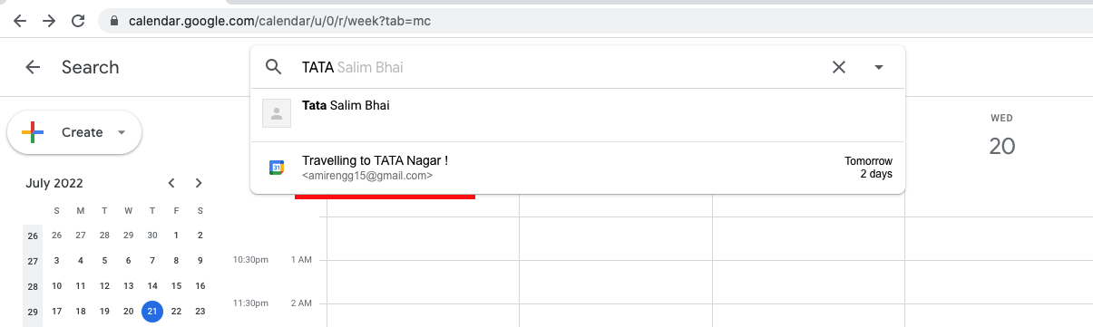

STEP3: Click on it to get more formal details:

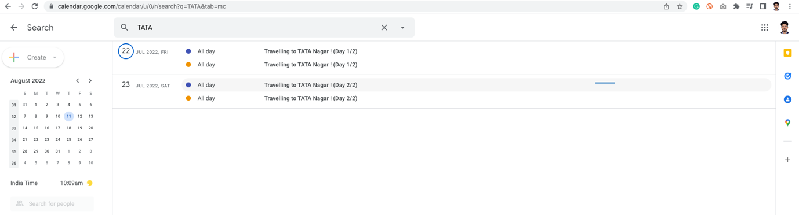

🡪 The colour tells us it is on which calendar.

🡪 We can narrow down our filters clicking dropdown arrow of search

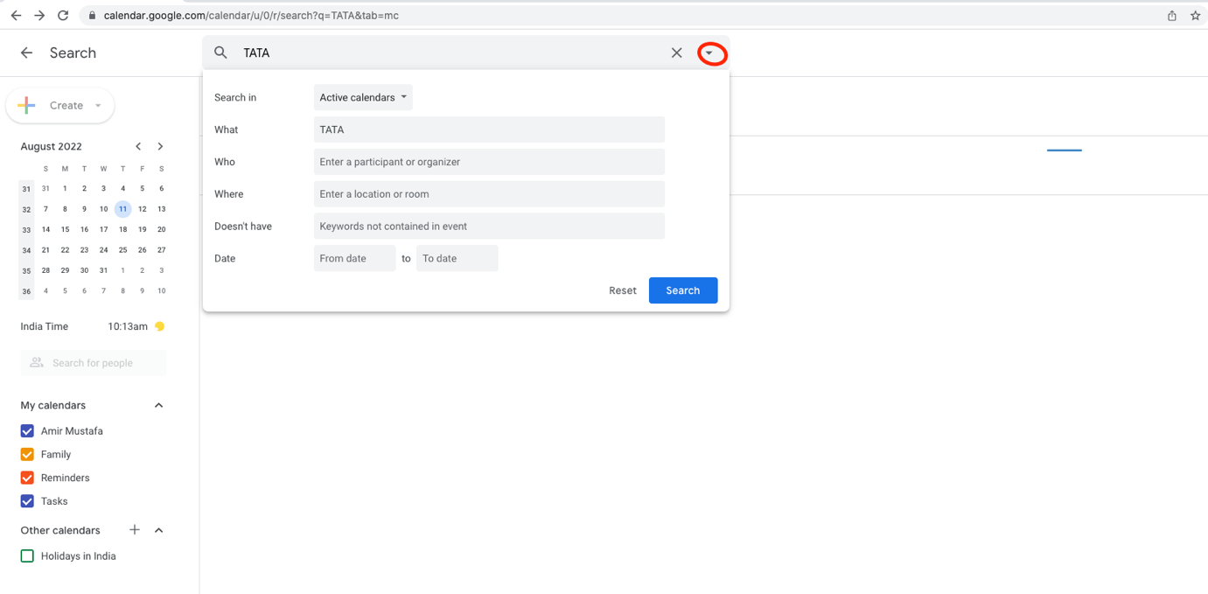

Say we want to see results of Family calendar only.

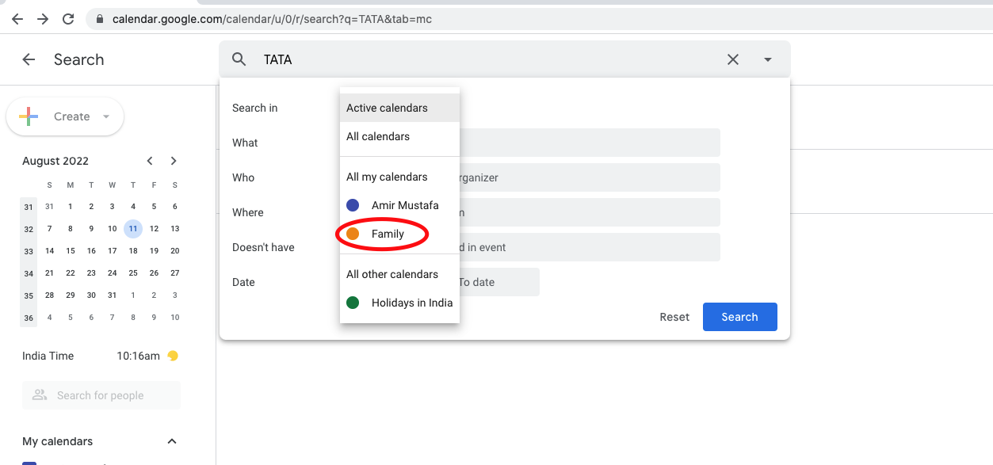

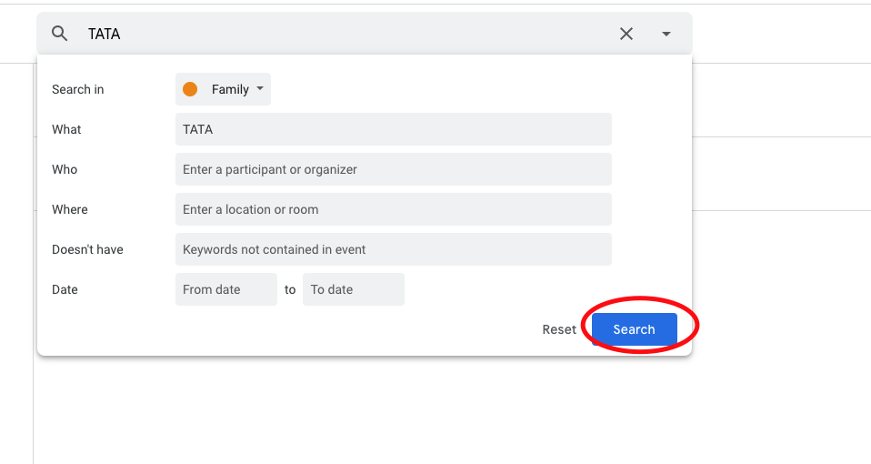

🡪 Tada, we have it

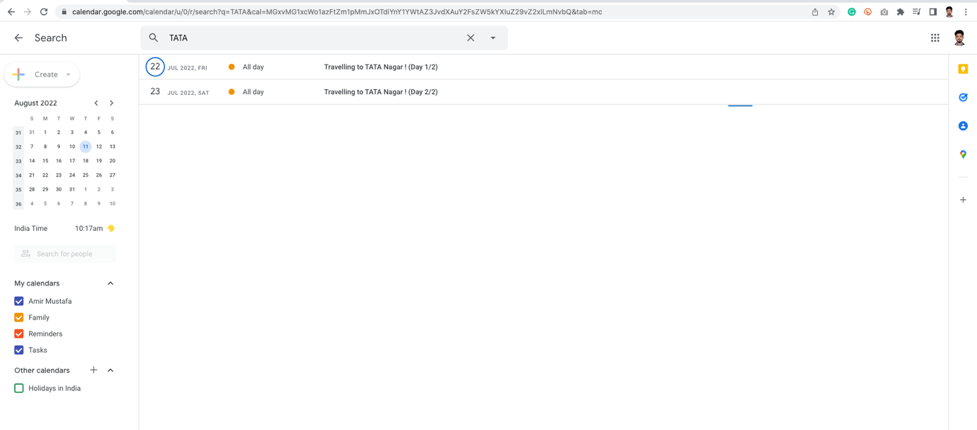

Share Calendar with Others:

1. Open someone else’s Google calendar:

🡪 If we want to add someone else’s calendar – say your Youtube channel ID in your calendar.

STEP1: Go to your personal calendar (i.e. [amirengg15@gmail.com](mailto:amirengg15@gmail.com)). Click + in Other calendar 🡪 write email ID of the calendar we need to access (i.e. [happylearnings1@gmail.com](mailto:happylearnings1@gmail.com))

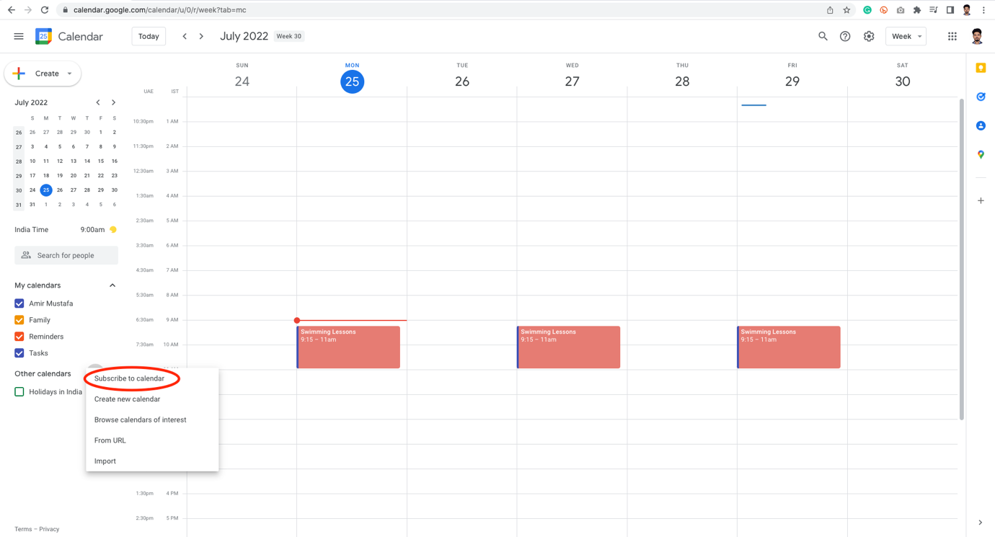

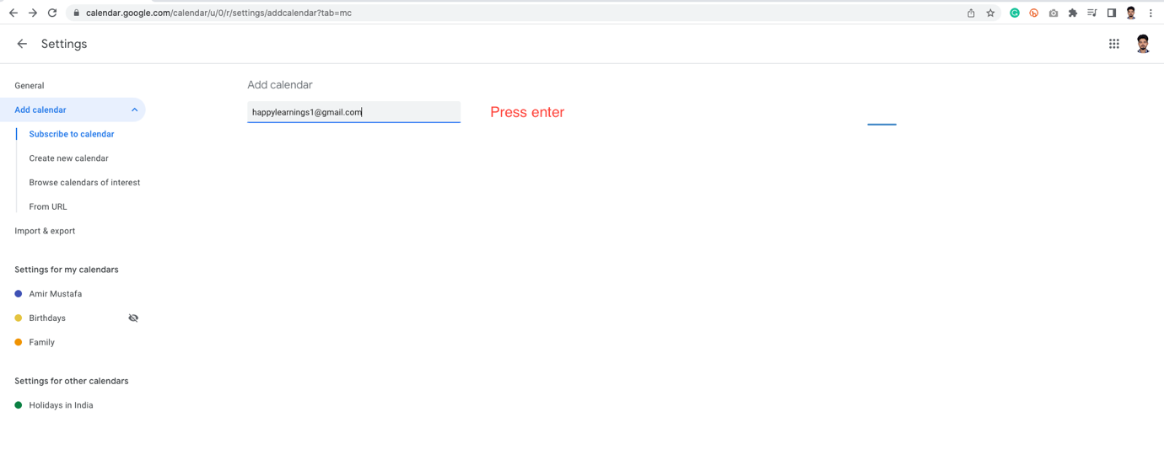

🡪 We cannot directly see other people’s calendar directly. First we have to request access

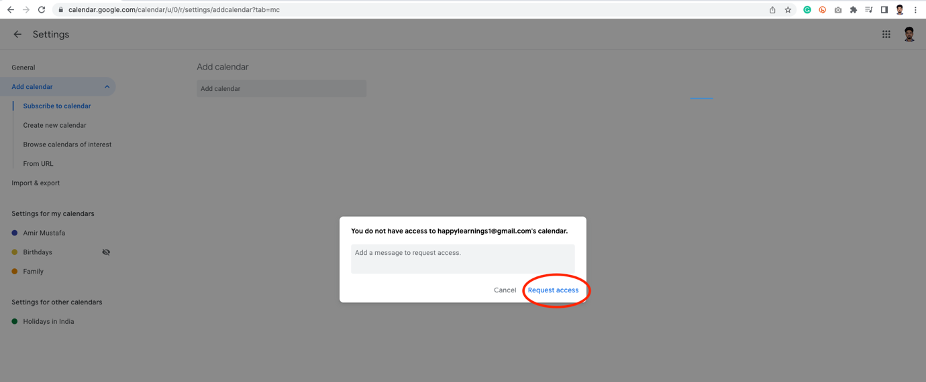

View of other people user:

🡪 Receive Email, open it

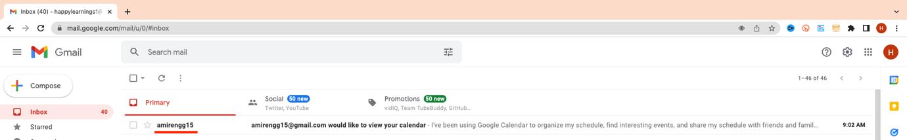

🡪 Click the link to accept the request of other people’s request

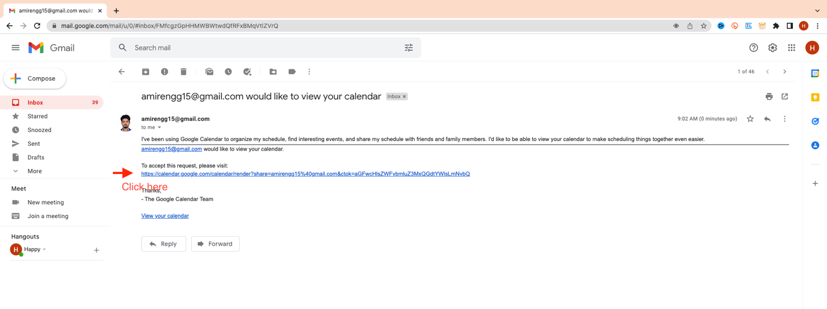

🡪 Click Send button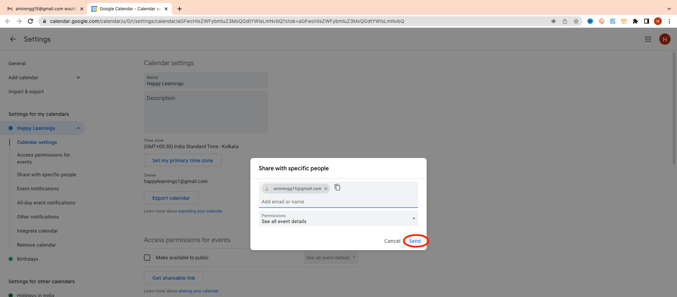

🡪 If we now go back to the view of requester calendar. We see calendar is now added.

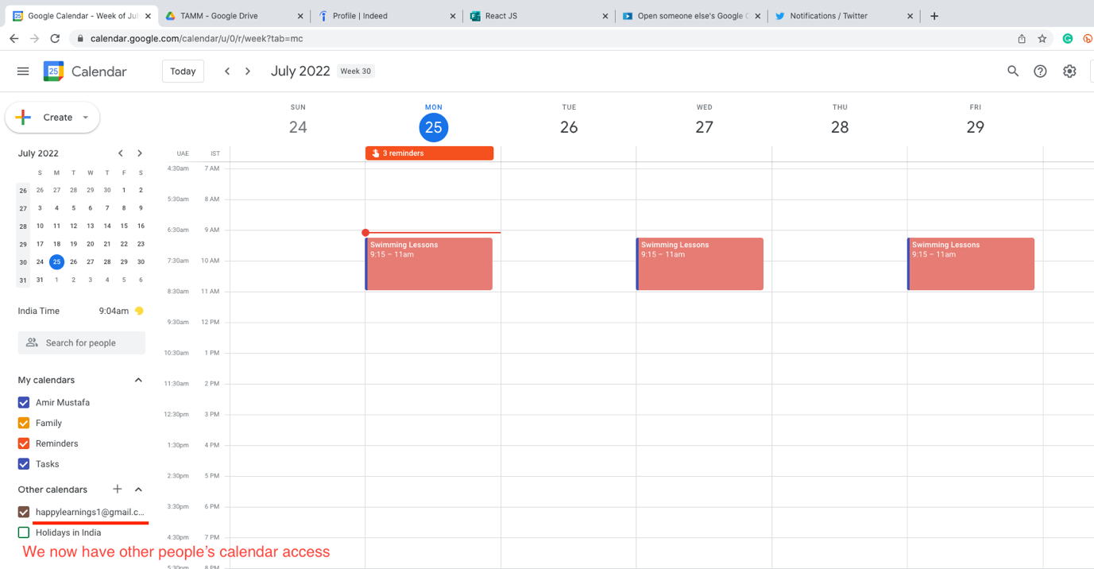

🡪 Let Happy Learning Create one event in their calendar:

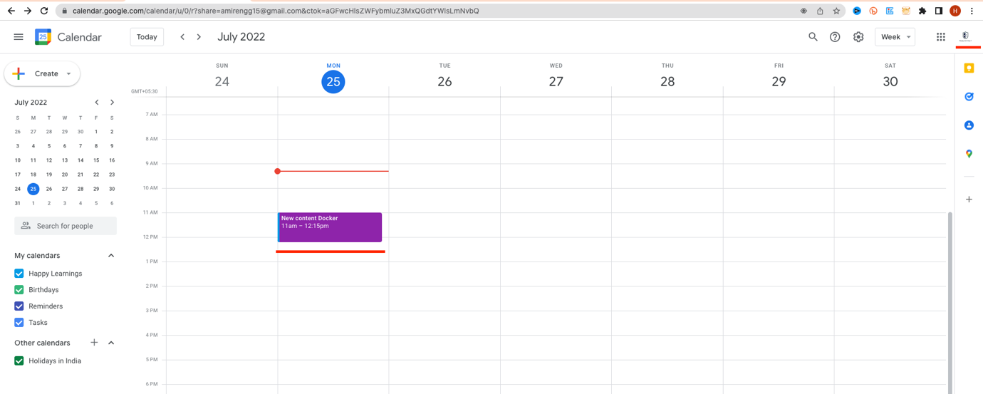

🡪 We will now see their calendar now reflected in mine

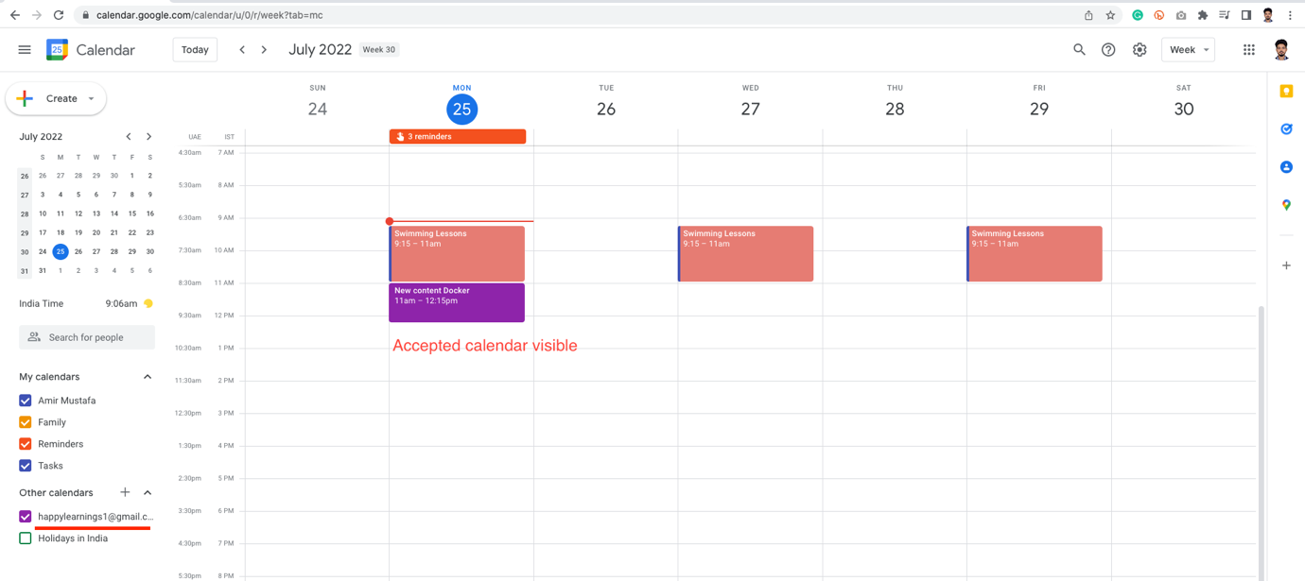

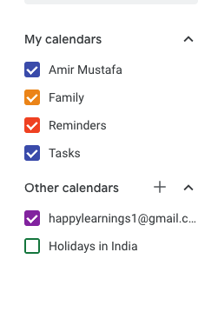

Day View also has neat representation view:

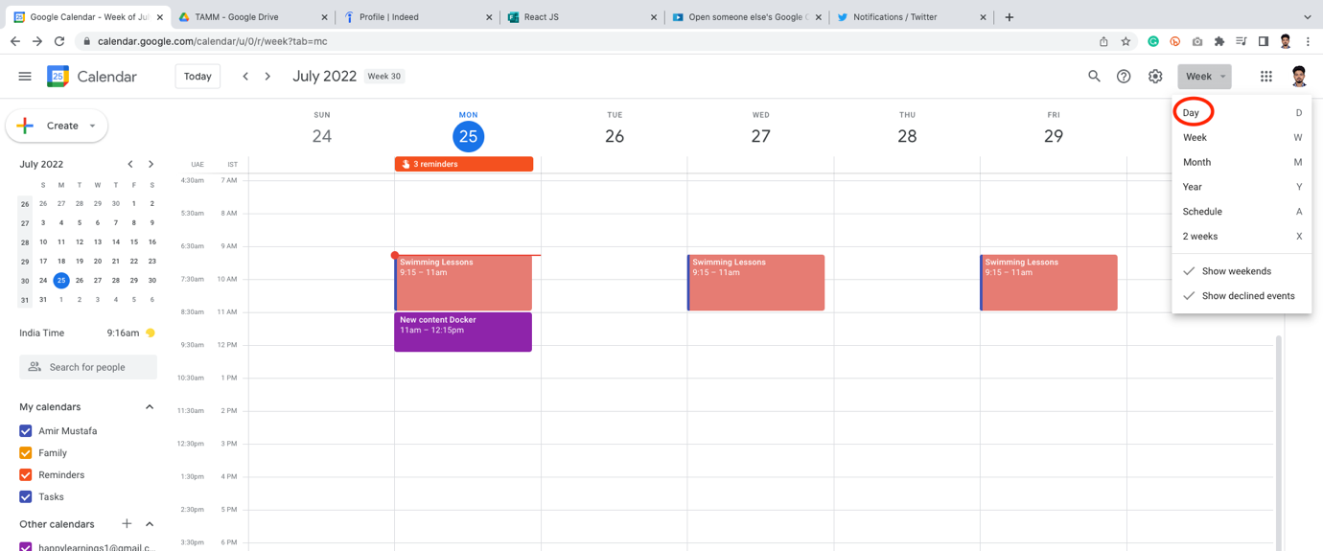

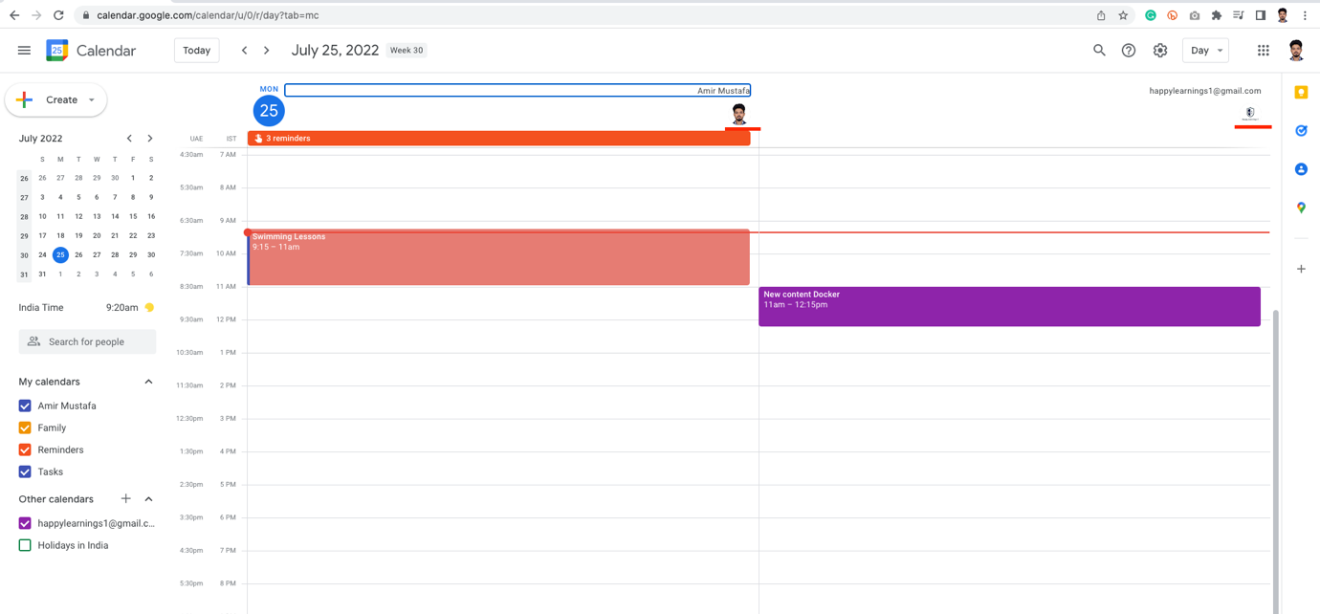

1. Subscribe to ICS Calendar (iCal format):

🡪 If some people use calendar other than Google format. Sharing calendar invite is helpful here.

🡪 People can subscribe to the ics calendar (format = .ics)

STEP 1: Click on the + sign 🡪 From URL

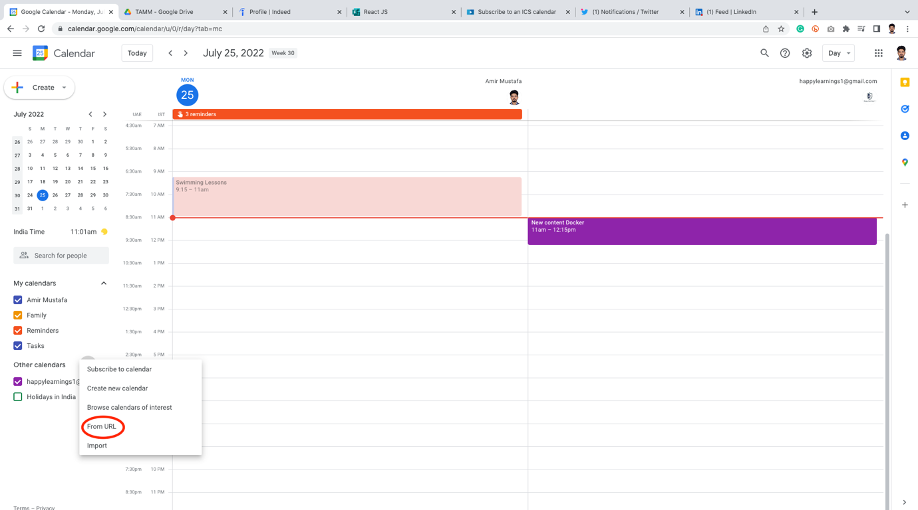

🡪 Most of the time this is useful. If a non-google account sends the invite (say outlook). They will also share .ics URL or download path

🡪 We need to add here

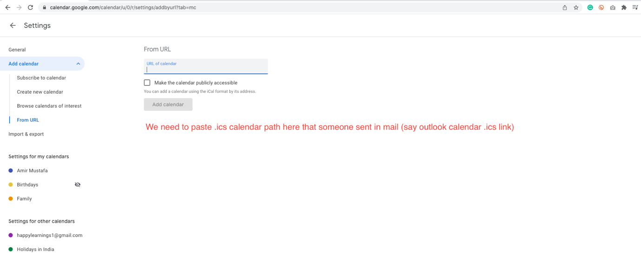

🡪 This will behave similar like below:

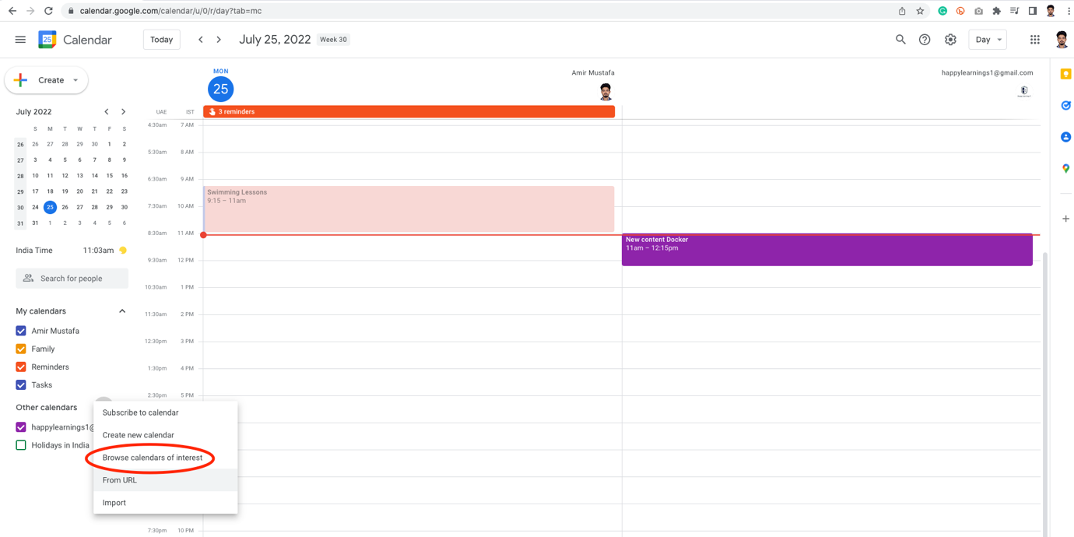

🡪 Click Browse some calendars 🡪 Google auto suggested calendar’s eg. Phase of Moon

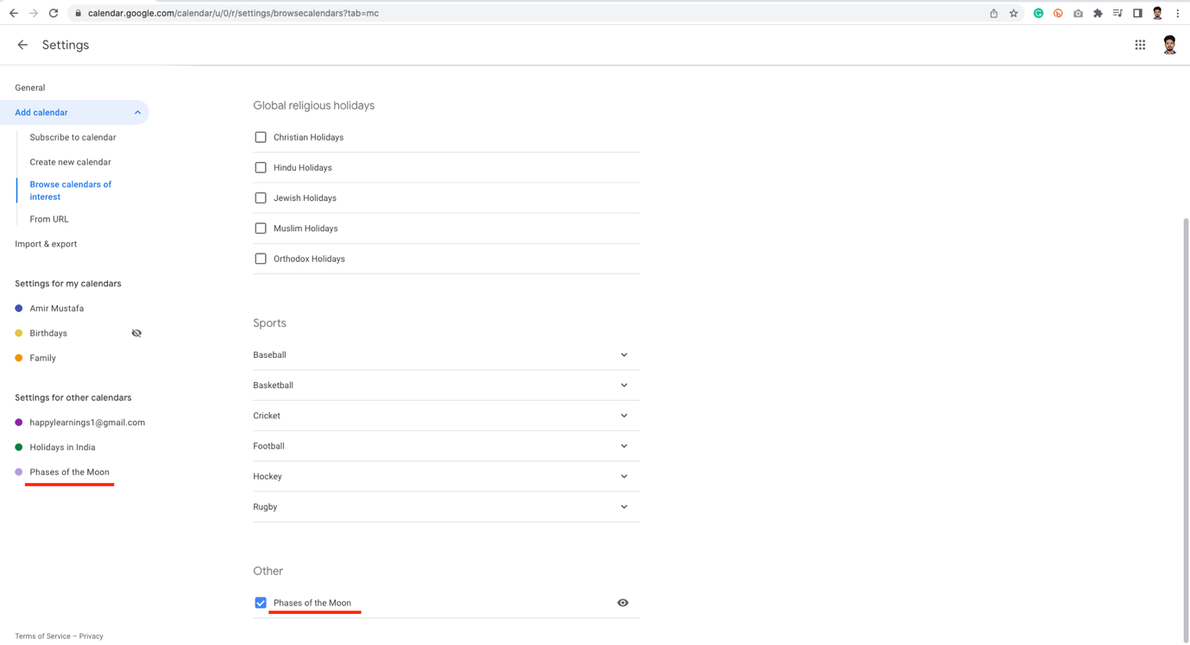

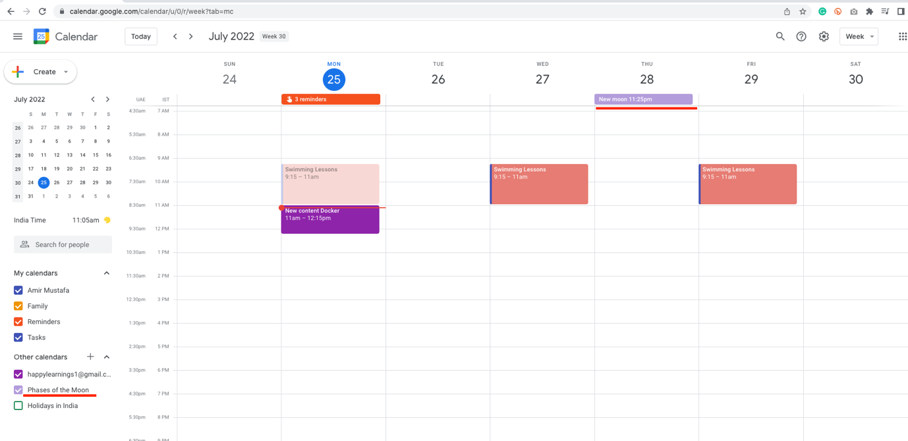

🡪 The calendar will be visible in our calendar. The same works for URL one as well. We need .ics file URL.

1. Share your Calendar with others:

🡪 if we want to share our Google calendar with others, this can be done.

🡪 From the left chose the calendar you want to share. Click three vertical dots 🡪 Setting and sharing

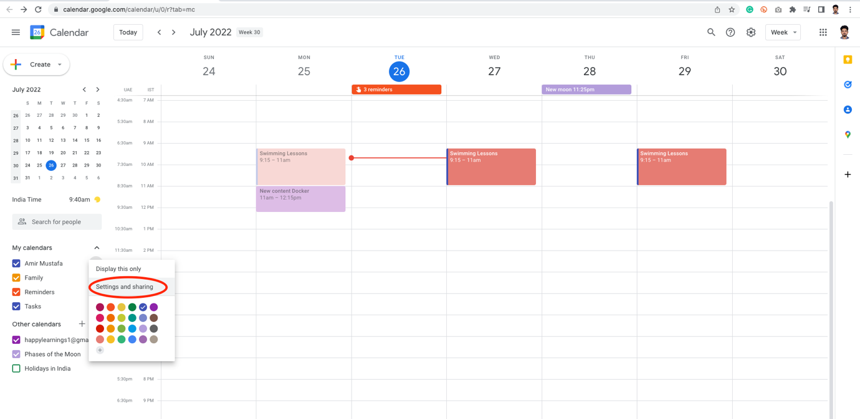

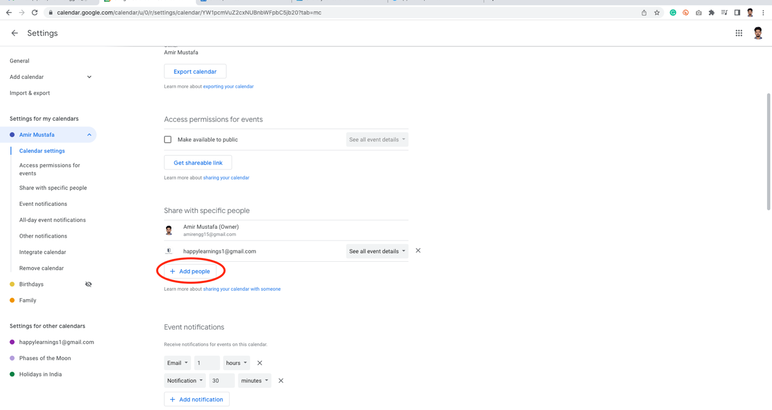

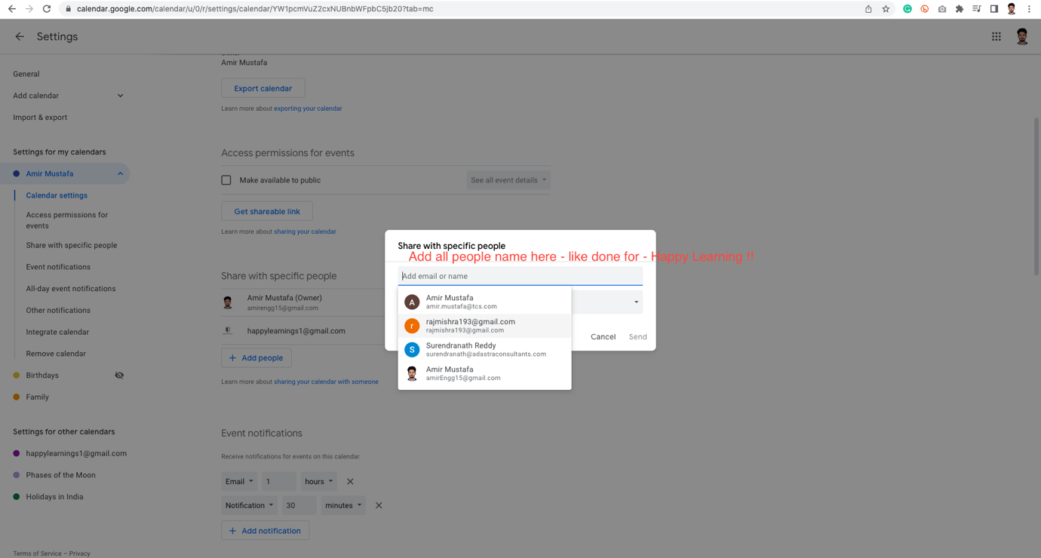

🡪 The other person can come here and subscribe to the calendar.

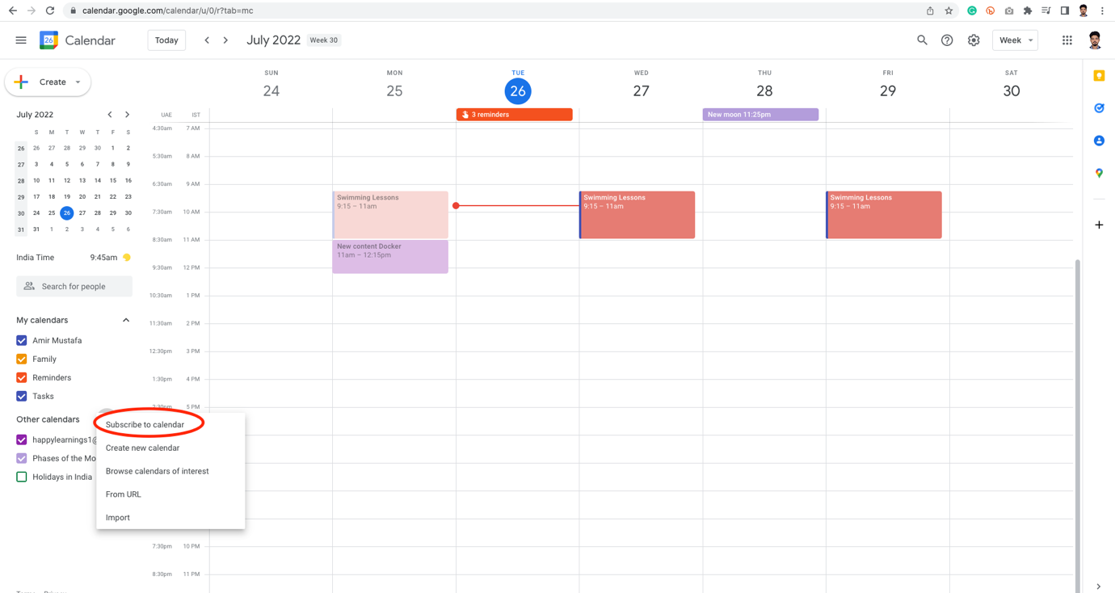

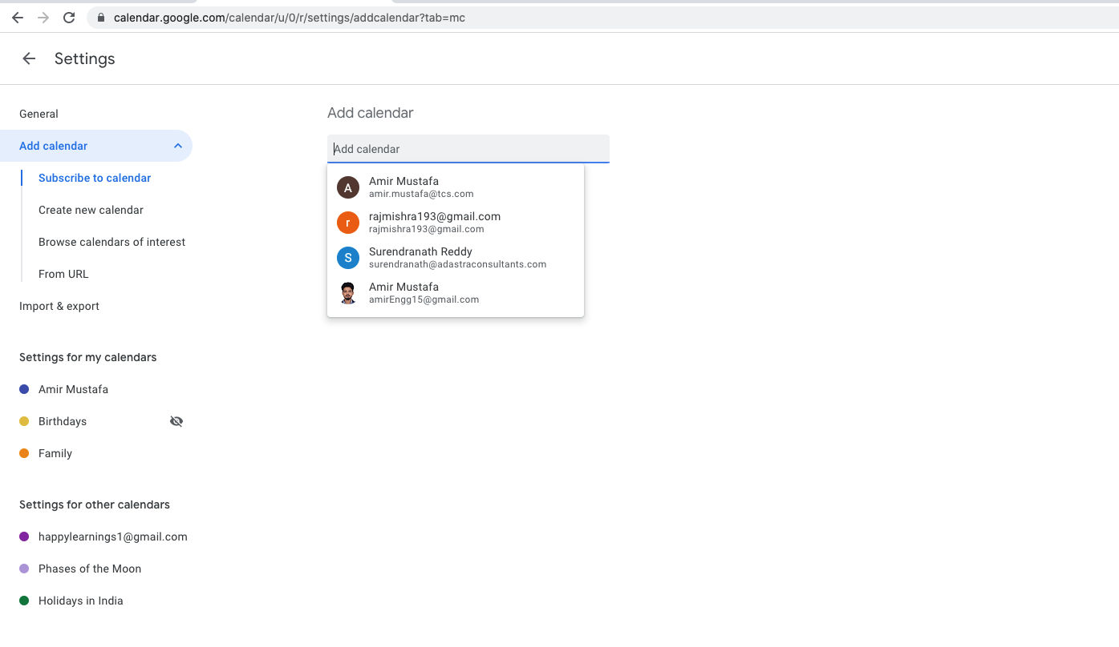

🡪 We can also show busy instead of actual events in calendar

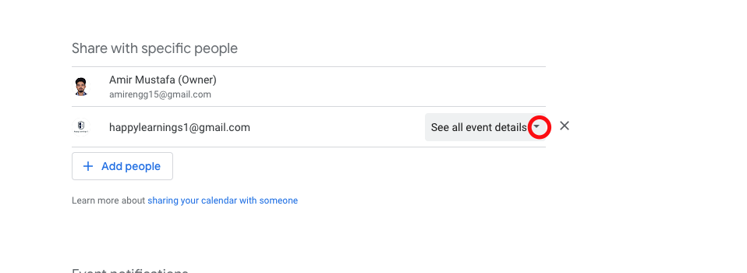

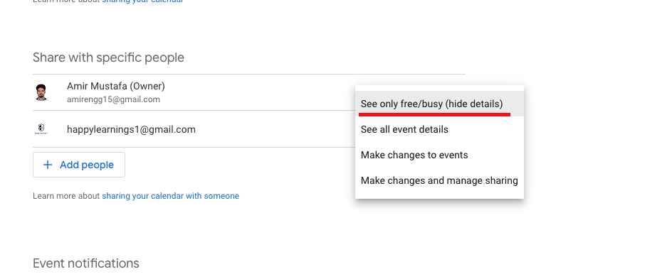

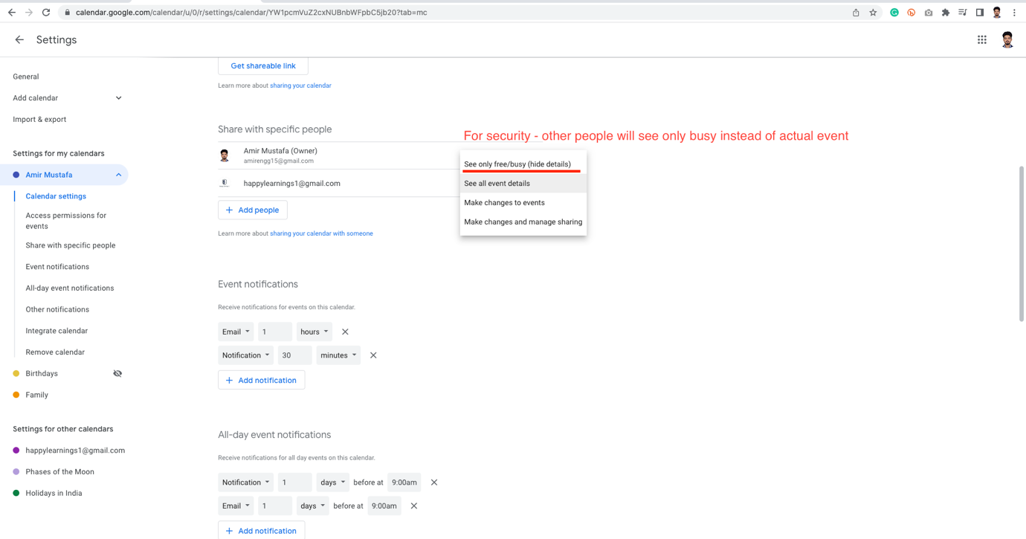

🡪 People will only see only the calendar we are sharing say family and not all.

Share Calendar with Non-Google user:

🡪 For this we need to share .ics (iCal format ) link of my Google calendar.

STEP 1: Choose your google calendar .ics file to share.

STEP 2: Click Integrate Calendar:

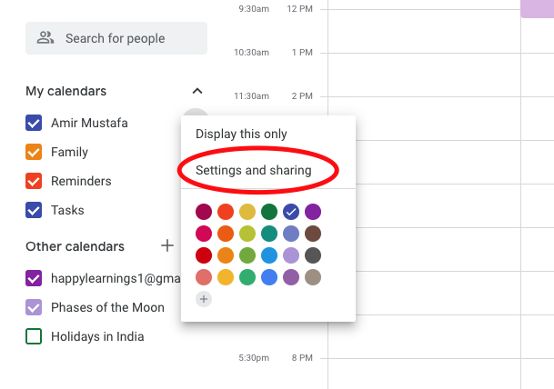

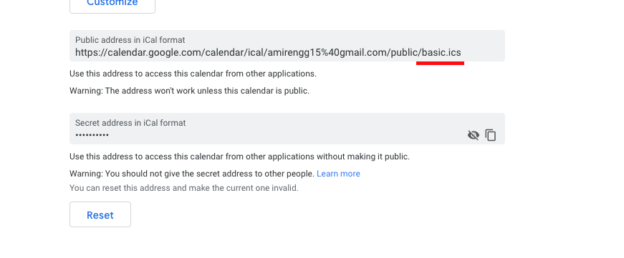

<https://calendar.google.com/calendar/ical/amirengg15%40gmail.com/public/basic.ics>

<https://calendar.google.com/calendar/ical/amirengg15%40gmail.com/private-ebad24cccb7fb1c74ded1edf50e2ad3d/basic.ics>

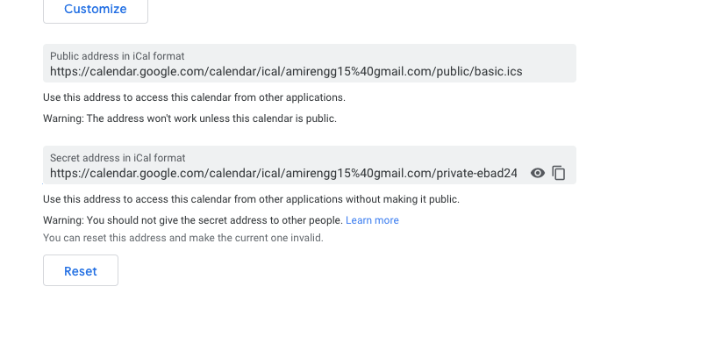

🡪 This is a very private link. Anytime you feel the link is compromised we can reset from above button.

Make a Calendar public – set free/busy:

STEP 1: Chose the calendar whom we want to share say (work calendar – Amir Mustafa)

STEP 2: Click Settings and Sharing



Search: Access permissions for events 🡪 Check box 🡪 From From Dropdown chose Set busy/free

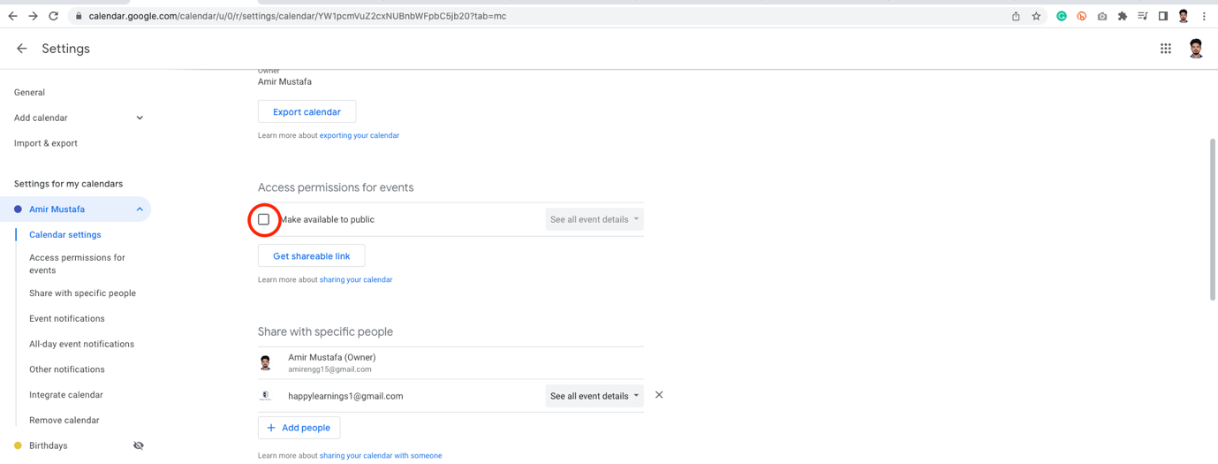

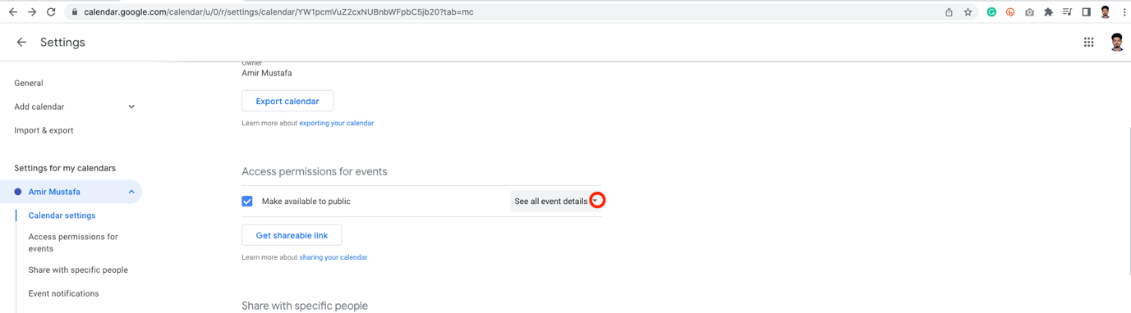

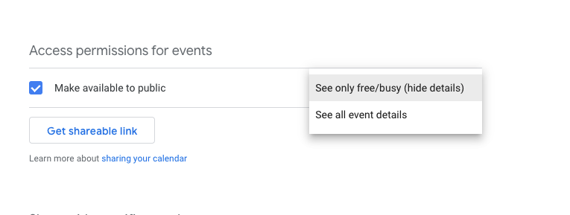

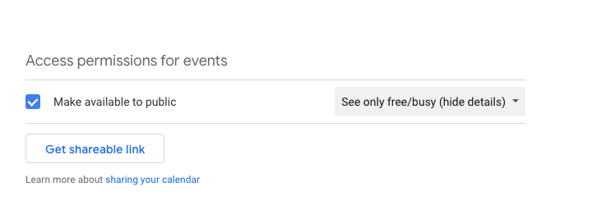

🡪 Click Get shareable link:

If owner opens the link – event name visible:

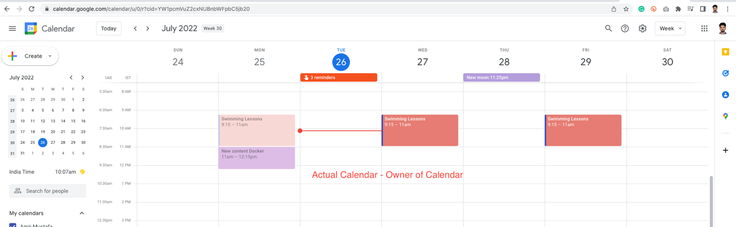

🡪 If other users opens this calendar, will see busy instead of name. On hitting the URL first time asks for add.

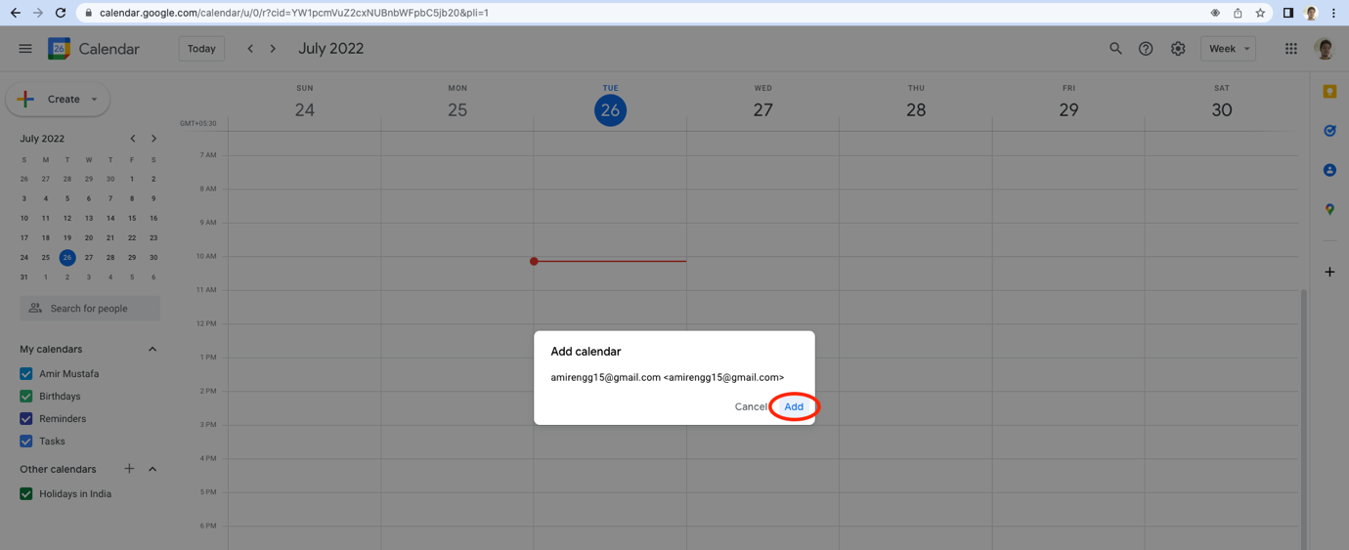

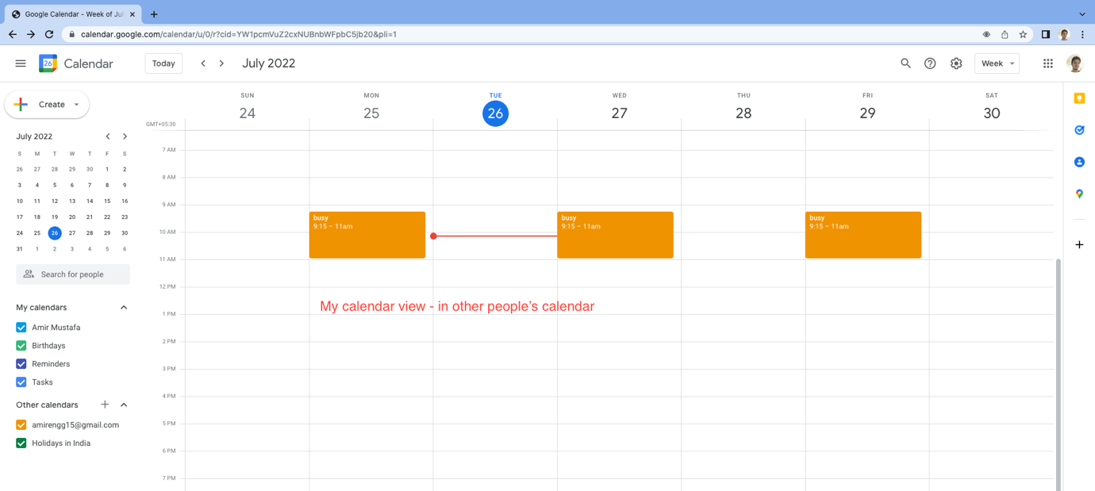

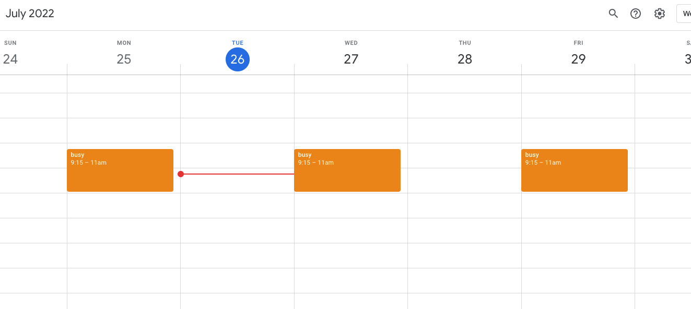

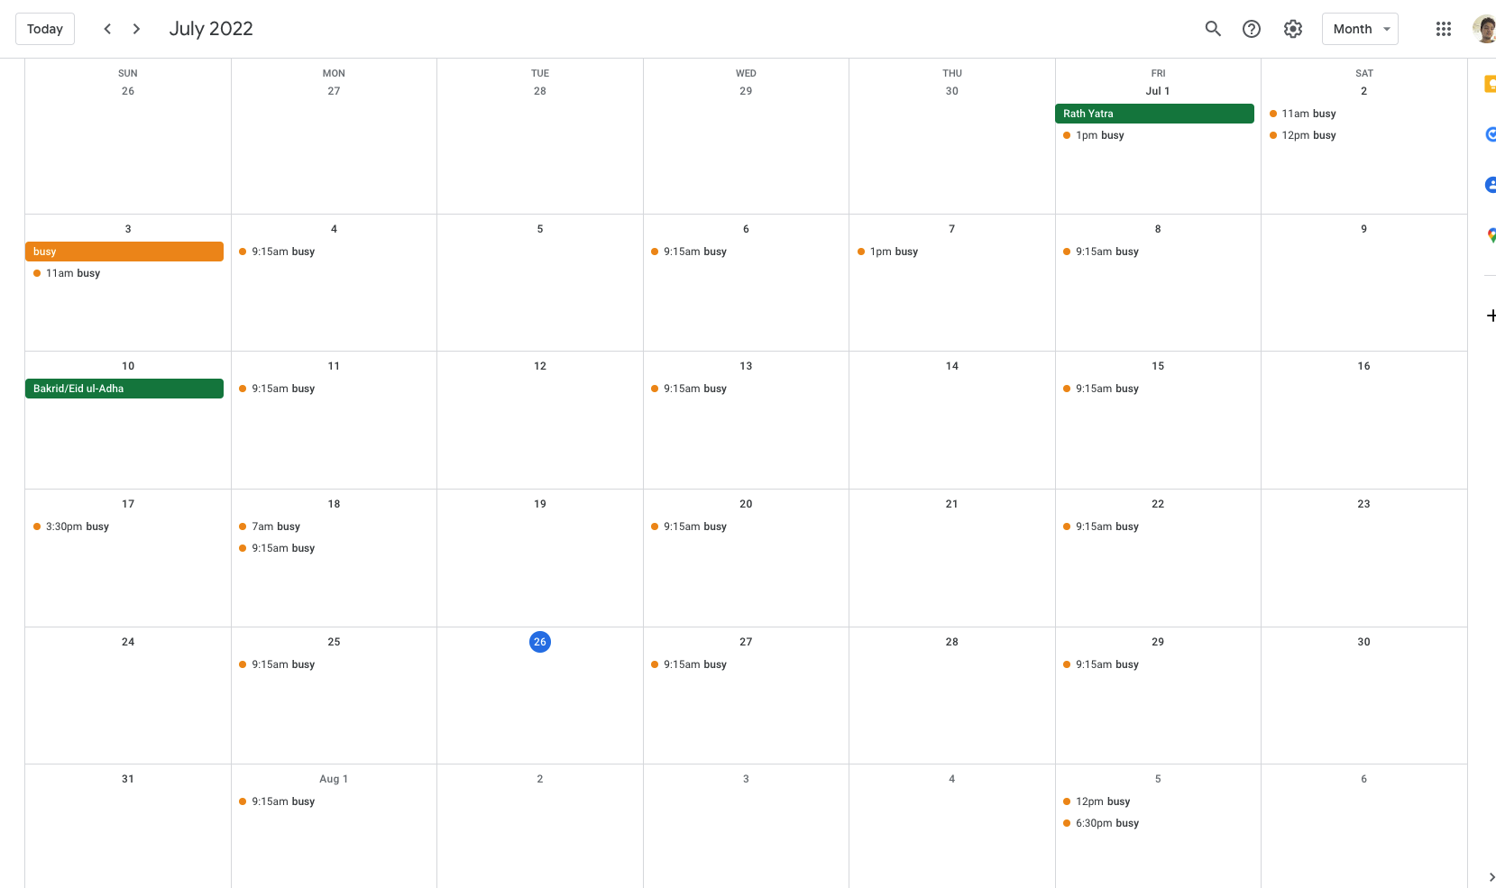

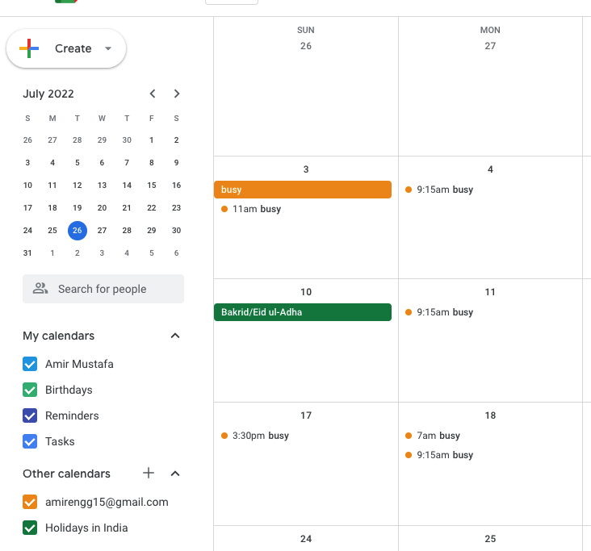

Mobile App and Desktop Access:

🡪 Open Google Calendar in mobile device

🡪

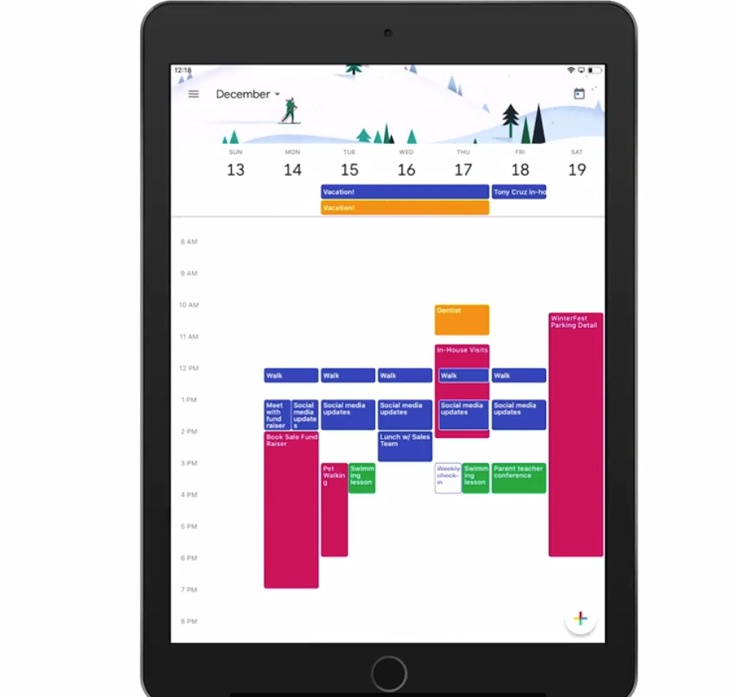

🡪 We can even click on month to explore both month and week view:

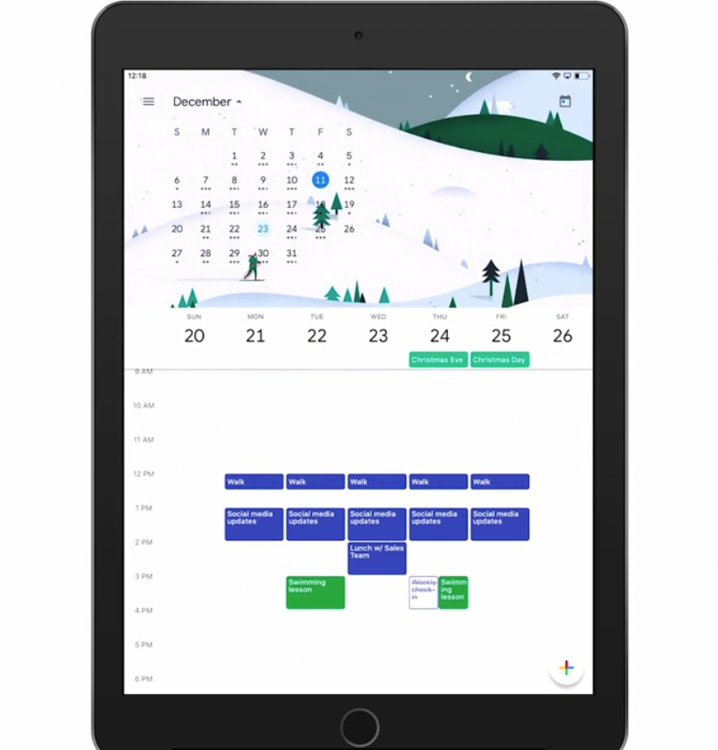

🡪 We can swipe right or left in calendars

🡪 To go to today’s date 🡪 Tab calendar icon on right hand of screen

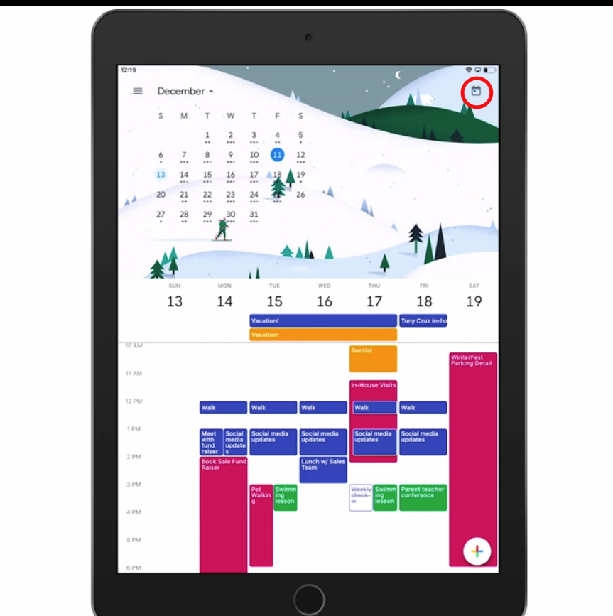

🡪 We can tap event to see large version of it.

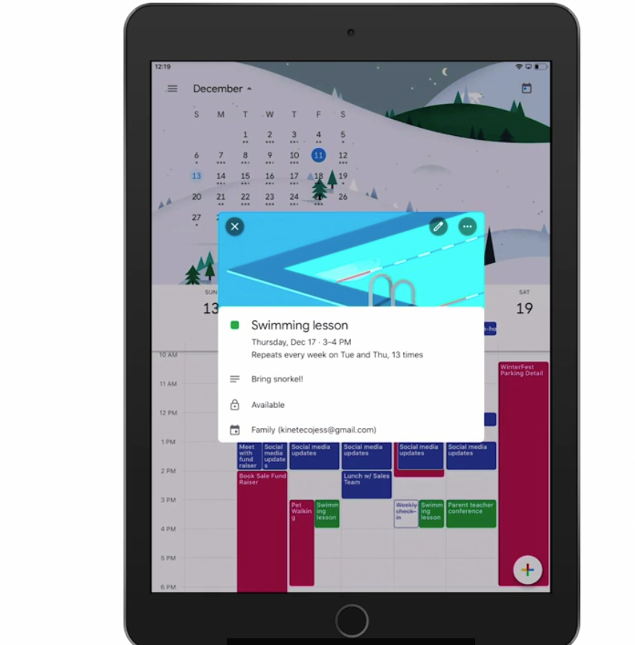

🡪 For creating event from mobile device 🡪 tan + icon

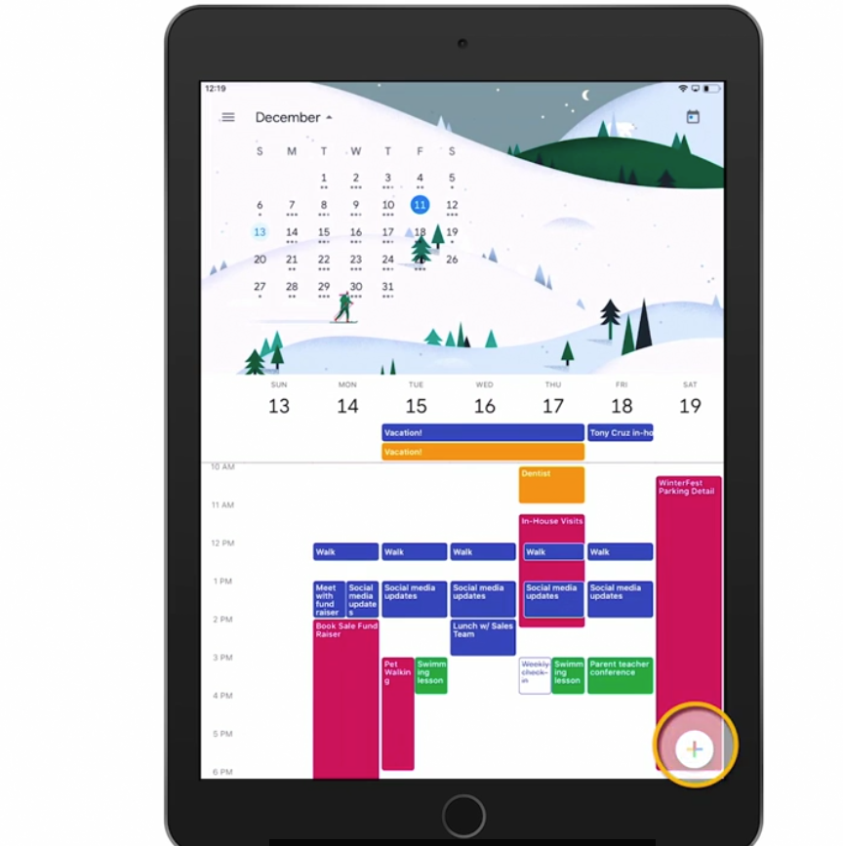

🡪 Tap Event

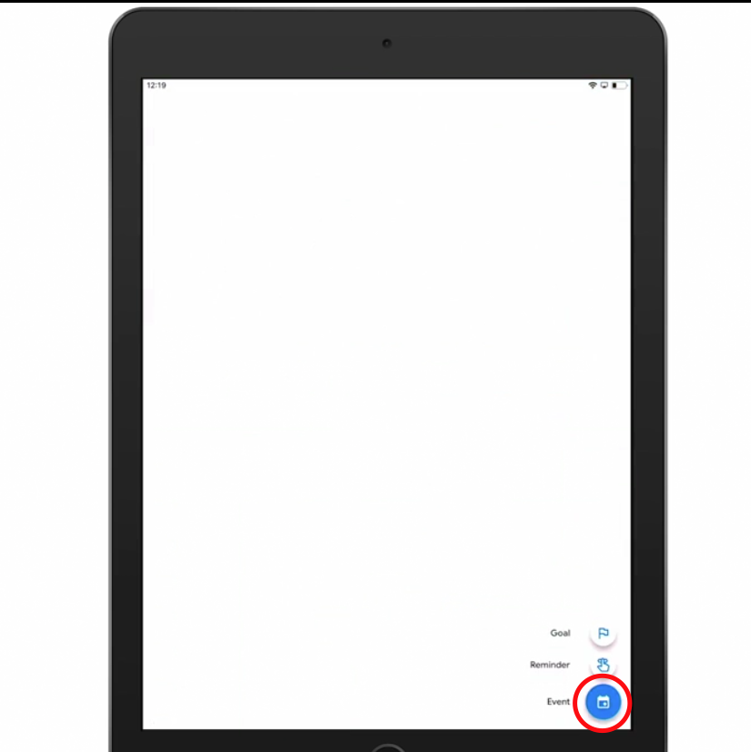

🡪 Chose a specific calendar in your current account – say Amir Mustafa (work) or family

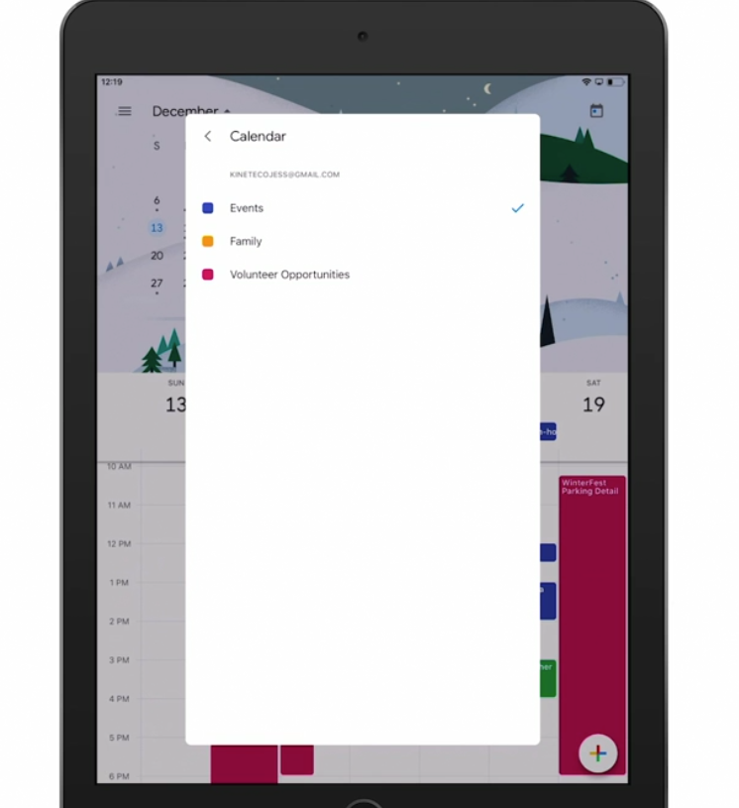

🡪 Enter your details and click save

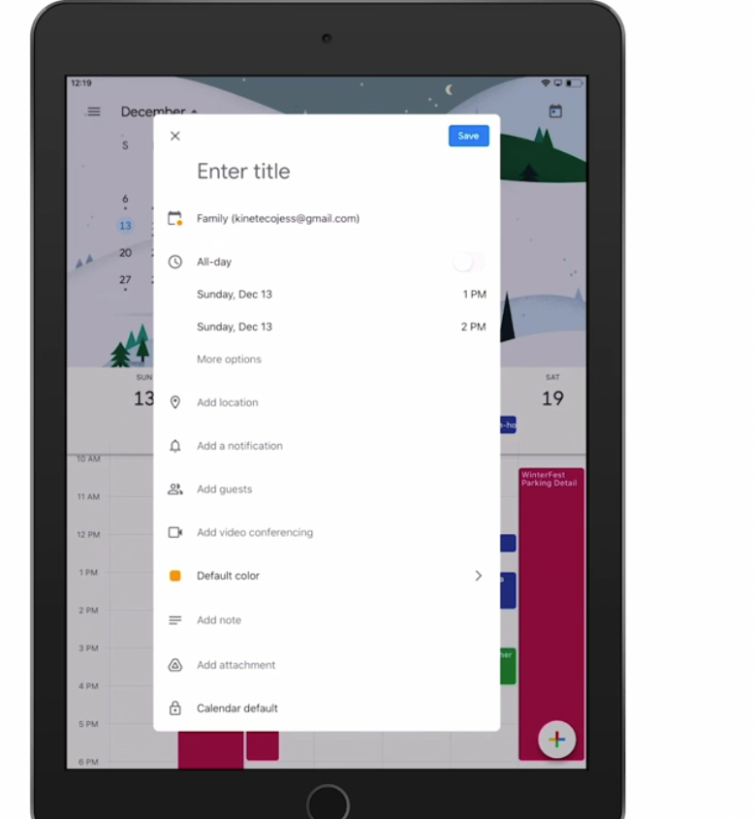

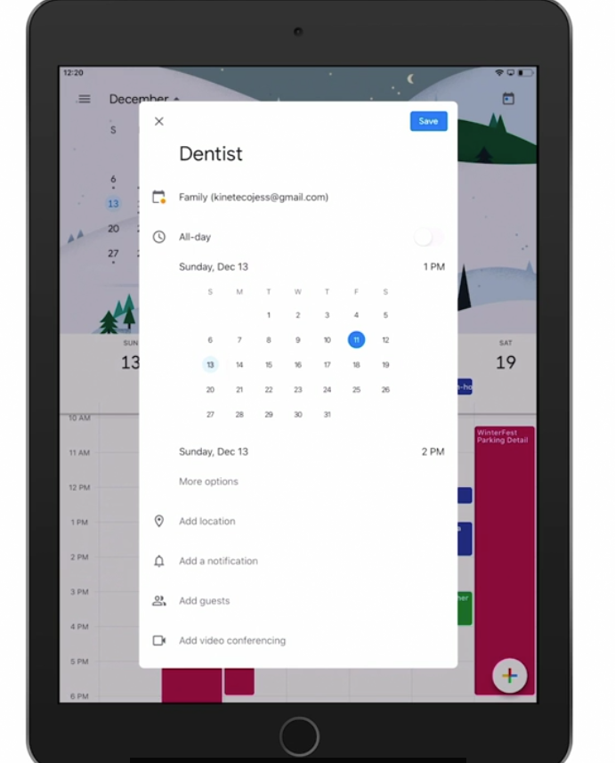

🡪 There is also a nice schedule view of calendar from left menu

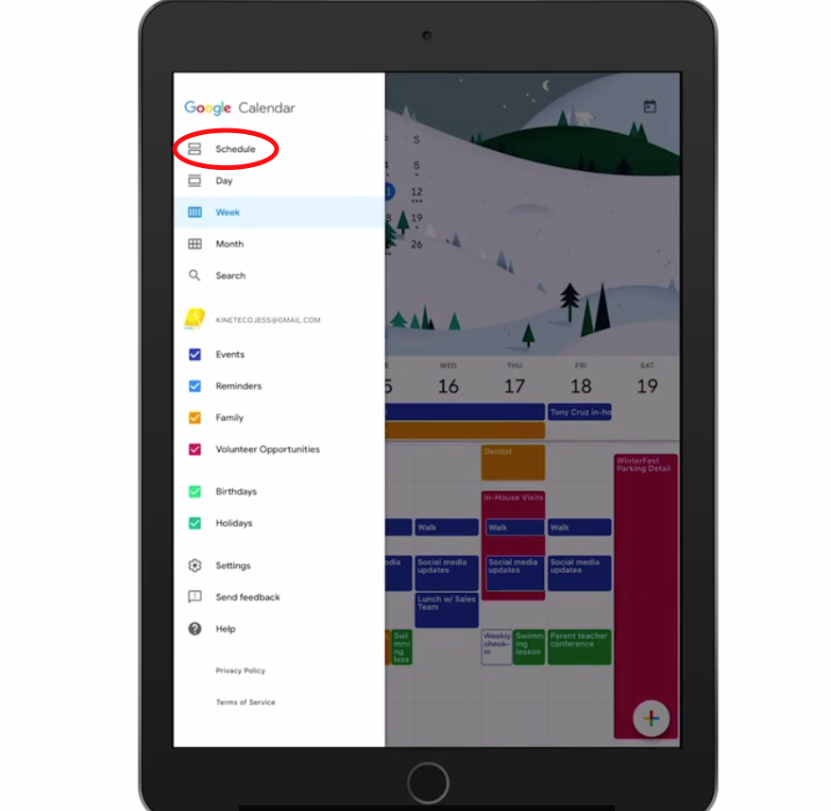

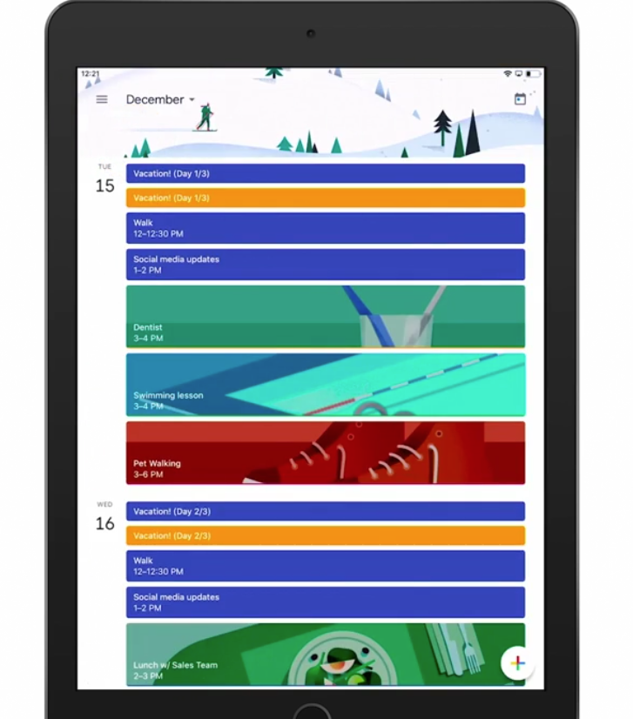

🡪 We can also turn on/off specific calendar from left menu panel

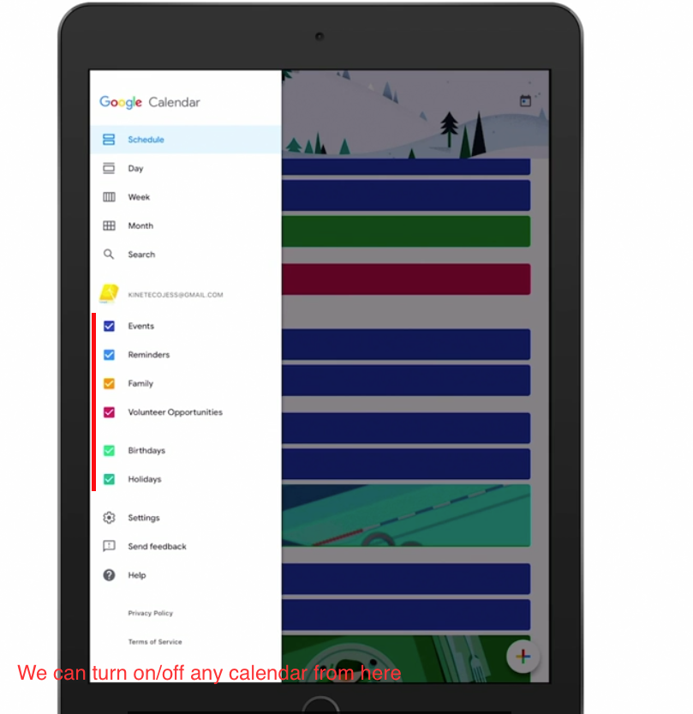

Desktop for Mac:

Open Mac default calendar

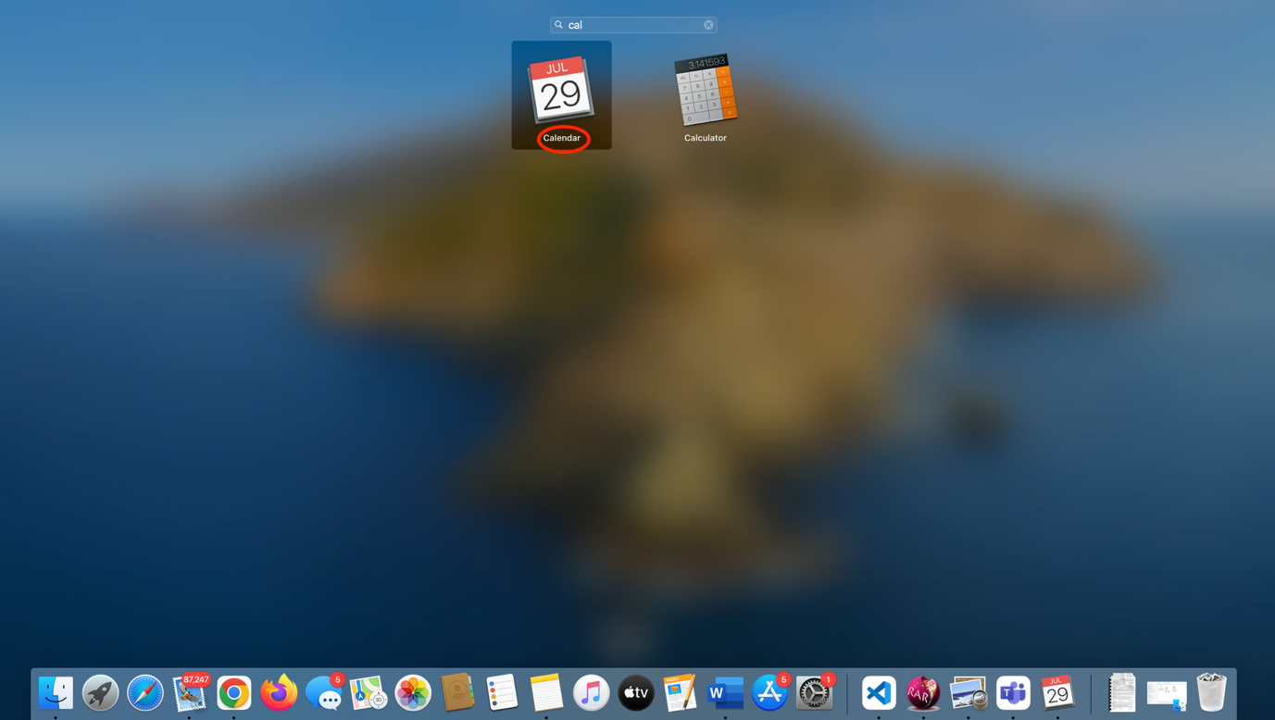

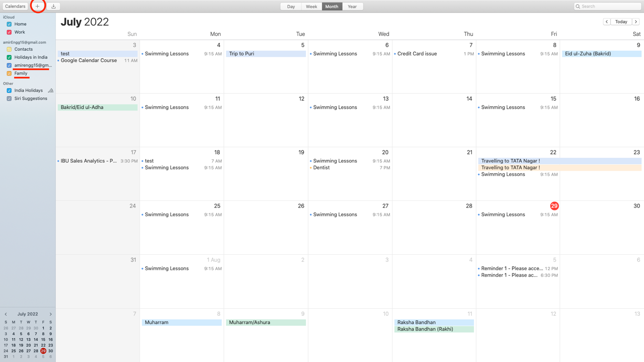

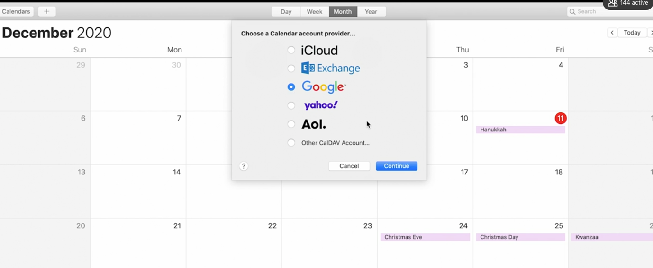

Week View:

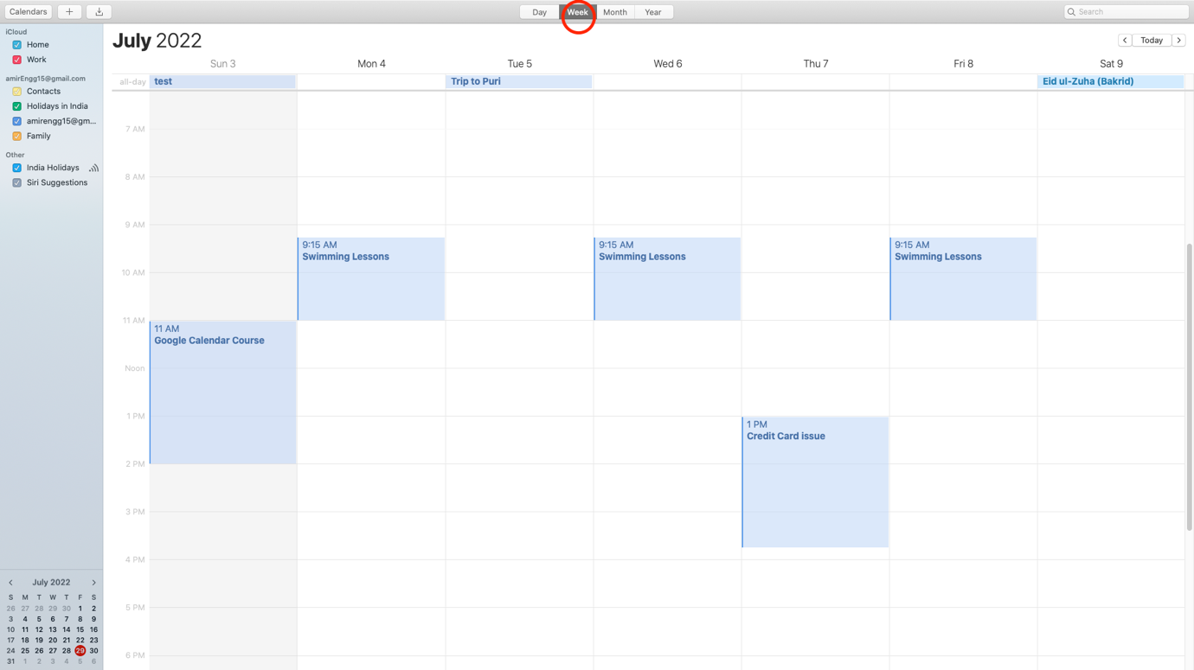

Day View:

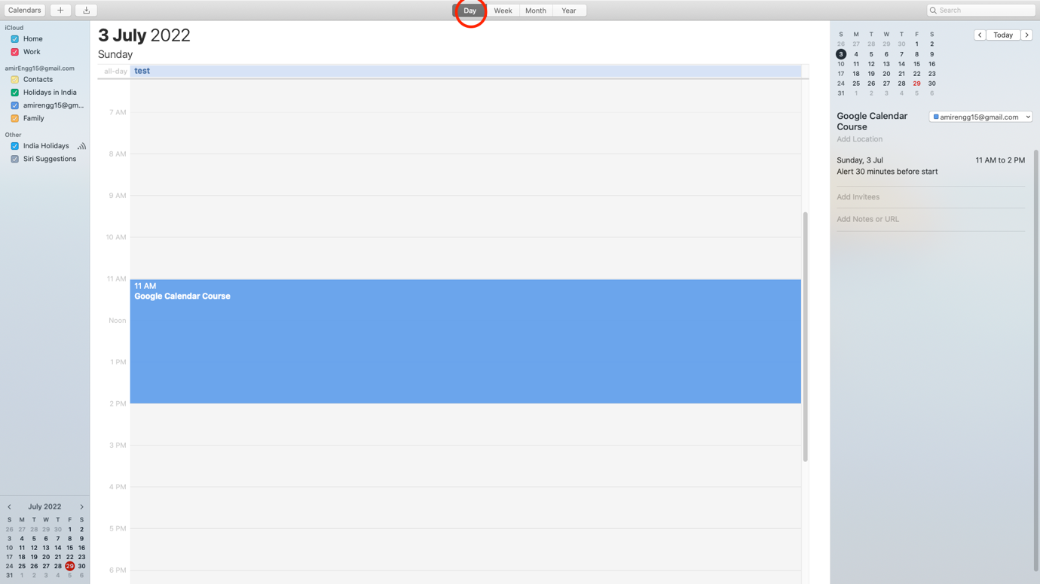

Year View:

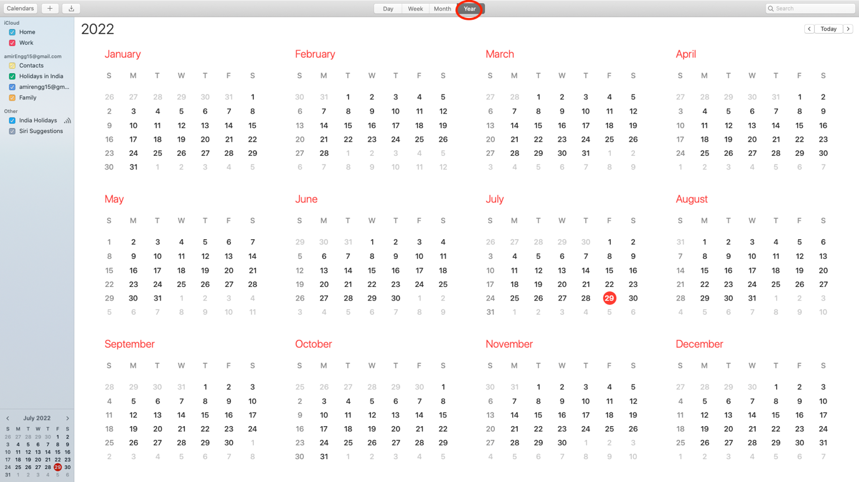

🡪 We can easily create Calendar events from here that will be synched with calendar across all devices

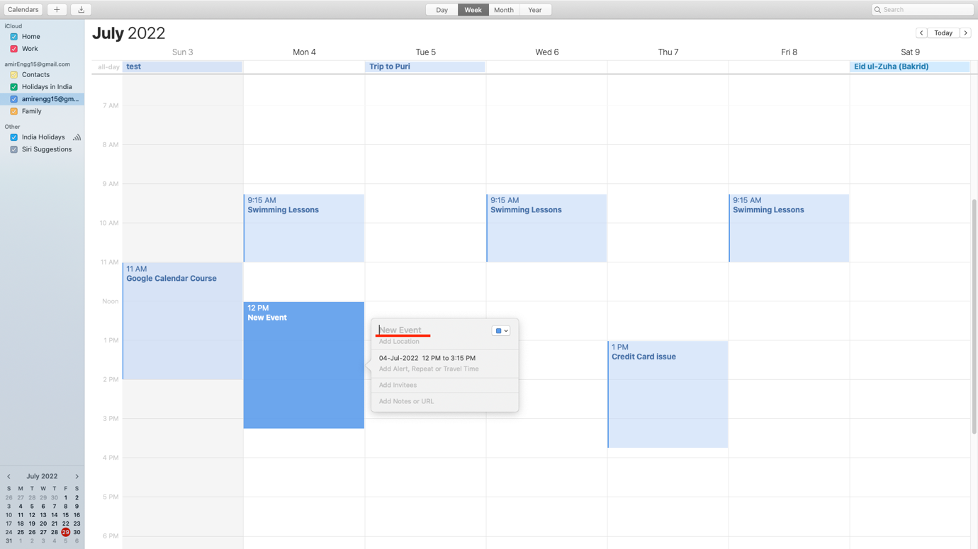

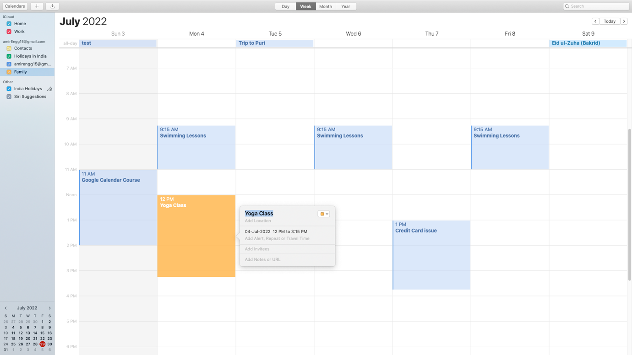

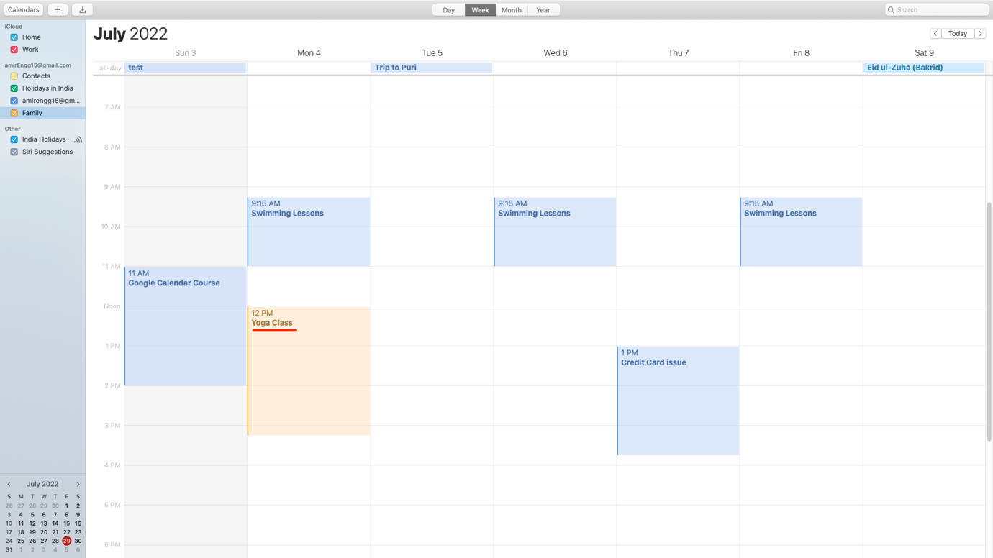

🡪 We can also delete from here using right click:

